

**Calorie2Grocery**

**PROJECT REPORT**

***Submitted By***

SRAVANI PUNYAMURTHULA, LAKSHMI VAISHNAVI AIENAMPUDI, VINAYA PODDUTURI, LEELA NAGA DEVI GAJULA

FOR THE PARTIAL FULFILMENT OF THE COURSE

CS551-ADVANCE SOFTWARE ENGINEERING

SPRING – 2015

Instructor TA’s

Dr. Yugyung Lee Malathy Krishnan

Mayanka Chandrashekar

Bharath Viswanadham

**Table of Contents**

|  |  |  |
| --- | --- | --- |
| **S.no** | **Description** | **Page No** |
| **1.** | **Project Deployment** |  |
| **2.** | **User Manual** |  |
| **3.** | **Project Management** |  |
| **4.** | **Project Proposal** |  |
| **5.** | **Project Plan** |  |
| **6.** | **First Increment** |  |
| **7.** | **Second Increment** |  |
| **8.** | **Third Increment** |  |
| **9.** | **Fourth Increment** |  |
| **10.** | **Presentation Materials and Project Evaluation** |  |

**PROJECT DEPLOYMENT**

The entire code of implementation has been completed and deployed in GitHub. The GitHub link is provided below:

<https://github.com/vaishnavi5054/AdvSoftEng/tree/master/ASE%20Increment_4%20PG_12>

The project description and methodologies are described briefly and are captured as a video. The video has been uploaded to the YouTube which can be viewed using the following link:

<https://youtu.be/tT-zoL18Qd8>

Our project has been planned using the Scrum do which is an agile tool and the link is given below as follows:

<https://www.scrumdo.com/projects/project/calorie2grocery3/summary>

**USER MANUAL**

**GitHub Project URL:**

<https://github.com/vaishnavi5054/AdvSoftEng/blob/master/ASE%20Increment_4%20PG_12/ASE_Increment4_PG12.pdf>

1. **Introduction**

Diet plays a major role in leading a healthy life style. Due to busy schedules, it has become difficult to plan for a healthy and nutritious diet. Diet is nothing but a pattern of eating food. It is important to concentrate on diet to stay healthy and happy. Proper diet reduces the risk of many diseases.

Obesity and weight gain are the most common problems today. Irregular and improper diet leads to obesity. So it is important to plan our meal to include necessary ingredients and avoid over consumption of food. Calorie information gives the energy content of food. Hence, Calorie intake is a good measure to check on weight gain.

Another common problem in day to day life is grocery management. Now-a-days, it is common to forget the groceries available at home. Not keeping track of the expiry dates leads to wastage of food. There are many web apps/Android apps which give the calorie information for different varieties of food items. Also, there are apps which aid in grocery management. But there is no single application that handles both the functionalities. An integrated app is much more useful to the user because it helps in proper planning of the meal based on calories per serving and groceries available.

1. **How to use the system:**

This is an android application. Any user can access our system by registering and logging in for free.

## **How to access the system:**

## **How to access the system:**

Upon opening our application, it will display the “Login Page”. It also provides a registration button, which allows the new users to register. We are also providing login with facebook option through which users can login into this application with their facebook credentials. After getting successfully logged into the system, the application redirects to home page. In the home page different options will be provided to the users related to grocery and recipe management.

User can search for a recipe using any keyword. The application retrieves the results based on the search keyword. If the user wants to see the recipe, he can click on the recipe name. It then gives a list of ingredients along with calorie information. If the user wishes, he can import the recipe and generate a shopping list.

The user can also create a recipe and share it using twitter and facebook. The user can also edit the imported recipes, he can delete the ingredients, add more ingredients and can also update the quantity.

The application also provides a feature fro grocery management, where user can maintain a grocery list. He can update the quantity whenever used along with units. Our application also provides another feature for notifications. If the user wants, the applications generates a notification of the expiry dates of all the groceries.

**PROJECT MANAGEMENT**

As part of our Project Management, We used Scrum Do for planning our tasks. We divided the project into 4 increments. Created user stories for each independent task in the increments and assigned the tasks to our team.

1. Sravani Punyamurthula
2. Lakshmi Vaishnavi Aienampudi
3. Vinaya Podduturi
4. Leela Naga Devi Gajula

<https://www.scrumdo.com/projects/project/calorie2grocery3/summary>

**PROJECT PROPOSAL**

**PROJECT GOAL AND OBJECTIVES**

**Motivation:**

Obesity and weight gain are the most common problems today. Irregular and improper diet leads to obesity. So it is important to plan our meal to include necessary ingredients and avoid over consumption of food. Calorie information gives the energy content of food. Hence, Calorie intake is a good measure to check on weight gain.

Another common problem in day to day life is grocery management. Now-a-days, it is common to forget the groceries available at home. Not keeping track of the expiry dates leads to wastage of food. There are many web apps/Android apps which give the calorie information for different varieties of food items. Also, there are apps which aid in grocery management. But there is no single application that handles both the functionalities. An integrated app is much more useful to the user because it helps in proper planning of the meal based on calories per serving and groceries available.

Since mobile devices are available for every human in the world where we had experienced a lot of innovation in the areas of Education we decided to develop an android application that manages both calorie and grocery information.

**Significance:**

Our project focuses on providing all the required information for the user to plan for a healthy meal. A user can have a clear view of the groceries available at home from anywhere. This helps the user to plan his/her meal, search for the recipe and buy the required ingredients before reaching home. The app also gives the calorie information for each ingredient in the recipe thus providing nutritional information to the user. This information could drive the user to go for healthier meal options. Also, the app provides flexibility to add/remove ingredients in the recipe or create his/her own recipes. Our app works as follows:

Suppose a user would like to have vegetable sandwich for dinner. Say, he has tomatoes, onions and bread at home. Using our app he can do the following:

1. User can add tomatoes and onions to his currently available groceries list. User can update the list every time he purchases groceries.
2. User can search for a recipe of veg sandwich
3. The app displays the ingredients for the sandwich. Eg : Bread, Potatoes, Onions, Cucumber, Tomatoes, Lettuce
4. Based on the calorie information, user decides to remove potatoes from the sandwich and add olives. The app then updates the overall calorie count of the sandwich.

Once the user is satisfied with the recipe he can click ok, the app then displays the groceries he/she needs to buy to prepare the sandwich. Also, the quantity of tomatoes and onions will be decreased in the backend to reflect the usage. In this example, the app shows that the user needs to buy Cucumber, lettuce and olives.

**Overall Goal and Objectives:**

Taste wins over health for most of the people. Also, after a day of work it is natural to prepare meal based on the ingredients that are available at home. Sometimes if vegetables are not available at home, people tend to eat junk food to fulfill their hunger. Hence it is important to plan for proper meal to maintain healthy life style.

Mobile apps are fun to use. Our endeavor is to develop an application that can be very useful in maintaining proper diet along with managing groceries efficiently. Our project aims to fulfill two main objectives:

* Firstly to provide calorie information about the ingredients used in preparing a recipe. This helps the user to take healthy choices about their meal.
* Secondly, to automatically generate a shopping list so that the user doesn’t miss something he needs to buy.

Users can create a recipe/search for a recipe and get the calorie count of the ingredients in the recipe. Based on the calorie information, user can chose to add or remove some of the ingredients in the recipe. Thus the app helps in planning for a healthy meal.

Our app provides the flexibility to log the groceries available at home as well as prepare a shopping list. Our app will generate alerts & notifications about the expiry date of the groceries, thus it helps in reduction of wastage of food. Also, based on the recipe chosen, our app prepares the list of ingredients to buy in order to prepare the recipe. Thus the app functions as a unified meal planner which takes care of grocery management as well as provide calorie information to plan for a healthy meal.

**PROJECT PLAN**

**Introduction**

Diet plays a major role in leading a healthy life style. Due to busy schedules, it has become difficult to plan for a healthy and nutritious diet. Diet is nothing but a pattern of eating food. It is important to concentrate on diet to stay healthy and happy. Proper diet reduces the risk of many diseases.

Obesity and weight gain are the most common problems today. Irregular and improper diet leads to obesity. So it is important to plan our meal to include necessary ingredients and avoid over consumption of food. Calorie information gives the energy content of food. Hence, Calorie intake is a good measure to check on weight gain.

Another common problem in day to day life is grocery management. Now-a-days, it is common to forget the groceries available at home. Not keeping track of the expiry dates leads to wastage of food. There are many web apps/Android apps which give the calorie information for different varieties of food items. Also, there are apps which aid in grocery management. But there is no single application that handles both the functionalities. An integrated app is much more useful to the user because it helps in proper planning of the meal based on calories per serving and groceries available.

**Overall Goal and Objectives**

Taste wins over health for most of the people. Also, after a day of work it is natural to prepare meal based on the ingredients that are available at home. Sometimes if vegetables are not available at home, people tend to eat junk food to fulfill their hunger. Hence it is important to plan for proper meal to maintain healthy life style.

Mobile apps are fun to use. Our endeavor is to develop an application that can be very useful in maintaining proper diet along with managing groceries efficiently. Our project aims to fulfill two main objectives:

* Firstly to provide calorie information about the ingredients used in preparing a recipe. This helps the user to take healthy choices about their meal.
* Secondly, to automatically generate a shopping list so that the user doesn’t miss something he needs to buy.

Users can create a recipe/search for a recipe and get the calorie count of the ingredients in the recipe. Based on the calorie information, user can chose to add or remove some of the ingredients in the recipe. Thus the app helps in planning for a healthy meal.

Our app provides the flexibility to log the groceries available at home as well as prepare a shopping list. Our app will generate alerts & notifications about the expiry date of the groceries, thus it helps in reduction of wastage of food. Also, based on the recipe chosen, our app prepares the list of ingredients to buy in order to prepare the recipe. Thus the app functions as a unified meal planner which takes care of grocery management as well as provide calorie information to plan for a healthy meal.

**Significance**

Our project focuses on providing all the required information for the user to plan for a healthy meal. A user can have a clear view of the groceries available at home from anywhere. This helps the user to plan his/her meal, search for the recipe and buy the required ingredients before reaching home. The app also gives the calorie information for each ingredient in the recipe thus providing nutritional information to the user. This information could drive the user to go for healthier meal options. Also, the app provides flexibility to add/remove ingredients in the recipe or create his/her own recipes. Our app works as follows:

Suppose a user would like to have vegetable sandwich for dinner. Say, he has tomatoes, onions and bread at home. Using our app he can do the following:

1. User can add tomatoes and onions to his currently available groceries list. User can update the list every time he purchases groceries.
2. User can search for a recipe of veg sandwich
3. The app displays the ingredients for the sandwich. Eg : Bread, Potatoes, Onions, Cucumber, Tomatoes, Lettuce
4. Based on the calorie information, user decides to remove potatoes from the sandwich and add olives. The app then updates the overall calorie count of the sandwich.
5. Once the user is satisfied with the recipe he can click ok, the app then displays the groceries he/she needs to buy to prepare the sandwich. Also, the quantity of tomatoes and onions will be decreased in the backend to reflect the usage. In this example, the app shows that the user needs to buy Cucumber, lettuce and olives.

**Project background and related work**

There are few applications that gives calorie information of the particular item that could help the user to maintain proper diet, but this does not include the grocery information. Some of the other apps that are developed provides user with only grocery management and recipe information. Our idea is to facilitate the user with both the calorie information and grocery management. In this project, we are going to implement this idea which combines both the functionalities.

The Grocery management application titled “Fresh Box” addresses the mundane task by allowing users to simply snap a photo and upload it into their own virtual ice box. They call this their "what you see is what you get" feature, and the beautifully illustrated interface makes stocking the fridge a fun process similar to updating your Instagram. Once photos are uploaded, users can set an expiration date so the milk doesn't go sour, produce doesn't go bad. The following are the features of this application:

* Take snapshots of the items purchased
* Upload the photos in virtual ice box
* Set expiry date for the items

The Calorie intake application named “Fooducate” is helpful in making choices at the grocery store. You can scan an item’s barcode and the app will share nutritional highlights, compare it to similar items, and provide alternatives. But this app doesn’t provide the option to log the groceries available at home. Using this app, we can only compare the calorie count of similar products. Main features:

* The user gets the calorie details of the product
* Similar items are retrieved as alternatives which are having same count of calories

One of the Grocery shopping list application “Anylist” is specifically designed for grocery lists and recipes. When we start typing to add a new item, AnyList displays an auto-complete list. Tap an item to add it, and AnyList groups items in your list by store sections: Bakery, dairy, meat, frozen food, and so on. We can create multiple lists—one for each store and we can share them with others who use the app. You can also add recipes, so each item needed gets added to your grocery list. But this app doesn’t give the calorie information about the ingredients. The features of this application:

* Search for the particular recipe and get the ingredients
* Categorize the groceries into different groups
* Share the list with others

|  |  |  |  |
| --- | --- | --- | --- |
| Fresh Box | Fooducate | Anylist | Proposed System |
| User can add the items along with expiration date and get notifications whenever the product expired. | User can add the items based on barcodes but cannot add products which doesn’t have barcodes. | User can just add the groceries list depending upon the category. | User can add the items along with expiration date and get notifications whenever the product expired.  Expiration date will be automatically calculated if not entered. |
| Does not provide calorie information | Provides calorie information for a particular product but not for a recipe. | Calorie information is not evaluated for a recipe. | User can get the calorie count for each ingredient and can edit the quantity of ingredients depending on his/her choice and get the overall calorie count per serving. |
| No option to create and save recipes | No option to create and save recipes | User can search for a recipe but cannot save it for future reference | User can search for recipes/create his own recipe and save it. |
| Does not provide information regarding nearest grocery stores. | Does not provide information regarding nearest grocery stores. | Does not provide the information regarding nearest grocery stores. | Whenever ingredient is not available for the recipe the user can search for the nearest grocery store based on current location. |

**Proposed System**

**Requirement Specification**

**Functional:**

The goal of the project is to develop an application that allows the user to

1. Register or login securely through Facebook
2. Maintain a list of groceries available in their home
3. Search for recipes and save them for quick reference
4. Get the detailed information of calories per each ingredient required for the recipe
5. Add/remove the ingredients and adjust the quantity of the ingredients
6. Get the final count of calories per serving of the recipe
7. Based on the ingredients, get a list of groceries to buy in order to prepare the recipe.
8. Get the nearest grocery stores based on the current location
9. Get alerts/notifications about the expiry date of the groceries in home.

**Non-Functional:**

* Security: The app doesn’t require access to any sensitive information of the users. The app requests access for only the current location of the user. Also, users can login securely using Facebook.
* Stability: The app is designed to function as expected on any device with android version 4.0 and above.
* Visual Quality: The app displays all the text blocks and forms in acceptable formats.
* Performance: The app needs to load quickly and respond within 3-5 seconds.

**Technological and architectural requirements:**

|  |  |
| --- | --- |
| Requirement | Tools |
| Operating System | Android 4.0 or above |
| Development Operating System | Windows |
| Platform | Android Studio/Eclipse |
| UML Diagrams | Microsoft Visio |
| Languages | Java, C# , ASP.Net |
| Database | SQL Lite |
| Planning | ScrumDo |
| Version Control System | GIT |
| Rest Services | Facebook API |
| Google Places API |
| NDB API |

**Web Services:**

* Google Places API: <https://developers.google.com/places/>
* Google Maps API: <https://developers.google.com/maps/documentation/android/>
* Facebook API: <https://developers.facebook.com/docs/facebook-login/v2.2>
* Google Plus API: <https://developers.google.com/+/web/signin/>
* USDA NDB API: <http://ndb.nal.usda.gov/ndb/api/doc>

**Class Diagram:**



Figure 1.1 Class Diagram

**System Architecture Diagram:**

The overall system architecture can be represented as below: Users interact with the application through GUI. Based on the user input, a request will be sent to the database/rest services. The response is then redirected to the user through the GUI.



Figure 1.2 System Model

**System Architecture Diagram:**

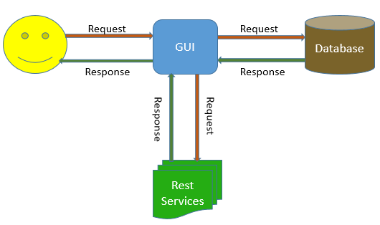

**Activity Diagram:**



Figure 1.4 Activity Diagram

**Sequence diagram:**

Figure 1.4 Sequence Diagram

**Task Planning**

We are planning to implement the project by using latest technology & tools. The project is divided into four iterations.

**Increment#1:**

* Create a home page for the application.
* Create a function to login with facebook/google plus by using rest services.
* Create a register page.
* Create a feature to search nearby grocery stores using google places api.

**Increment#2:**

* Add functionality to add groceries to the database
* Add a browser to the app to be able to search recipes.

**Increment#3:**

* Add functionality to import ingredients from the recipe
* Add functionality to get calorie information using NDB api for the imported ingredients

**Increment#4:**

* Add functionality to enable the user to add/remove ingredients from the recipe
* Automatically generate shopping list

In brief each iteration consists of following tasks:

1. Designing graphical user interface.
2. Connecting to the database and implementing web services.
3. Testing the entire application and bug fixing.

The whole process of development and tasks division has been completely displayed in the scrum Do tool and below is the link for the Scrum DO action of our project.

<https://www.scrumdo.com/projects/project/calorie2grocery2/summary>

**Risk Management**

**Technological & Architectural Requirements:**

* User should be having a smart phone with Android version 4.0 and above.
* GPS should be turned on to get the current location.

**Bibliography**

<https://developer.android.com/training/index.html>

<http://www.apartmenttherapy.com/whats-for-dinner-6-fridge-management-apps-weekly-smartphone-app-roundup-189441>

<http://www.snaptohealth.org/nutrition-hub/nutrition-on-the-go/>

<http://www.techhive.com/article/2455133/six-grocery-shopping-apps-to-replace-your-paper-list.html>

<http://www.groceryiq.com/>

<https://www.anylistapp.com/>

**PROJECT INCREMENT 1**

**Introduction**

Diet plays a major role in leading a healthy life style. Due to busy schedules, it has become difficult to plan for a healthy and nutritious diet. Diet is nothing but a pattern of eating food. It is important to concentrate on diet to stay healthy and happy. Proper diet reduces the risk of many diseases.

Obesity and weight gain are the most common problems today. Irregular and improper diet leads to obesity. So it is important to plan our meal to include necessary ingredients and avoid over consumption of food. Calorie information gives the energy content of food. Hence, Calorie intake is a good measure to check on weight gain.

Another common problem in day to day life is grocery management. Now-a-days, it is common to forget the groceries available at home. Not keeping track of the expiry dates leads to wastage of food. There are many web apps/Android apps which give the calorie information for different varieties of food items. Also, there are apps which aid in grocery management. But there is no single application that handles both the functionalities. An integrated app is much more useful to the user because it helps in proper planning of the meal based on calories per serving and groceries available.

**Objective**

“Calorie2grocery” is an android application that helps its users to plan for a proper meal to maintain healthy life style. Firstly, it provides the calorie count of a recipe. The app has a browser which allows the user to import a recipe and get a list of ingredients. The app then displays the calorie count for each ingredient in the recipe. Each user has his/her own specifications and preferences for recipes. Hence the app provides its users with an option to edit the ingredient list. Users can add or remove ingredients and can get the total calorie count of that recipe. The calorie count helps its users to take healthy choices about their meal. Secondly, it automatically generates a shopping list so that the user does not miss anything that he needs to buy. It provides us the flexibility to log the groceries available at our home. Our app will generate alert notifications about the expiry dates of groceries which in turn helps in reducing the wastage of food. Based on the recipe chosen it, prepares the list of ingredients to buy in order to prepare the recipe. Thus the app functions as a unified meal planner which takes care of grocery management as well as provide calorie information to plan for a healthy meal. Our app also displays a list of nearby grocery stores, so that the user can easily go and purchase products.

**Framework Specification:**

Our framework consists of three stages namely GUI, API, Database and a parser. Database handles the storage of data like the user profile information, grocery list, saved recipes etc. GUI editor is developed as mobile application. The GUI connects to the database/API and gets the required data. The data fetched from the API’s is parsed by the parser and displayed in the user interface.

**Increment#1:**

We have built the GUI for login, registration and home pages as part of Increment1. The home page will be modified throughout the project as we add functions to our application. We have established the database connection from the GUI. As part of increment1, we have added functionality to store the user profile information in the database. API is used to display the current location of the user and to display the nearby grocery stores. We have added authentication logic which enables the GUI to communicate with the database and verify the user.

**System Architecture:**



**Application Specifications:**

|  |  |
| --- | --- |
|  | **Tools** |
| Platform | Android 4.0.3 |
| UML Diagrams | Microsoft Visio |
| Languages | Java, C# , ASP.Net |
| Database | SQL Lite |
| Planning | ScrumDo |
| Version Control System | GIT |
| Rest Services | Google Places API |

**Implementation of User Interface:**

We have developed four layouts as part of UI implementation.

1. Registration page
2. Login page
3. Welcome/Home page
4. Layout for viewing the google maps

If the user is a new user, then he has to register to use the app. After registering, the app redirects to the login page where the user can login to use the features of this app. When the user logs in successfully, he can perform the following operations:

* He can visualize his current location using google maps.
* He can search the list of nearby grocery stores.

**Design of Mobile Client Interface:**

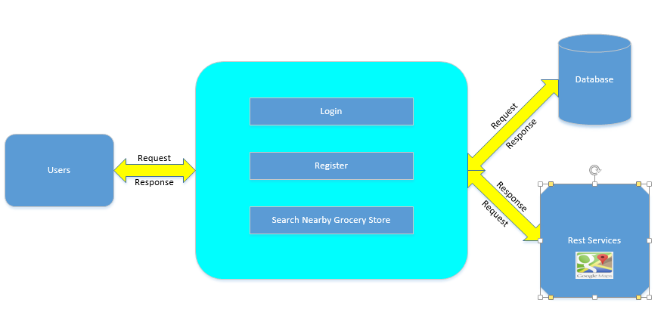

GUI

**Class Diagram:**

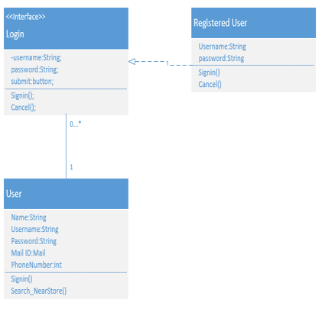

**Sequence Diagram:**

In our sequence diagram, there are five components. When the user is an unregistered or a new user, the GUI asks the user to register with his details. The details of all the users are stored in the data base. If the user is already a registered user, the GUI asks the user to login. When the registered user enters his login credentials, the GUI checks the details from the database, and if he is a valid user, it redirects to the home page. Once, he goes to home page, the user has the options to view the current location and get the list of nearby grocery stores. When the user wishes to search for a nearby grocery store, the GUI communicates with the API and returns the results to the GUI where the user can visualize. The GUI component is displayed as Admin in the following diagram.

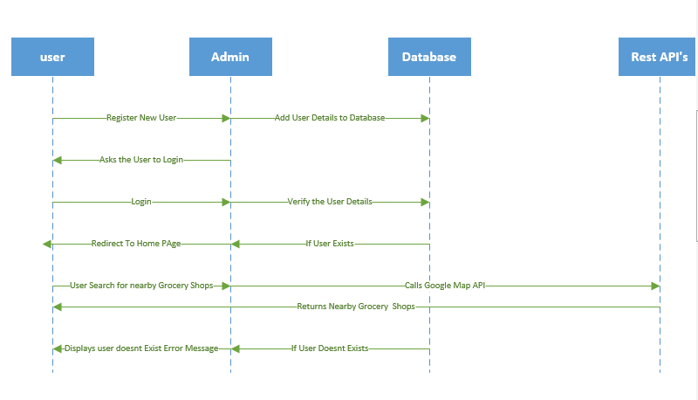

Here users interact with the GUI to login or register. When the user logs in, the GUI checks the data from the database and displays Welcome Screen. When the user clicks to Search a nearby grocery store, the GUI interacts with the Rest service API to get the data and displays it on the google map.

**Screen Shots of the UI:**

1. **Login Page:**

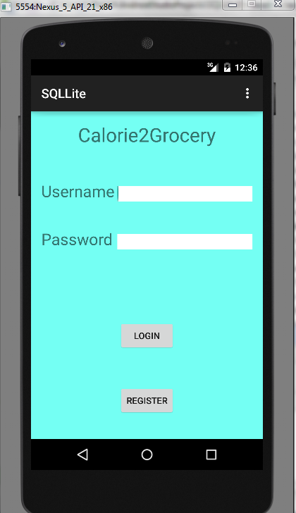

* The user interface provides the users with two options:
  + Login for already registered users.
  + Register button for new or unregistered users.

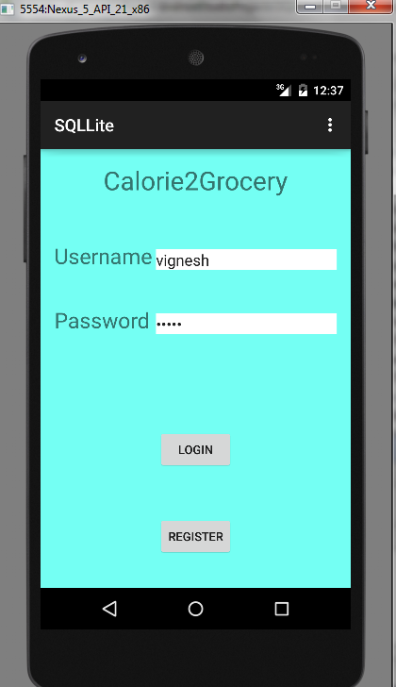

1. **Home Page:**

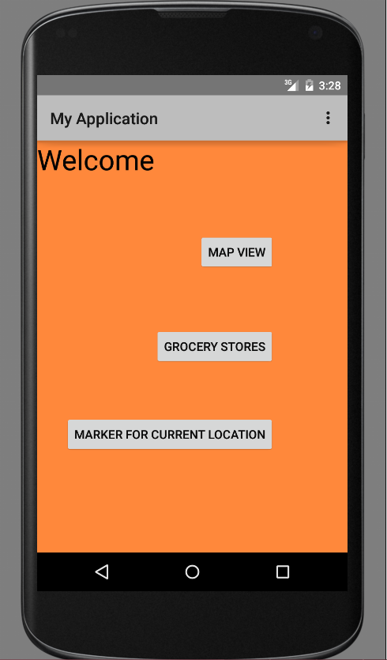

* This is the home screen
* It provides user three options:
  + Map View
  + Grocery Stores
  + Marker for current location

1. **Registration page for new or unregistered users.**

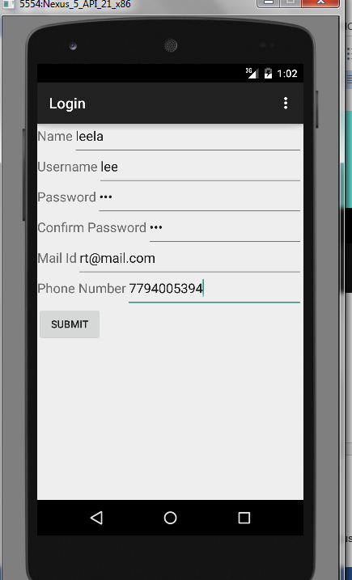

* This is the Registration Page
* User has to provide the following details:
  + Name
  + Username
  + Password
  + Mail Id
  + Phone number

**Implementation of existing API:**

Our welcome page has three buttons related to location services. The grocery store button displays the nearby grocery stores using the google places API. We have started implementing the API by first fetching the information to display the current location. The button “Marker for current location” implements this logic. Then we have implemented the logic for opening the google maps. The “Map View” button is used for executing this logic.

For using google API’s, we have installed google play services from android SDK manager. We have created an application in google console to get the API key and API secret key which need to be configured in the manifest file of the android application.

**Screen Shots for implementation of API:**

**Grocery Stores**

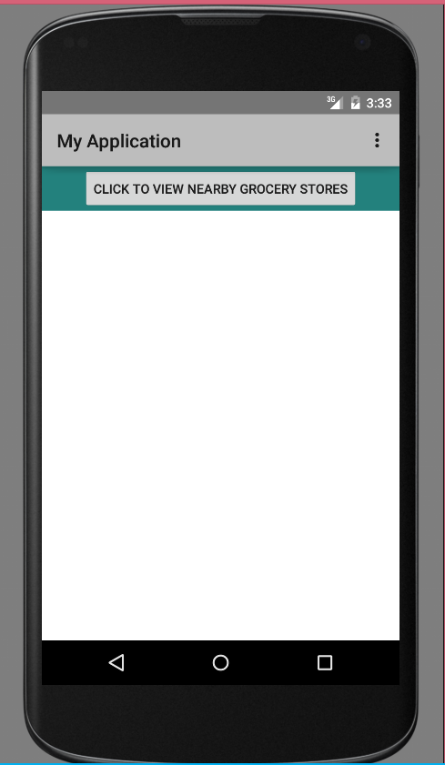

* This page is displayed when the user clicks on grocery stores. This page has a button which redirects to google maps on clicking it. When the user clicks the button, it displays a google maps page with markers at nearby grocery store.

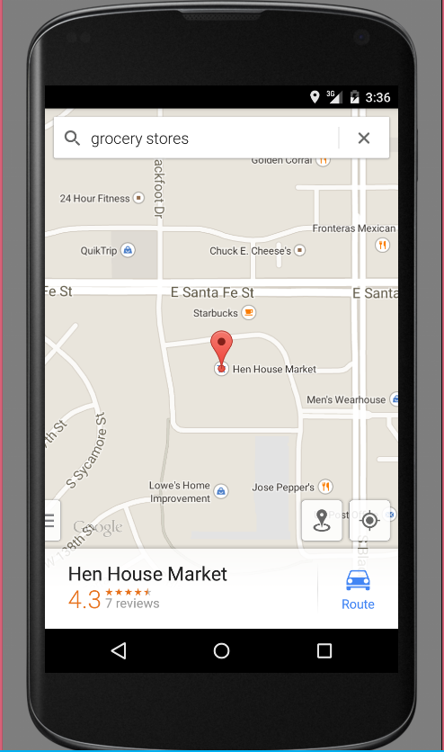

* When the user clicks on grocery stores, it transitions to another page. The screen shot displays the screen how it looks like when we click grocery store.

**Marker Button:**

* When the user clicks on marker button, it redirects to a google maps page which has a button named city. The below screenshot shows the page that loads on clicking the marker button.
* When the user clicks on CITY button, the user interface displays a marker at the users’ current location with a tag “You’re here!!!”.

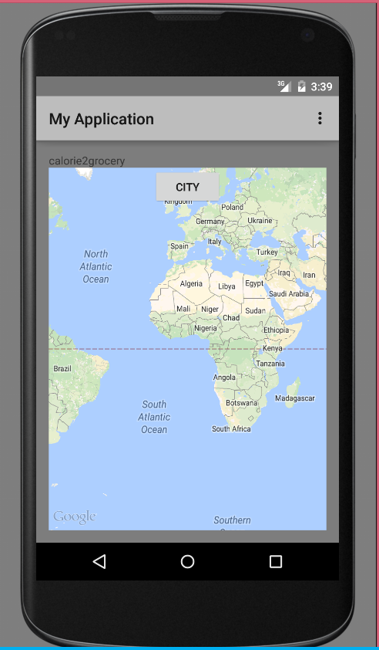

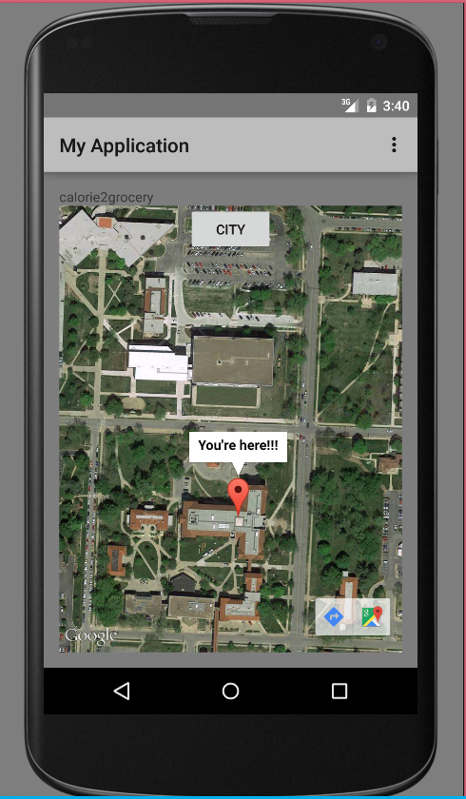

* When the user clicks on CITY button, the user interface displays a marker at the users’ current location with a tag “You’re here!!!”.

**Database Implementation:**

We have established the connection to the SQLLite database from the android application. To establish the connection, we have installed the SQLLite plugin. We have created the register table in the database. The information that the user inputs from the registration page will be loaded into the database. During login, the username and password entered by the user will be authenticated using the values present in this table.

The below screen shot shows the image of how the values are stored in the database when the user registers. We have created sample users as part of testing.

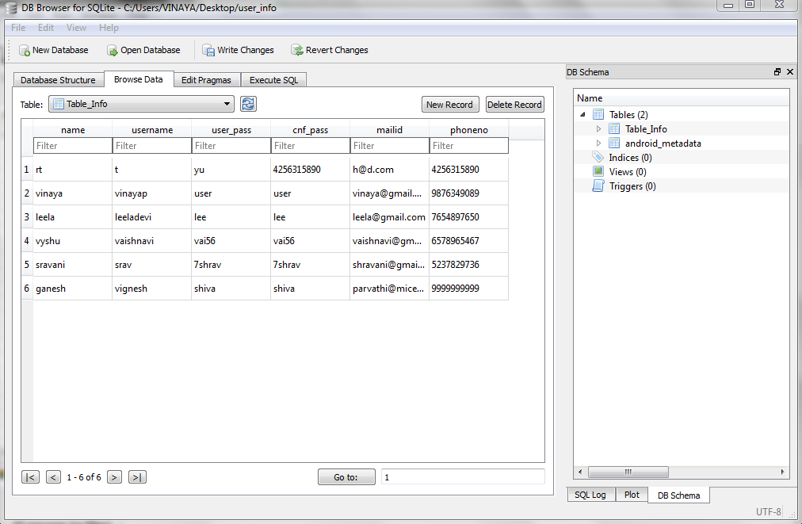

**Data Model**

This is the data model for our application. It consists of three database tables.

* 1. User_Profiles: Maintains user related data.
  2. Grocery_list: Maintains all grocery related data.
  3. Recipes: Maintains all recipe information.
  4. Shopping_list: Consists of all the items that are generated from all the recipes, when user clicks on generate shopping list.

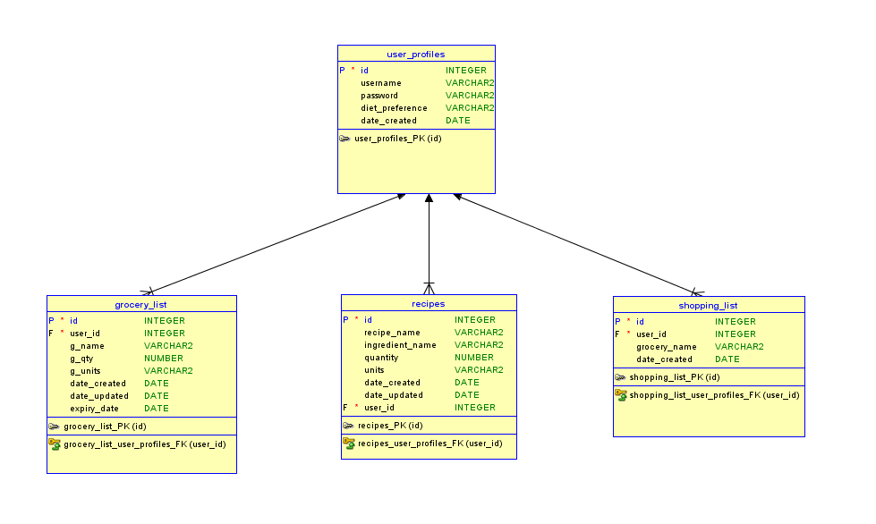

**Design of Test Cases:**

We have divided the test cases into two parts:

1. UI Testing
2. Data validation

**UI Testing:**

As part of UI testing, we have verified that the transitions from page to page happen as expected. Following are the manual test cases for transition of the UI.

|  |  |  |  |
| --- | --- | --- | --- |
| **Page** | **Button** | **Expected** | **Actual** |
| Login | Register | Registration page | Registration page |
| Login | Login (with correct username & password) | Welcome Page | Welcome Page |
| Login | Login (with incorrect credentials) | Error Message, ask to re-enter credentials | Error Message, ask to re-enter credentials |
| Registration | Submit | Thank you page to show successful registration | Thank you page to show successful registration |
| Registration Success Page | Click to Login | Login page | Login page |
| Welcome Page | Grocery Stores | Grocery layout | Grocery layout |
| Grocery | Click to view nearby grocery stores | Google maps | Google maps |
| Welcome Page | Marker for current location | Google maps | Google maps |

**Data Validation Tests:**

For Increment#1, we have two test cases for data validation.

1. We have verified that the data entered in the register table matches with the user input.
2. **User authentication:**

Positive test case: Upon entering the correct user credentials, the authentication should succeed and the GUI need to transition to the Welcome page.

Negative test case: If we enter incorrect username and password, the app should throw an error message.

**Scrum Do :**

We have used Scrumdo to track the progress of the project. The project development is divided into four increments. All the functions and development tasks are written as user stories.

**Link:**

<https://www.scrumdo.com/organization/umkc240/dashboard>

Following are the screen shots of the scrum board for all the increments:

**Increment#1**

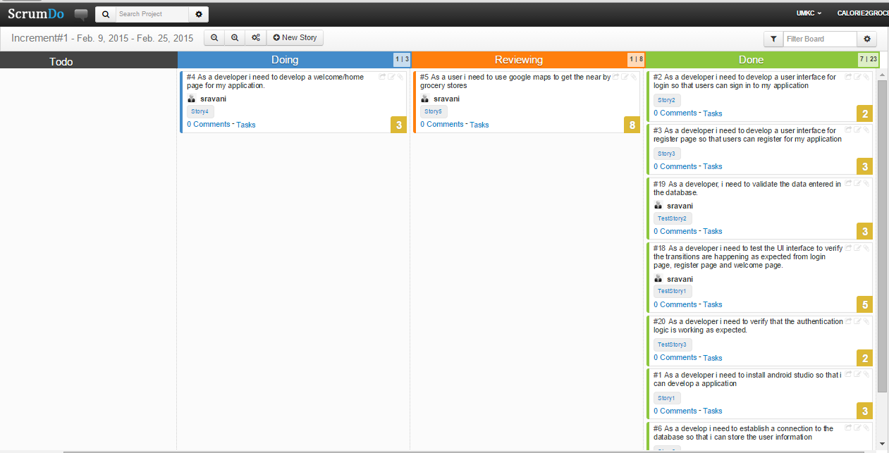

**Increment#2:**

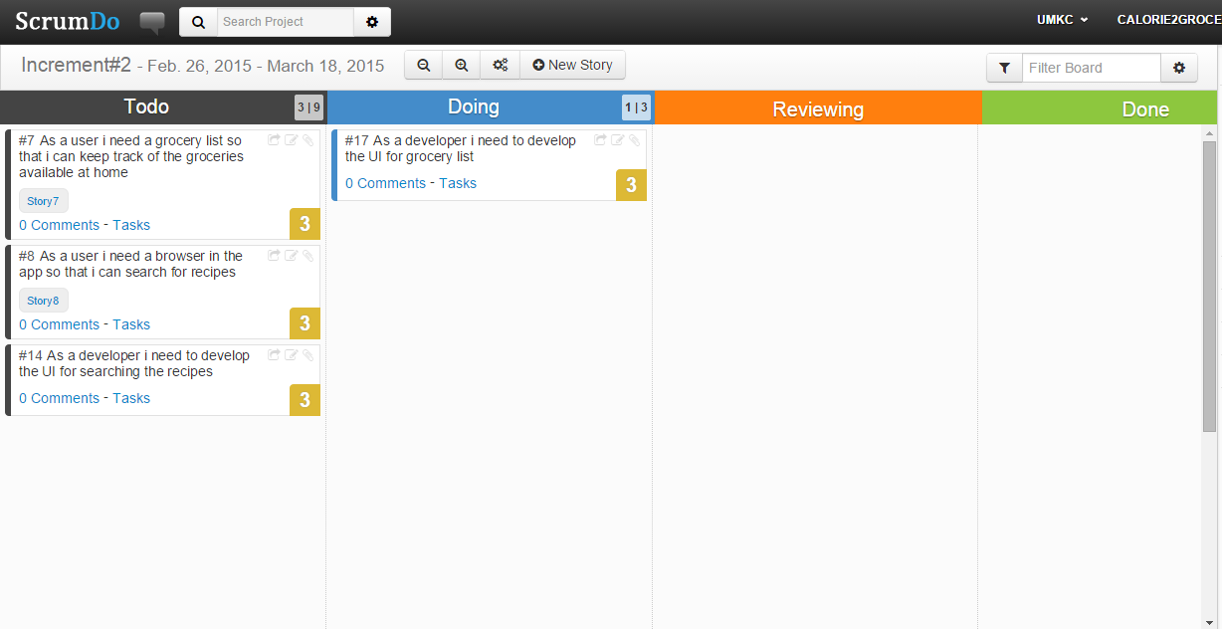

**Increment#3:**

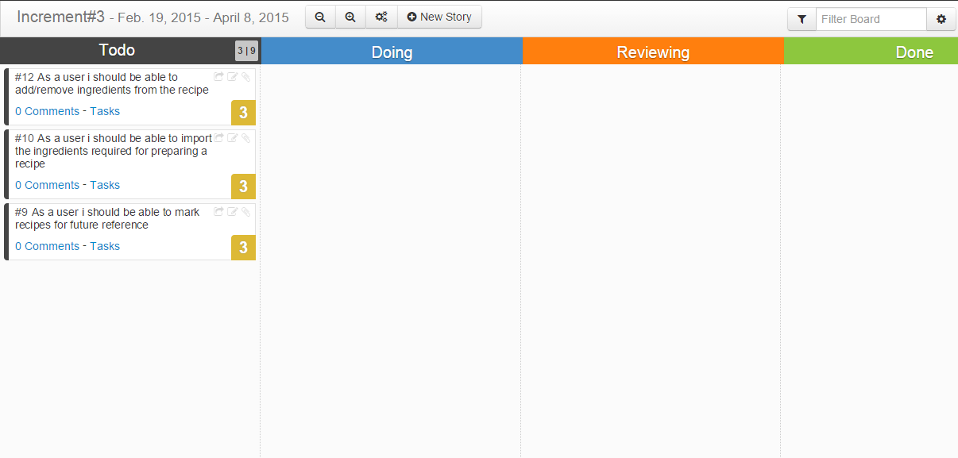

**Increment#4:**

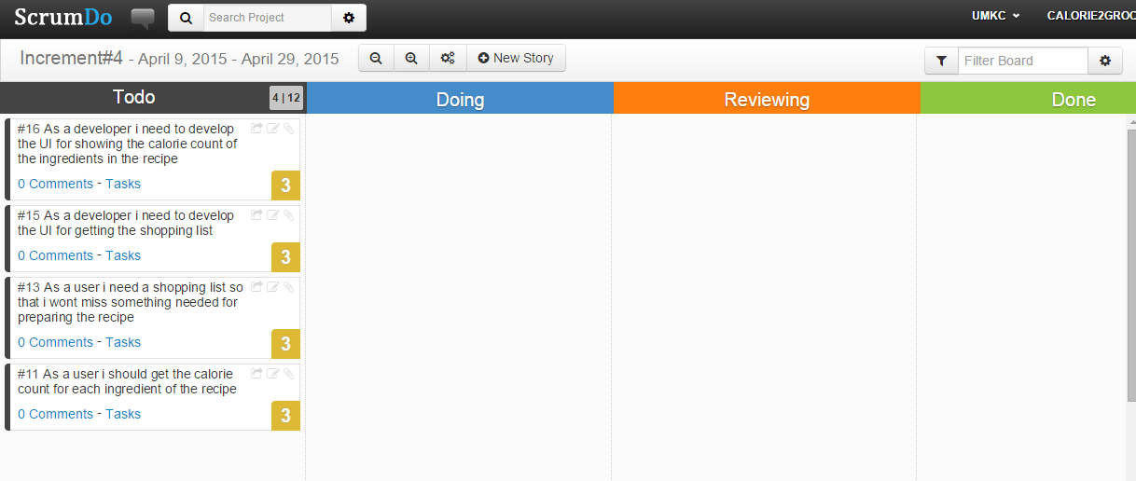

**Implementation Status Report:**

**Work Completed:**

1. **GUI**

Description:

Implementation of login & Registration pages along with database connection. UI implementation of these pages include page transition.

Responsibility:Vinaya , Leela

Time taken: 8 Hours

Contribution:

Database Connectivity: Vinaya (40%) , Leela (30%)

Division of tasks:

Vinaya : Creating the UI for login page and developing the logic for authentication.

Leela: Creating the UI for registration page and developing the logic to load the user input into database.

Testing: Leela(10%) Sravani(10%) Vaishnavi (10%)

Testing includes validation of data and ensuring that the page transitions are performed correctly.

1. **API & Welcome Page**

Description:

Implementation of google places api to get the nearby grocery stores. Creation of welcome page/home page that has all the features of the app.

Responsibility:Sravani , Vaishnavi

Time taken: 10 Hours

Contribution:

Database Connectivity: Sravani (40%) , Vaishnavi (30%)

Division of tasks:

Sravani : Creating the UI for welcome page and developing the logic for fetching data from google places api.

Vaishnavi: Implemented the marker logic to show the current location.

Testing: Vaishnavi(10%) Vinaya(10%) Leela (10%)

**Issues/Concerns:**

The android studio is very slow. Hence we had to invest more time than normally required for developing applications. Also there is less support online for android studio compared to eclipse for developing android applications.

**PROJECT INCREMENT 2**

**Project Goal**

The goal of our project is to develop an android application “Calorie2grocery”, which helps its users to plan for a proper meal to maintain healthy life style. Firstly, it provides the calorie count of a recipe. The app has a browser which allows the user to import a recipe and get a list of ingredients. The app then displays the calorie count for each ingredient in the recipe. Each user has his/her own specifications and preferences for recipes. Hence the app provides its users with an option to edit the ingredient list. Users can add or remove ingredients and can get the total calorie count of that recipe. The calorie count helps its users to take healthy choices about their meal. Secondly, it automatically generates a shopping list so that the user does not miss anything that he needs to buy. It provides us the flexibility to log the groceries available at our home. Our app will generate alert notifications about the expiry dates of groceries which in turn helps in reducing the wastage of food. Based on the recipe chosen it, prepares the list of ingredients to buy in order to prepare the recipe. Thus the app functions as a unified meal planner which takes care of grocery management as well as provide calorie information to plan for a healthy meal.

**Increment #2**

We have developed an application which helps the user do the following:

Add groceries items that are available at home to a list.

View grocery list

Search for a recipe.

See the ingredient list for that recipe.

Import the ingredient list to the local system.

We developed a native android application for adding the list of groceries along with quantity. We have used web technologies for implementing the client side logic rest of the functionalities listed above. We are storing the data in SQL Server remote database. Hence we have created rest services to push/pull the data from the database.

**Application Specifications:**

|  |  |
| --- | --- |
|  | **Tools** |
| Platform | Android 4.0.3 |
| UML Diagrams | Microsoft Visio |
| Languages | Java, C# , ASP.Net , JQuery , JavaScript , AJAX |
| Database | SQL Server |
| Planning | ScrumDo |
| Version Control System | GIT |
| Existing Rest Services | Recipe Search |
| New API’s | Grocery list Import API |

**Existing Services:**

**1. Recipe Search & Diet API :**

This API provides services for the following:

Nutritional Analysis

Recipe Search

We are using Recipe Search and Diet API to search for a recipe. This API provides information about the ingredients, the preparation time and procedure for a recipe. This API provides detailed information about the quantity of ingredients, total calorie count of the recipe etc. Also this API provides additional search capabilities like we can include restrictions on allergic items etc. Hence we are using this API to get the list of recipes based on a keyword and import the ingredient list.

API: <https://api.edamam.com/search?q=chicken&app_id=51aba909&app_key=9fcd3aa5746d2a423a350cee3ea4d57d>

Reference:<https://developer.edamam.com/>

**New Services:**

We have created 2 rest services for implementing the server side logic for this application.

**Grocery List**: This API is used to maintain the grocery lists. We have implemented two methods in this API.

Add grocery Item: This method is used to insert the data entered by the user in the database. User name, grocery name, quantity and units are given as a input to this method.

API: [http://kc-sce-cs551-](http://kc-sce-cs551-2.kc.umkc.edu/aspnet_client/MPG12/Sravani/AddGrocery/Service1.svc/addgrocery/Sravani/butter/30/gm)

[2.kc.umkc.edu/aspnet_client/MPG12/Sravani/AddGrocery/Service1.svc/addgrocery/Sra vani/butter/30/gm](http://kc-sce-cs551-2.kc.umkc.edu/aspnet_client/MPG12/Sravani/AddGrocery/Service1.svc/addgrocery/Sravani/butter/30/gm)

**View grocery list:**

This method is used to retrieve the grocery list from the database. Username is passed as an input to this method.

API: [http://kc-sce-cs551-](http://kc-sce-cs551-2.kc.umkc.edu/aspnet_client/MPG12/Sravani/viewGrocery/Service1.svc/JsonGrocery/Sravani)

[2.kc.umkc.edu/aspnet_client/MPG12/Sravani/viewGrocery/Service1.svc/JsonGrocery/S ravani](http://kc-sce-cs551-2.kc.umkc.edu/aspnet_client/MPG12/Sravani/viewGrocery/Service1.svc/JsonGrocery/Sravani)

**Import Recipe:** This API is created to import the recipe information from the recipe search API and store the recipe name and ingredient list in the database. We need to import this information to the database so that we can enable the users to customize the recipe.

API: [http://kc-sce-cs551-](http://kc-sce-cs551-2.kc.umkc.edu/aspnet_client/MPG12/vinaya2/RecipeIngredient/Service1.svc/data/)

[2.kc.umkc.edu/aspnet_client/MPG12/vinaya2/RecipeIngredient/Service1.svc/data/](http://kc-sce-cs551-2.kc.umkc.edu/aspnet_client/MPG12/vinaya2/RecipeIngredient/Service1.svc/data/)

**Use Case Template for Adding grocery items:**

|  |  |
| --- | --- |
| **Use Case Name** | Add grocery items |
| **Primary Actor** | User |
| **Pre-Conditions** | User has the app installed on his/her mobile.  User should be logged into the app. |
| **Guarantee(Post Conditions)** | Grocery items are stored in the database |
| **Main Success Scenario** | User clicks on “Add Grocery” button in the home page.  The system transitions the UI to the “Add Grocery” layout.  User enters the grocery item name, quantity, selects the measuring unit from the drop down menu and clicks on “Add”.  System adds the grocery information to the database.  System sends a notification that the grocery item is successfully added to the database.  User can go back to the home page by clicking on return button. |
| **Extensions** | 3a. User enters incorrect value for quantity. Systems throws an error asking the user to add proper value.  4a. If the grocery item is already present in the list, systems sends an alert saying the given name already exists in the list. The user can update the quantity of the item in the list if desired.  5a. User can add as many groceries items as he needed to by following steps 3 & 4 and then go back to the home page. |

**Use Case Template to View the grocery list:**

|  |  |  |
| --- | --- | --- |
| **Use Case Name** | View grocery list | |
| **Primary Actor** | User | |
| **Pre-Conditions** | User has the app installed on his/her mobile.  User should be logged into the app. | |
| **Guarantee(Post Conditions)** | User can view the list of groceries.  User can update the quantity of grocery items. | |
| **Main Success Scenario** | User clicks on “View Grocery List” button in the home page.  The system transitions the UI to the “View Grocery” layout.  System fetches the grocery list of the user from the database. | |
|  | 4. | System displays the grocery list to the user. |
|  | 5. | User can update the quantity of any of the grocery items. |
|  | 6. | System updates the database to reflect the changes made by the user. |
|  | 7. | System sends a notification saying the update is successful. |
| **Extensions** | None |  |

**Use Case Templates for searching and importing a recipe:**

|  |  |
| --- | --- |
| **Use Case Name** | Search & import a recipe |
| **Primary Actor** | API |
| **Pre-Conditions** | The user must be a valid user to use the app |
| **Post-Conditions** | Retrieves the results for the search |
| **Main Success Scenario** | If the user wants to search for a recipe, then, the user enters the keyword to search.  User clicks on the search recipes.  The system displays ten recipe names.  If the user wants to see the ingredient list, then the user can click on the recipe name.  System displays ingredient list along with quantity.  If the user wants to import the ingredient list then click on import.  The system stores the ingredient list in the database. |
| **Extensions** | None |
| **Special Requirements** | None |

**UML CLASS DIAGRAM:**

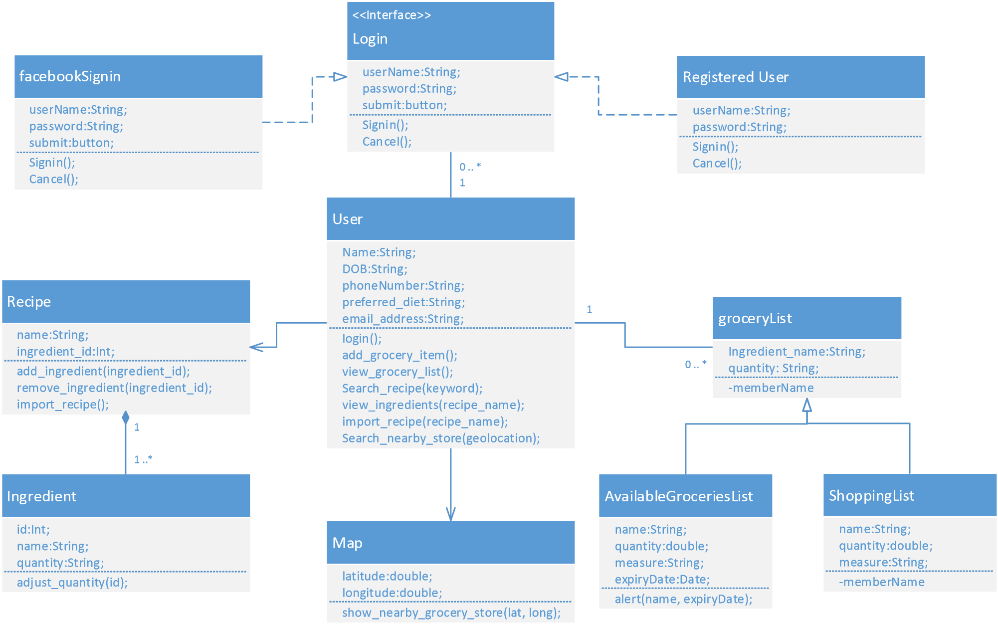Figure 1: UML Class Diagram of the entire system

**Activity Diagram for the functionality implemented in Increment 2:**

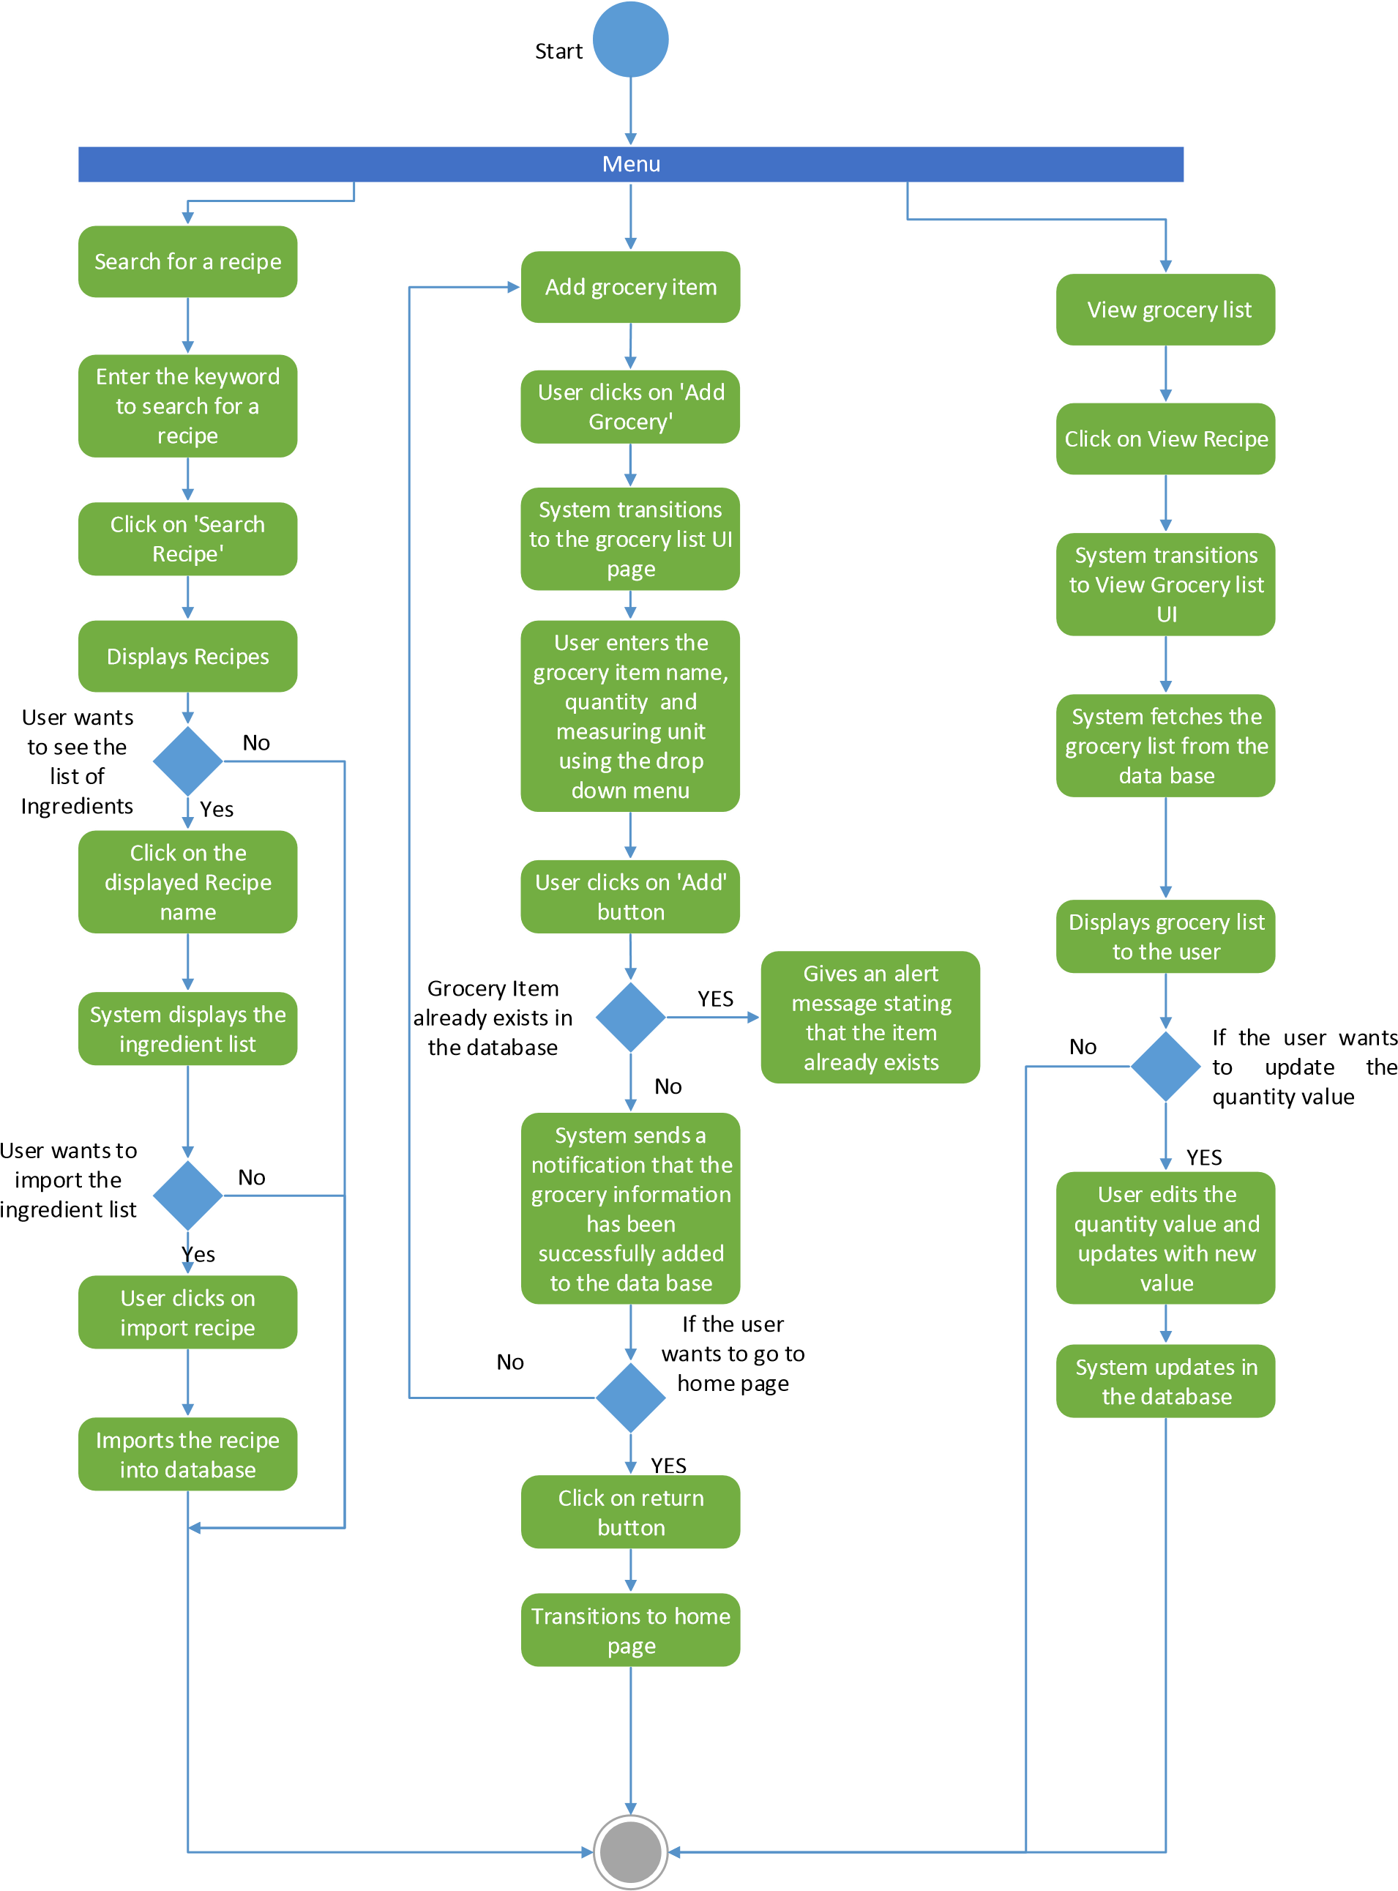

**Sequence Diagram:**

**USER**

**REST API for**

**Remote**

**Database**

**REMOTE**

**DATABASE**

Add items to grocery list

**Recipe**

**Import API**

**Recipe**

**Search API**

items added

Views list of items

Sends the request to the database

Displays the grocery items from the database

Update Quantity of the grocery

Updates the quantity value into the data base

Search a recipe

Returns the recipe list

Select the desired recipe and get the ingredient list

Displays the ingredient list

Import the recipe and ingredient list

Imports the recipe and ingredient ist to the remote database

Figure 3: Sequence Diagram

**Increment#2 Implementation:**

**Implementation of User Interface:**

We have developed four layouts as part of UI implementation.

* Home Page
* Add Grocery
* View Grocery List
* Search Recipe

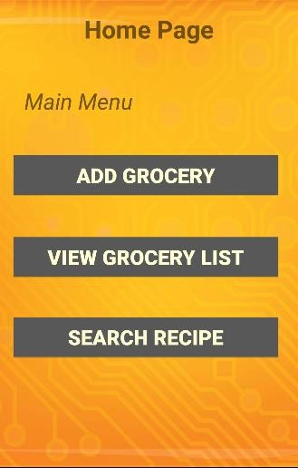**Screenshots:**

Home Page

User is provided with three buttons:

Add Grocery Button: User can click this button If he wants to add grocery items to his list.

View Grocery List: If user wants to view the grocery list, he/she could click on this button.

Search Recipe button: If user wants to search for a recipe, then he/she could click on this button.

Screenshot 1: Home Page page.

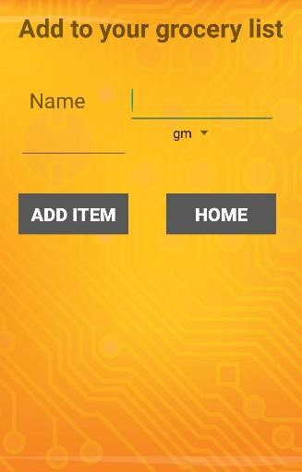

Add Grocery

When the user clicks on Add grocery button, the UI is transitioned to add grocery item

User enters the grocery item, name,quantitiy.

User can select the measuring unit from the drop down menu

**Technical Details:**

Client side logic is implemented in android studio as a native app.

Screenshot 2: Add Grocery page

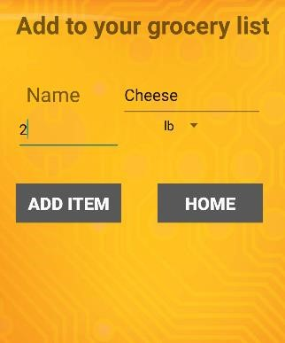Add Grocery

After entering the details about the grocery item, user clicks on add.

System adds the information to the Sql server database.

**Technical Details:**

We have created a web service for inserting the data entered by the user in the grocery_list table in the remote database.

Screenshot 3: Add Grocery page

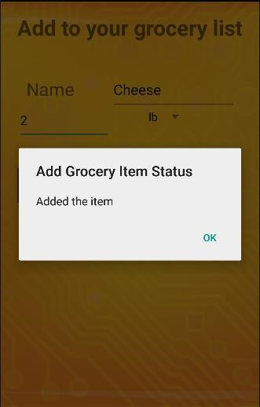

Add Grocery

System sends a notification to the user saying the grocery item is added successfully.

After user clicks ok the add grocery UI is refreshed, the user can add more grocery items or use the home button to go to the home page.

**Technical Details:**

Web service to add the grocery items to database sends the result of the insert operation in the form of Json.

Created a class for parsing the Json string.

Used alert dialog to display the output message from the web service as a notification.

Screen shot 4: Add Grocery notification

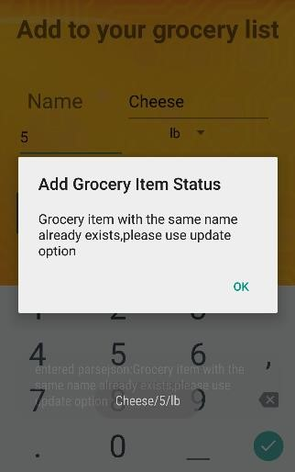Add Grocery

If the user tries to add the same name again, then the system throws an alert saying “a grocery item with the same name already exists in the list.

**Technical Details:**

Before insert, we are implemented a logic to check if a record is already present in the grocery_list table with the same name.

Screen shot 5: Add Grocery update alert

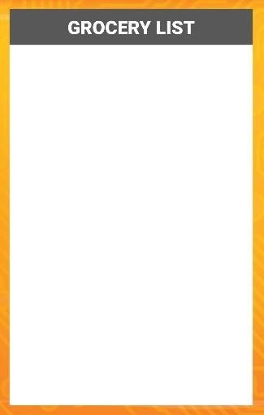View Grocery List

If the user clicks on “View grocery list” button in home page then the UI transitions to this page.

**Technical Details:**

Implemented the functionality for displaying the grocery list using web technologies.

Used Web view to display the page.

Screen shot 6: View Grocery list

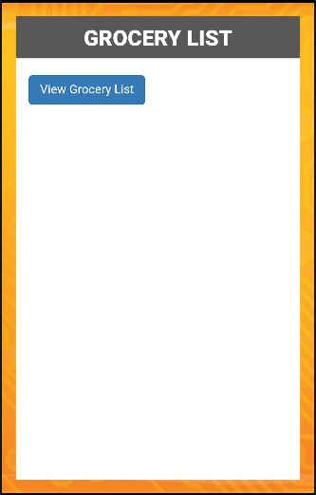View Grocery List

Once the user clicks on “Grocery List” button, the web page is loaded into the web view.

**Technical Details:**

Used JQuery to implement the client side logic.

Screen shot 7: View Grocery list

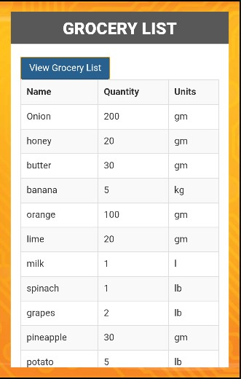

View Grocery List

Once the user clicks on View Grocery List button within the page, the list of groceries is displayed in a table.

**Technical Details:**

We have created a web service to retrieve data from the remote database

We have used Ajax function to call the API and display the data

Used twitter Bootstrap styling for table.

Screen shot 8: View Grocery list

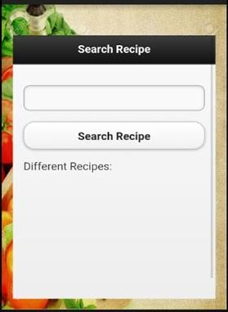Search Recipe

The user gets the search recipe page when he clicks the search recipe button in home page.

The user can search any recipe by giving the keywords in the search bar.

**Technical Details:**

The client side logic is implemented using web technologies JavaScript, Jquery & Ajax

Used bootstrap style sheets.

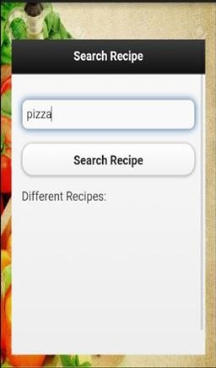Screenshot 9: Search Recipe

Search Recipe

User enters pizza as a search key to get various recipe on pizza

User clicks the search recipe button

**Technical Details:**

We are using the recipe & diet api to fetch the recipe information based on

keyword search

Screenshot 10: Search Recipe

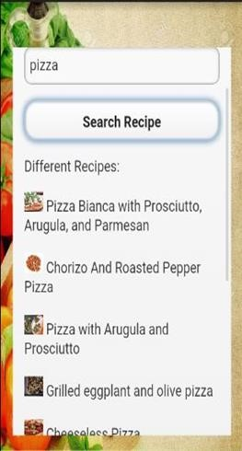Search Recipe

• System displays the list of recipes for pizza.

Screenshot 11: Recipe List

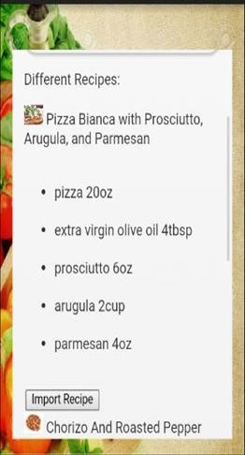

Search Recipe

If user wants to view the ingredients required for preparing a recipe, user clicks on recipe name

System displays the ingredient list for the recipe.

If the user wants to import the recipe, user clicks on “Import Recipe” button

System loads the recipe & ingredients details to the database.

Screenshot 12: Ingredient List

**3) Database Implementation**

For this increment we created a database “calorie2grocery” in SQL server database in remote server. In this database we created three tables. They are:

**User_profile**

This table is used to store the user information like user_id, username, password, email, phone number and food preference.

**Grocery_list**

This table is used to store the list of grocery items that are available at users home. In this table user can save the grocery item along with the quantity.

**Recipe**

This table stores the information regarding the recipe and the ingredient list when the user searches for a recipe and wants to import the ingredients and recipe.

**User_profile**

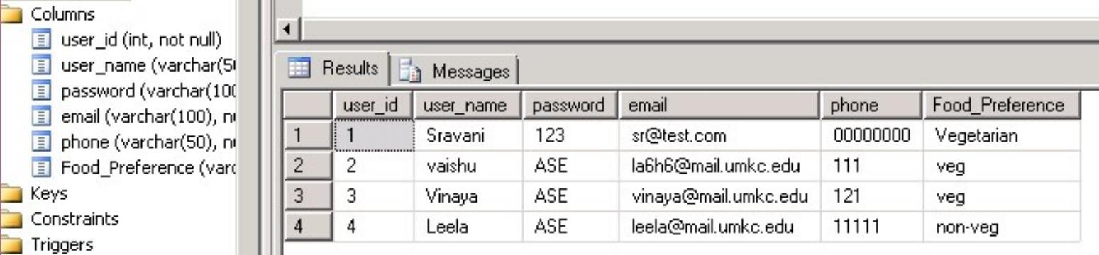

Fig: User _profiles table containing user data

**Grocery_list Insert Procedure:**

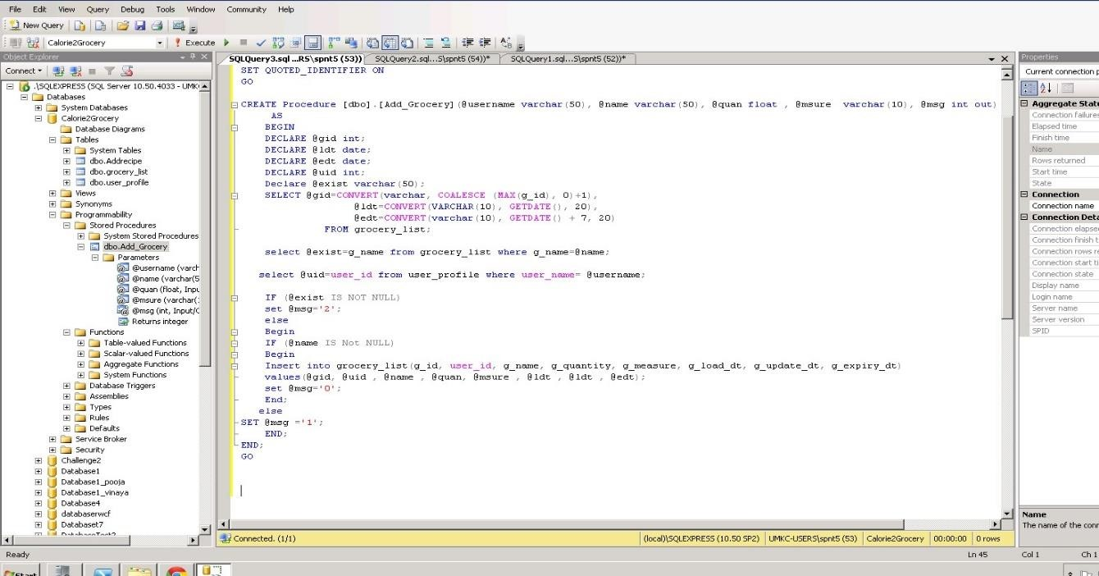

The above screenshot shows the logic which is used to validate the grocery items before inserting into the database. If the grocery item is already present in the database, it will give an output message stating that particular grocery item already exists in the data base.

**Grocery List table:**

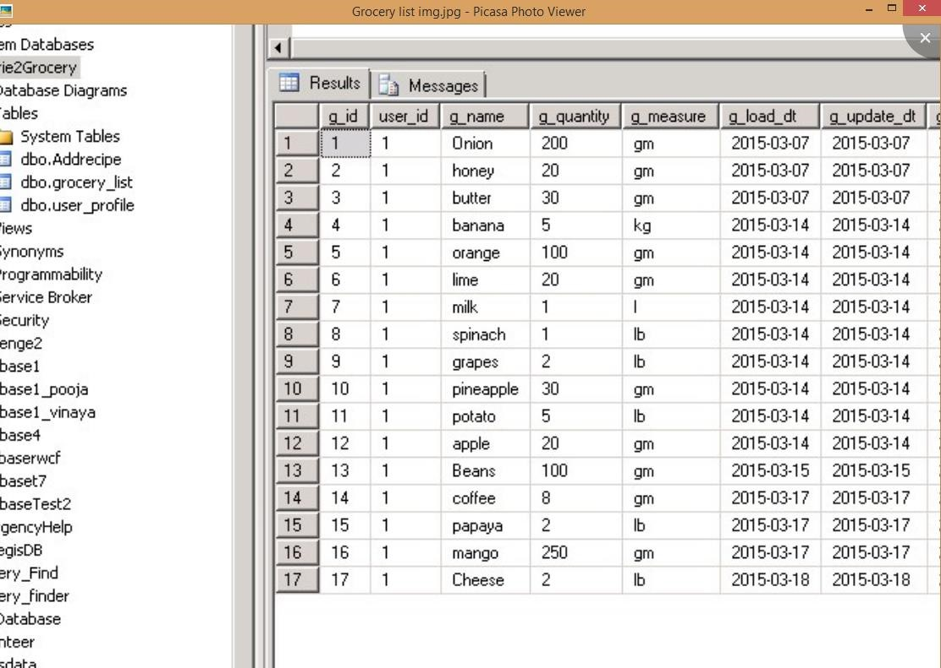

Fig : Table containing the grocery item information

**Recipe**

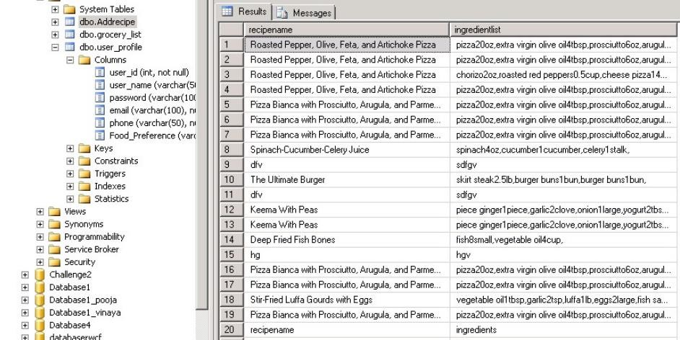

Fig: Table containing the imported recipe information

**Design Of Unit Test Cases**

**UI Testing:**

The following test cases has been written for UI testing and the actual output is validated with expected output. All of the below test cases which have been written obtained positive results.

|  |  |  |  |
| --- | --- | --- | --- |
| **Page** | **Button** | **Expected** | **Actual** |
| Home | Search Recipes | Open browser for search recipe | Open browser for search recipe |
|  | View Groceries list | Display the My groceries page | Displays the My groceries page |
|  | Add Groceries | Display the Add groceries page | Display the Add groceries page |
| Search recipe | Browse for a recipe | Should display list of the different recipes | Displays the list of  different recipes |
|  | Select a particular recipe | Should display the ingredients list for the  selected recipe | Displays the ingredients list for the selected recipe |
|  | Import recipe | The ingredients list of the selected recipe should be added to the remote database | The ingredients list of the selected recipe is added to the remote database |
| My Groceries | Add groceries | The list of items should be added to the database | The list of items are added to the database |
|  | View my grocery list | Should display the list of grocery items present | Displays the list of grocery items present |
|  | Update the quantities of an item | Should allow us to update the quantity of an item | Allowing us to update the quantity of an item |

**Data Validation:**

We have implemented N-Unit test cases to validate the data for all the newly created web services. We have used Assert methods to compare the actual output with the expected output.

**Screenshot of N-Unit validation: This is used to validate the data for Import recipe API:**

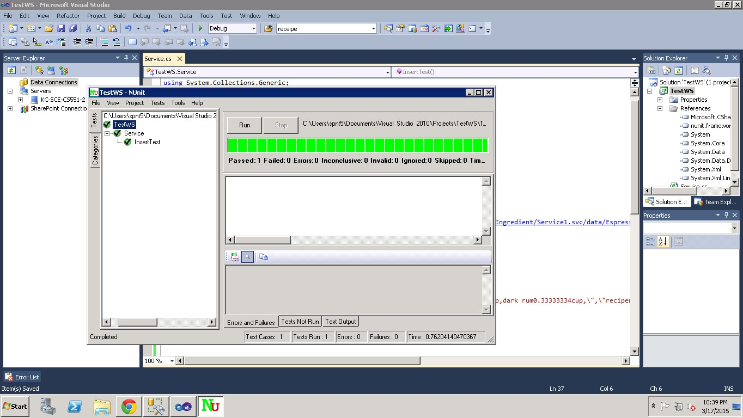

**Screenshot for N-Unit validation of Add groceries API:**

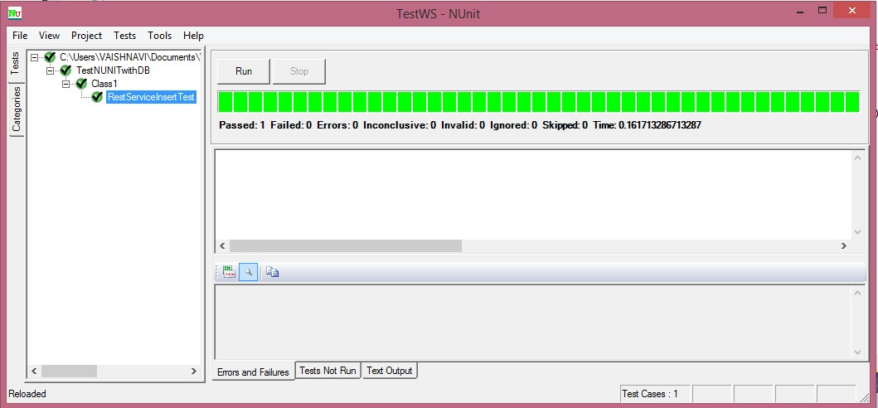

**ScrumDo**

We have used Scrumdo to track the progress of the project. The project development is divided into four increments. All the functions and development tasks are written as user stories.

Link: [https://www.scrumdo.com/projects/project/calorie2grocery3/iteration/122931#](https://www.scrumdo.com/projects/project/calorie2grocery3/iteration/122931)

**Screenshots for Increment#2 user stories:**

All the user stories planned for increment #2 have been successfully implemented.

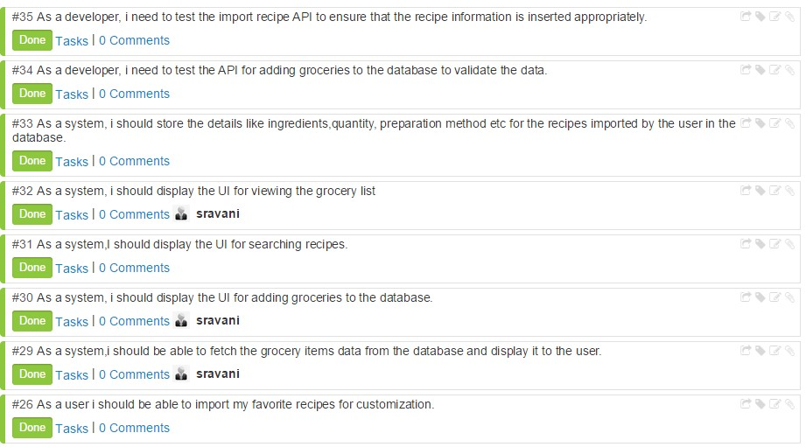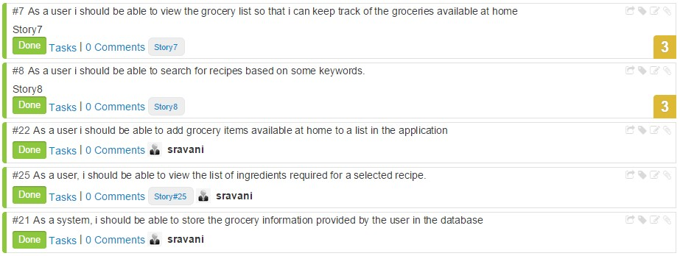

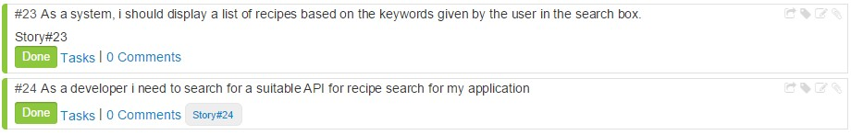

**Increment #3 user stories**

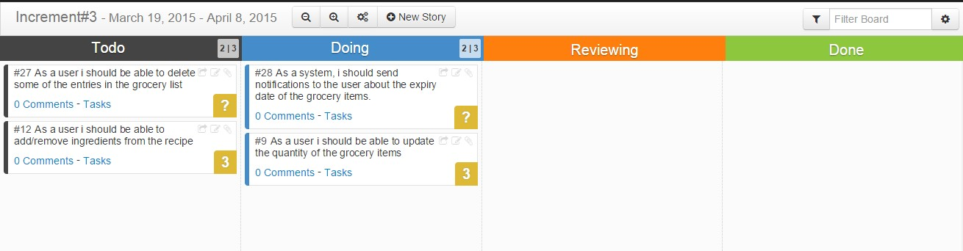

**Increment #4 user stories**

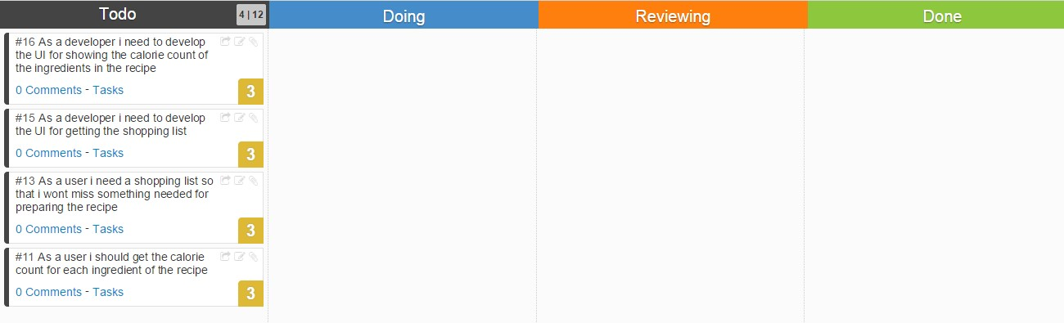

|  |  |  |  |  |
| --- | --- | --- | --- | --- |
| **User Story#** | **User Story** | **Hours Worked** | **Team Member** | **Status** |
| 30 | As a system, I should create the UI for adding groceries to the database. | 3 | Sravani | Done |
| 22 | As a user I should be able to add grocery items available at home to a list in the application | 8 | Sravani | Done |
| 21 | As a system, I should be able to store the grocery information provided by the user in the database | 8 | Sravani | Done |
| 24 | As a developer I need to search for a suitable API for recipe search functionality in my application | 10 | Vaishnavi, Vinaya | Done |
| 31 | As a system, I should display the UI for searching recipes | 8 | Vinaya, Vaishnavi | Done |
| 8 | As a user I should be able to search for recipes based on some keywords. | 12 | Vinaya, Vaishnavi | Done |
| 23 | As a system, I should display a list of recipes based on the keywords given by the user in the search box. | 10 | Vinaya, Vaishnavi | Done |
| 25 | As a user, I should be able to view the list of ingredients required for a selected recipe. | 4 | Sravani | Done |
| 26 | As a user I should be able to import my favorite recipes for customization. | 22 | Leela | Done |
| 33 | As a system, I should store the details like ingredients, quantity, and preparation method etc. for the recipes imported by the user in the database. | 20 | Leela | Done |
| 32 | As a system, I should display the UI for viewing the grocery list | 2 | Sravani | Done |
| 7 | As a user I should be able to view the grocery list so that I can keep track of the groceries available at home | 5 | Sravani | Done |
| 29 | As a system, I should be able to fetch the grocery items data from the database and display it to the user. | 12 | Sravani, Vaishnavi | Done |
| 34 | As a developer, I need to test the add groceries API to validate the data inserted into the database | 2 | Vaishnavi | Done |
| 35 | As a developer , I need to test the import recipe api to ensure that the recipe information is inserted appropriately | 2 | Vinaya | Done |

**GIT Hub URL:**

The Project code and documentation are uploaded to the following git hub URL:

<https://github.com/vaishnavi5054/AdvSoftEng>

**Bibliography:**

Reference: <http://api.bigoven.com/>

API: <http://api.bigoven.com/recipes/47725api_key=dvx30p6vcIMHZWh3G1mghS88YvV6140D>

This API provides two functions:

* Get Recipe
* Search Recipe

This is a REST based API. This API helps to search the recipes, display the list of ingredients. It redirects to another webpage where the user can see the recipe reviews etc… It also allows to update the grocery lists in the cloud. This supports either XML or JSON formats.

Reference: [https://www.recipal.com](https://www.recipal.com/) API: <https://recipal.com/api/v1/recipes/522>

This API helps to search and retrieve the recipes according to the scale. We can update an ingredient into the ingredient list. It also allows the user to create the customer ingredient object. The user can create a new recipe. Update an existing recipe etc…

Reference:<https://developer.edamam.com/>

API:https://api.edamam.com/search?q=chicken&app_id=51aba909&app_key=9fcd3aa5746d2a 423a350cee3ea4d57d

This API provides services for the following:

* Nutritional Analysis API
* Recipe Search and Diet API

Here we are using Recipe Search and Diet API to search for a recipe. This API gives retrieves more information about the ingredients, the preparation time and procedure for that recipe. So, this API is more useful for our project as it gives the detailed information which helps us to import the ingredients. With the help of this API we can filter more while searching for a recipe like we can give allergic restrictions etc.

**PROJECT INCREMENT 3**

**Project Goal**

The goal of our project is to develop an android application “Calorie2grocery”, which helps its users to plan for a proper meal to maintain healthy life style. Firstly, it provides the calorie count of a recipe. The app has a browser which allows the user to import a recipe and get a list of ingredients. The app then displays the calorie count for each ingredient in the recipe. Each user has his/her own specifications and preferences for recipes. Hence the app provides its users with an option to edit the ingredient list. Users can add or remove ingredients and can get the total calorie count of that recipe. The calorie count helps its users to take healthy choices about their meal. Secondly, it automatically generates a shopping list so that the user does not miss anything that he needs to buy. It provides us the flexibility to log the groceries available at our home. Our app will generate alert notifications about the expiry dates of groceries which in turn helps in reducing the wastage of food. Based on the recipe chosen it, prepares the list of ingredients to buy in order to prepare the recipe. Thus the app functions as a unified meal planner which takes care of grocery management as well as provide calorie information to plan for a healthy meal.

**Increment #3**

In Increment#2, we have developed an application which allows the user to a) Add grocery items available at their home to the database and view the list b) Search for a recipe and import the ingredients in the recipe.

In Increment3 we have added the following features to the application:

1) Update the quantity of grocery items

2) Delete the grocery items from the list

3) Create a recipe and store the recipe in the database

4) Share the recipe through Facebook and twitter

5) Add/Remove ingredients from recipes

6) Send notifications to users about the expiry date of recipes

7)Get calorie information for each ingredient of the recipe

**Application Specifications: Tools**

|  |  |
| --- | --- |
|  | **Tools** |
| Platform | Android 4.0.3 |
| UML Diagrams | Microsoft Visio |
| Languages | Java, C# , ASP.Net , JQuery , JavaScript , AJAX |
| Database | SQL Server |
| Planning | ScrumDo |
| Version Control System | GIT |
| Existing Rest Services | Recipe Search  Calorie API |
| New API’s | Grocery list - Added Update, Delete methods  Import API – Added Add, remove ingredient methods |

**Existing Services:**

1. **Recipe Search & Diet API :**

This API provides services for the following:

* Nutritional Analysis
* Recipe Search

We are using Recipe Search and Diet API to search for a recipe. This API provides information about the ingredients, the preparation time and procedure for a recipe. This API provides detailed information about the quantity of ingredients, total calorie count of the recipe etc. Also this API provides additional search capabilities like we can include restrictions on allergic items etc. Hence we are using this API to get the list of recipes based on a keyword and import the ingredient list.

API: <https://api.edamam.com/search?q=chicken&app_id=51aba909&app_key=9fcd3aa5746d2a423a350cee3ea4d57d>

Reference: <https://developer.edamam.com/>

1. **USDA Nutrition API :**

NDB is the nutrition database provided by the United States Department of Agriculture. Each food item is assigned a NDB number. We can fetch the calorie information any ingredient only by knowing the NDB No.

The following API fetches the NDB No. of a food item. Ingredient name is passed as parameter to this url:

<http://api.nal.usda.gov/usda/ndb/search/?format=json&q=spinach&sort=n&max=1&offset=0&api_key=DgxqZYmXG8YsyCIEfFLkJaAklM4ybQtEHORaKedx>

The following API accepts NDB No. as an input and fetches the calorie information:

<http://api.nal.usda.gov/usda/ndb/reports/?ndbno=03127&type=b&format=json&api_key=DgxqZYmXG8YsyCIEfFLkJaAklM4ybQtEHORaKedx>

For increment#3, we are displaying the calorie count per serving of the ingredient. We need to enhance the logic to take the quantity of the ingredient and display the exact calorie count in the final increment.

**New Services:**

We have created 2 rest services for implementing the server side logic for this application.

1. **Grocery List**: This API is used to maintain the grocery lists. We added two methods to this API.
2. **Delete Grocery Item:** This method is used to delete grocery items from the grocery list. We need to provide name as an input to the API URL.

API: <http://kc-sce-cs551-2.kc.umkc.edu/aspnet_client/MPG12/Sravani/viewGrocery/Service1.svc/deleteGrocery/Sravani/butter>

1. **Update Grocery Item:** This method is used to update the quantity & units of a grocery item. We need to pass the name, quantity & units as input to the URL.

API: <http://kc-sce-cs551-2.kc.umkc.edu/aspnet_client/MPG12/Sravani/viewGrocery/Service1.svc/updateGrocery/Sravani/butter/30/gm>

1. **Import Recipe:** This API is created to import the recipe information from the recipe search API and store the recipe name and ingredient list in the database. We added two methods to this rest service.
2. **Add Ingredient:** This method is used to add ingredients to the recipe based on user’s taste preference.

API: <http://kc-sce-cs551-2.kc.umkc.edu/aspnet_client/MPG12/vinaya2/RecipeIngredient/Service1.svc/data/>

1. **Remove ingredient:** This method is used to remove any of the ingredients from the recipe.

API: <http://kc-sce-cs551-2.kc.umkc.edu/aspnet_client/MPG12/Leela/ViewRecipeList/Service1.svc/viewRecipeList/gjh>

**Use Case Template to update grocery item:**

|  |  |
| --- | --- |
| **Use Case Name** | Update grocery items |
| **Primary Actor** | User |
| **Pre-Conditions** | 1. User has the app installed on his/her mobile. 2. User should be logged into the app. |
| **Guarantee(Post Conditions)** | Quantity of grocery items is updated in database. |
| **Main Success Scenario** | 1. User clicks on “View/Edit grocery list” button in the home page. 2. The system transitions the UI to the “View Grocery” layout. 3. System fetches the grocery list of the user from the database. 4. User clicks on the quantity of the grocery item he/she needs to update. 5. System changes the quantity cell to editable mode. 6. User updates the quantity and hits enter. 7. System updates the data in the remote database. |
| **Extensions** | 3a. User clicks the units cell of the grocery item.  4a. System changes the units cell to editable mode.  5a. User updates the unit for the grocery item.  6a. System updates the measure of the grocery item in database. |

**Use Case Template to delete grocery item:**

|  |  |
| --- | --- |
| **Use Case Name** | Delete grocery item |
| **Primary Actor** | User |
| **Pre-Conditions** | 1. User has the app installed on his/her mobile. 2. User should be logged into the app. |
| **Guarantee(Post Conditions)** | Grocery item is deleted from the database. |
| **Main Success Scenario** | 1. User clicks on “View/Edit Grocery List” button in the home page. 2. The system transitions the UI to the “View Grocery” layout. 3. System fetches the grocery list of the user from the database. 4. System displays the grocery list to the user. 5. User can click on “Edit” button 6. System display minus sign in front of each grocery item in the list. 7. User clicks on the minus sign in front of the grocery item he/she wants to delete. 8. System opens an alert dialog asking the user to confirm deletion. 9. User hits “OK”. 10. System deletes the grocery item from the database. 11. System removes the row in the display |
| **Extensions** | 9a. User hits “Cancel”.  9b. System doesn’t delete the grocery item. |

**Use Case Templates for Add Ingredient to a recipe:**

|  |  |
| --- | --- |
| **Use Case Name** | Search & import a recipe |
| **Primary Actor** | User |
| **Pre-Conditions** | The user must be a valid user to use the app |
| **Post-Conditions** | Retrieves the results for the search |
| **Main Success Scenario** | 1. If the user wants to search for a recipe, then, the user enters the keyword to search. 2. User clicks on the search recipes. 3. The system displays ten recipe names. 4. If the user wants to see the ingredient list, then the user can click on the recipe name. 5. System displays ingredient list along with quantity. 6. If the user wants to import the ingredient list then click on import. 7. The system stores the ingredient list in the database. |
| **Extensions** | User can view and update the recipe |

**Use Case Templates for View Favorite Recipe:**

|  |  |
| --- | --- |
| **Use Case Name** | View recipe |
| **Primary Actor** | User |
| **Pre-Conditions** | The user must be a valid user to use the app |
| **Post-Conditions** | Retrieves the results for the search |
| **Main Success Scenario** | 1. If the user wants to get the favorite recipe then user clicks the view favorite recipe button 2. User clicks on the favorite recipes. 3. User gets all the favorite recipe list from the database. |
| **Extensions** | User can update the recipe |

**Use Case Templates for Update Favorite Recipe:**

|  |  |
| --- | --- |
| **Use Case Name** | View recipe |
| **Primary Actor** | User |
| **Pre-Conditions** | The user must be a valid user to use the app |
| **Post-Conditions** | Retrieves the results for the search |
| **Main Success Scenario** | 1. If the user wants to get the favorite recipe then user clicks the recipe name. 2. User clicks on the get recipe button 3. User gets all the recipe name, ingredient list , quantity and label from the database. 4. User can add, remove, update the ingredient , quantity and label 5. User can click the update button. 6. System uploads the changed the recipe list to the database. |

**Use Case Templates for Create Favorite Recipe:**

|  |  |
| --- | --- |
| **Use Case Name** | View recipe |
| **Primary Actor** | User |
| **Pre-Conditions** | The user must be a valid user to use the app |
| **Post-Conditions** | Retrieves the results for the search |
| **Main Success Scenario** | 1. If the user wants to create the favorite recipe then user enters the recipe name , ingredients list and their quantity and labels. 2. User clicks on the add more button for more ingredients to the recipe. 3. User adds all the ingredients and quantity and their labels and clicks the save recipe button. 4. System uploads the recipe tot the database. |
| **Extensions** | User can Share the recipe in twitter and facebook. |

**Use Case Templates for Share Favorite Recipe:**

|  |  |
| --- | --- |
| **Use Case Name** | View recipe |
| **Primary Actor** | User |
| **Pre-Conditions** | The user must be a valid user to use the app |
| **Post-Conditions** | Retrieves the results for the search |
| **Main Success Scenario** | 1. If the user search for the recipe . 2. User gets the ingredients list, quantity and label for the recipe. 3. User can share the recipe in the twitter. 4. User can share the recipe in the facebook. |

**UML CLASS DIAGRAM:**



Figure 1: UML Class Diagram of the entire system

**Activity Diagram for the functionality implemented in Increment 3:**



**Sequence Diagram:**



Figure 3: Sequence Diagram

**Increment#3 Implementation:**

1. **Implementation of User Interface:**

We have grouped the functionalities and developed 3 new layouts as part of UI implementation.

1. Home Page
2. My Groceries : Once we go to My groceries page, there are 2 options:
3. Add Grocery
4. View/Edit Grocery (Enhanced the functionality in this page to update/delete the grocery item
5. Recipes: We have created two buttons in this page:
6. Search Recipe ( Added functionality to add/remove ingredients and display calorie information of each ingredient)
7. Create Recipe (User can create his/her own recipe and save it to the database)
8. Share Recipe (User can share recipes through Facebook or twitter.
9. Show Notifications: This page posts notifications to the user about the expiry dates of the grocery items.

**Screenshots:**

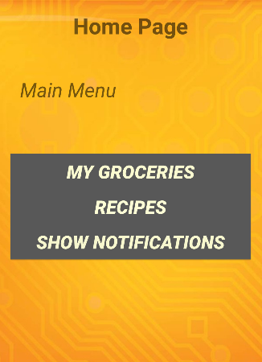

**Home Page**

User is provided with three buttons:

* My Groceries: User can click this button

For managing his grocery list.

* Recipe: User can click this button to search for recipes or create recipes.
* Show Notifications: User can click this button to view the notifications.

Screenshot 1: Home Page

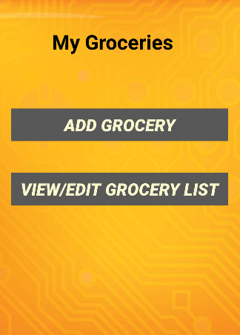

**My Groceries**

* When the user clicks on My Groceries button in the home page, the UI is transitioned to My Groceries page.
* User can add grocery items by clicking on Add Grocery button.
* User can view the grocery list, edit the quantity of the grocery items, and delete the grocery items by clicking on View/Edit grocery List.

Screenshot 2: My Groceries page

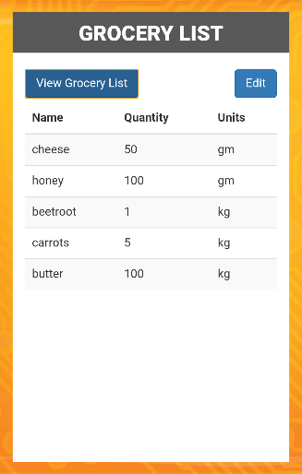

**View/Edit Grocery List**

* User can click the View grocery list button to view the grocery list.
* System fetch the grocery information from the remote database and displays it to user.

**Technical Details:**

* We have created a web service to retrieve data from the remote database
* We have used Ajax function to call the API and display the data
* Used twitter Bootstrap styling for table.

Screenshot 3: View/Edit Grocery page

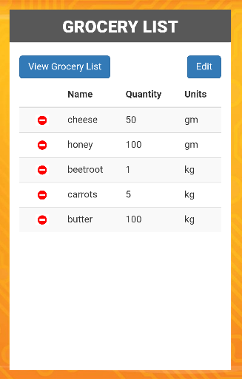

**View/Edit Grocery List**

* User clicks on “Edit” button to delete grocery items from the list.
* System displays “Minus” sign in front of every grocery item.
* User needs to click on the “Minus” sign to delete a grocery item.

**Technical Details:**

* We have implemented the client logic using Jquery.

Screen shot 4: Edit Grocery

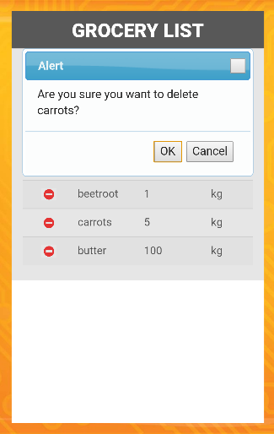

**View/Edit Grocery List**

* User clicks on the “Minus” sign in the “Carrots” row to delete carrots from grocery list.
* System displays an alert dialog asking the user to confirm.
* User can click on “Ok” to delete or “Cancel” to cancel the deletion.

**Technical Details:**

* Implemented the alert dialog using JQuery UI.

Screen shot 5: Delete grocery alert

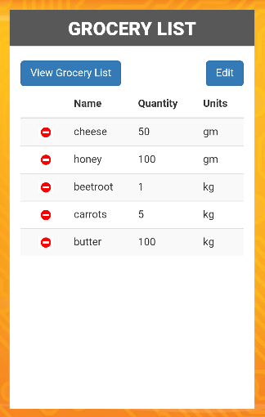

**View/Edit Grocery List**

* If the user clicks on “Cancel” button in the alert dialog then nothing happens.

Screen shot 6: Delete Grocery

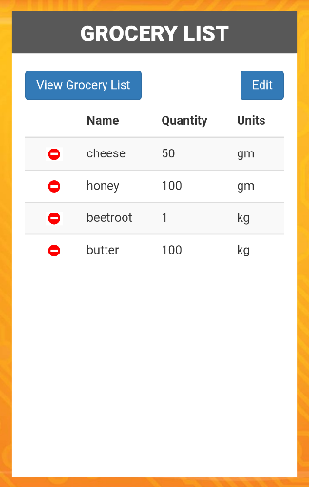

**Delete Grocery**

* Once the user clicks on “Ok” button in the alert dialog, grocery item “Carrots” is deleted from the list

**Technical Details:**

* We have created a rest service for deleting the grocery item in the remote database.

Screen shot 7: Delete Grocery

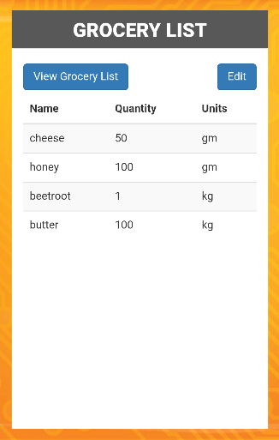

**View Grocery List**

* Once the user clicks on View Grocery List button within the page, the page comes out of the editable mode and refreshes the grocery list.

Screen shot 8: View Grocery list

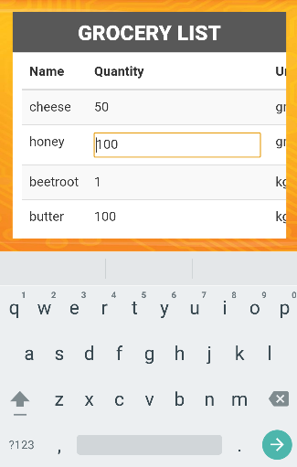

**Updating Quantity**

* User can click on any quantity/units cell of any grocery item row to update.
* Eg: The screen shot shows that after clicking the quantity cell of Honey, the cell is changed to editable mode.

**Technical Details:**

* The client side logic is implemented using web technologies JavaScript, Jquery & Ajax
* Used bootstrap style sheets.

Screenshot 9: Update Grocery

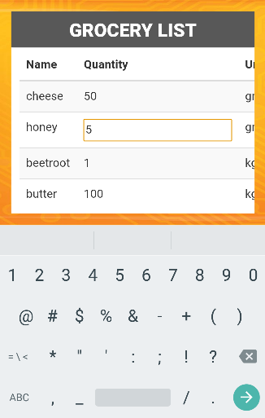  
 Screenshot 10: Update Grocery

**Updating Quantity**

* User can change the quantity and hit enter. Eg: changed the quantity of honey from 100 to 5.
* In a similar manner, he can click on the Units cell of any grocery item and update it.

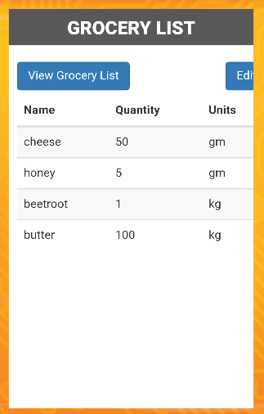

**Update Quantity**

* The quantity of the grocery item “honey” is changed to 5.

**Technical Details:**

* We have created a update grocery method in the rest service.
* We have used Ajax function to call the API and update the data in the database.

Screenshot 11: Update Grocery

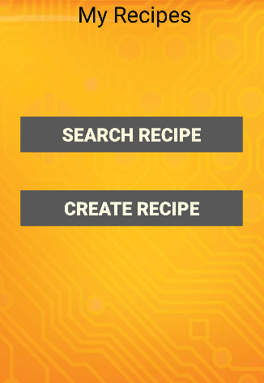

**Recipes Page**

* If the user clicks on the “Recipes” button in the home page, then the UI is transitioned to My Recipes page.
* There are two buttons in this page, one to search for recipes, the other to create their own recipe.

Screenshot 12: Recipes Page



**Search Recipes Page**

* If the user clicks on the “Search Recipes” button in the Recipes page, then the UI is transitioned to Search Recipe page.
* User can enter in the recipe name in the input box and enter Go!.

**Technical Details:**

* We have used bootstrap to style the input control with a placeholder for this page.

Screenshot 13: Search Recipe

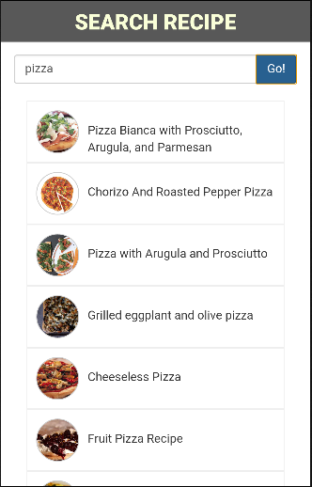

**Search Recipes Page**

* In this screenshot, the user entered “Pizza” in the input box and hit Go.
* System displays list of recipes for Pizza.

**Technical Details:**

* We have used Ajax to make calls to the rest service in order to fetch the recipes.

Screenshot 14: Search Recipe

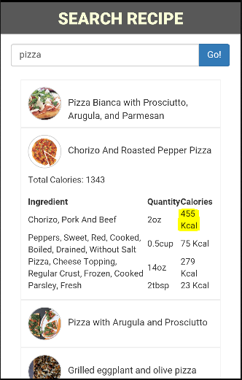

**Search Recipes Page**

* To get the ingredients required for a recipe, user can click on any recipe name in the list.
* System displays the list of ingredients along with their calorie information
* System displays the total count of calories for the recipe.

**Technical Details:**

* To get the calorie information for each ingredient, we are making two Ajax calls to USDA NDB database.
* The first call gets the ndb_no for the ingredient
* The second calls gets the ingredient calories based on the ndb_no.

Screenshot 15: Ingredients with calorie info

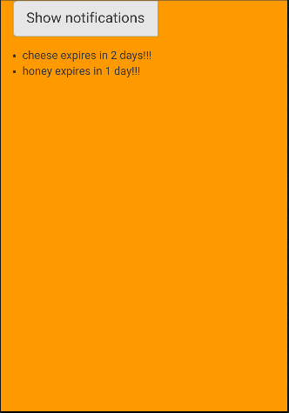

**Notifications Page**

* Once the user clicks on the “Show Notifications button on the home page, UI is transitioned to this page.
* System displays the alert messages related to the expiry dates of the grocery items.

**Technical Details:**

* We have used a rest service to get the expiry date information of the grocery items from the database.

Screenshot 16: Notifications

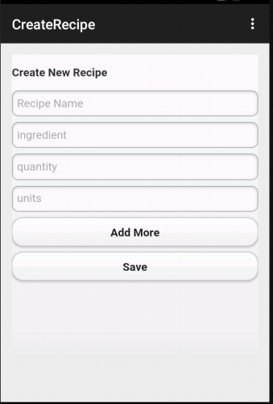

**Create Recipe Page**

* User can create a new recipe by entering the recipe name, ingredients along with quantity and units.
* Add more: This button lets the user to add more ingredients along with quantity and units.
* Save: Used to save the created recipe.

Screenshot 17: Create Recipe

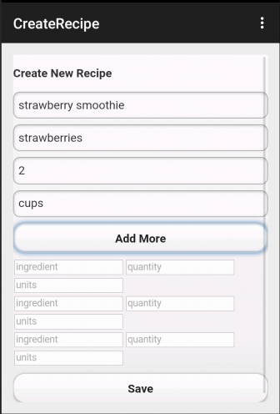

**Create Recipe Page**

* This screenshot shows creating Strawberry Smoothie recipe using the application.

Screenshot 17: Adding ingredient

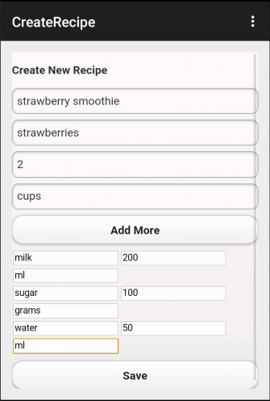

**Create Recipe Page**

* Add more: This button lets the user to add more ingredients along with quantity and units.
* The screen shows adding additional ingredients milk, sugar, water to the recipe.

Screenshot 17: Adding more ingredients

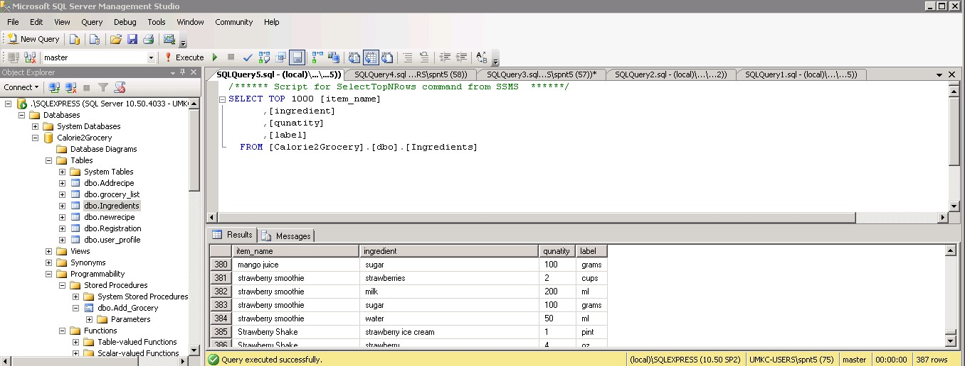

Screen Shot: 18 shows that the above created recipe has been added to the database successfully.

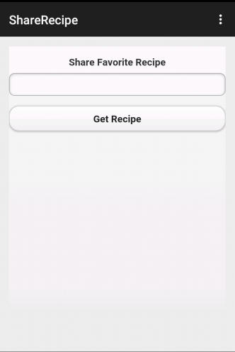

**Share Recipe in Facebook and Twitter:**

* The user can enter the recipe name and search from the database to get the recipe details.
* **Get Recipe:** Gives the list of recipes, that maches the keyword along with share options.

Screen Shot: 19 Share Recipe Page

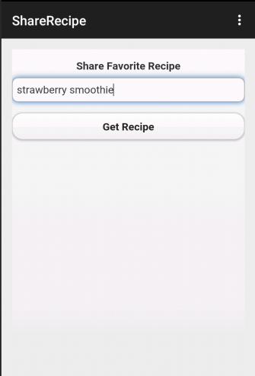

**Share Recipe Page**

* Screenshot shows searching for strawberry smoothie recipe that was previously created.

Screen Shot: 20 Share Recipe

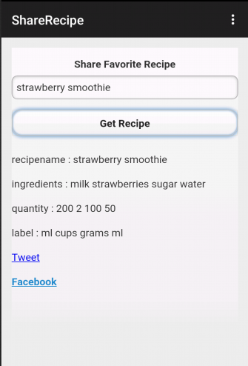

**Share Recipe Page**

* Screenshot shows displaying the details of the strawberry recipe.

Screen Shot: 21 Showing the recipe details

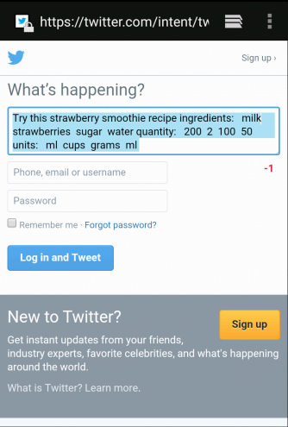

**Share Recipe using Twitter**

* On clicking the Tweet hyperlink, user can login to twitter and share the recipe.

Screenshot: 22

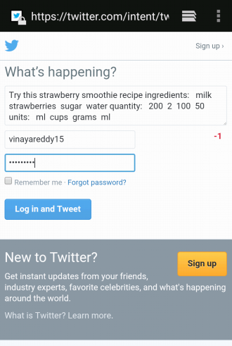

Screenshot : 23

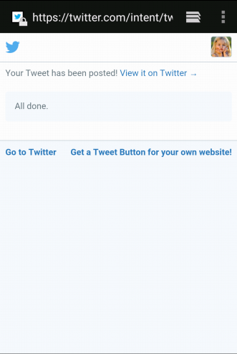

**Share Recipe using Twitter**

* Screenshot showing success message after posting the tweet.

Screenshot : 24

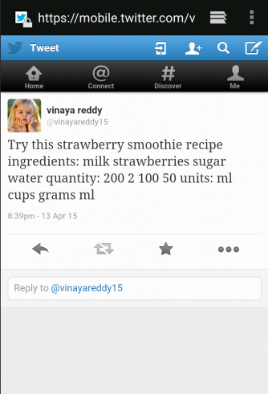

**Share Recipe using Twitter**

* Screen shot showing the post in twitter page.

Screenshot :25 Twitter post

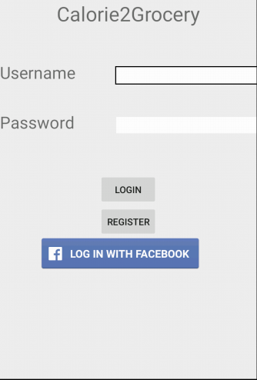

**Facebook Login**

* In Increment#1 , we had an issue with the facebook login. After login, the UI was not transitioning to our application.
* We have fixed that issue in increment#3.

Screen shot: 26 Feacebook login

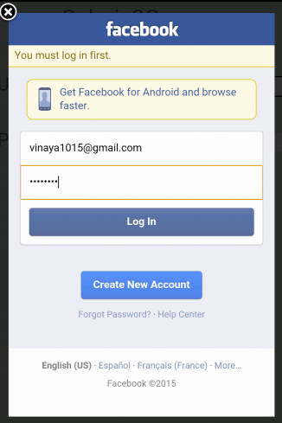

**Facebook Login**

* This screenshot shows entering the login details for Facebook.

Screen shot :27 Facebook login

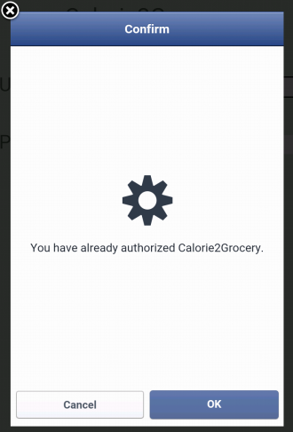

**Facebook Login**

* This screenshot shows that the user has authorized the Calorie2Grocery application to access basic info from facebook.

Screen shot:28 Facebook login

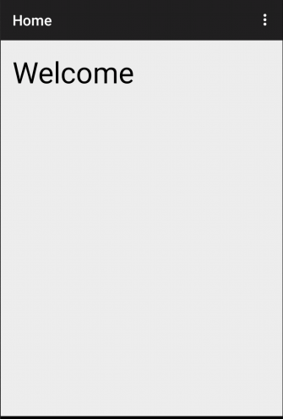

**Facebook Login**

* This screenshot shows the successful transition of UI from Facebook login to our application.

Screen shot: 29

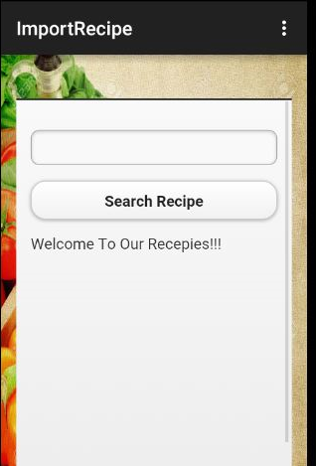

**Search Recipe**

* The user gets the search recipe page when he clicks the search recipe button in home page.
* The user can search any recipe by giving the keywords in the search bar.

**Technical** **Details:**

* The client side logic is implemented using web technologies JavaScript, Jquery & Ajax
* Used bootstrap style sheets.

Screenshot: 30 Search for a recipe

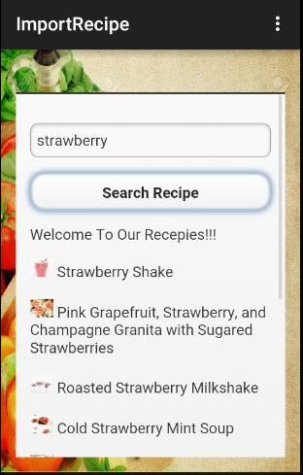

**Search Recipe**

* If user wants to view the ingredients required for preparing a recipe, user clicks on recipe name
* System displays the ingredient list for the recipe.
* If the user wants to import the recipe, user clicks on “Import Recipe” button

System loads the recipe & ingredients details to the database

Screen shot: 31 Search recipe

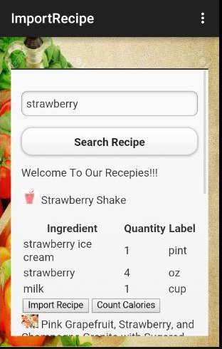

**Import Recipe:**

* Once the user clicks import recipe, the recipe is loaded into the database using a rest service.

Screen shot: 32 Import recipe

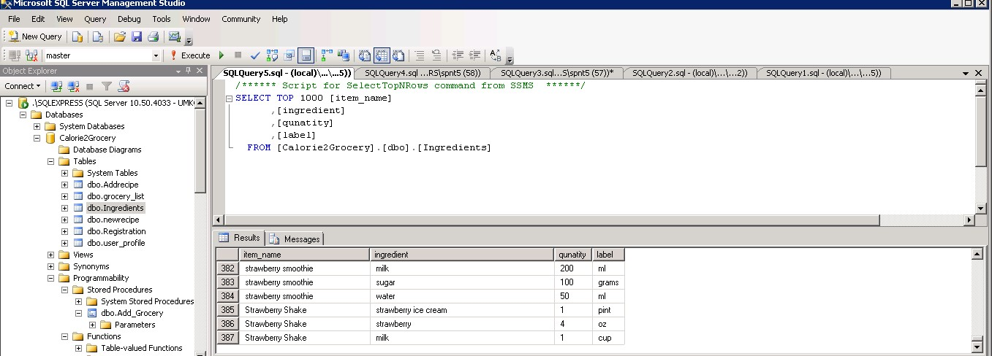

Imported the Strawberry Shake into the Ingredients Table

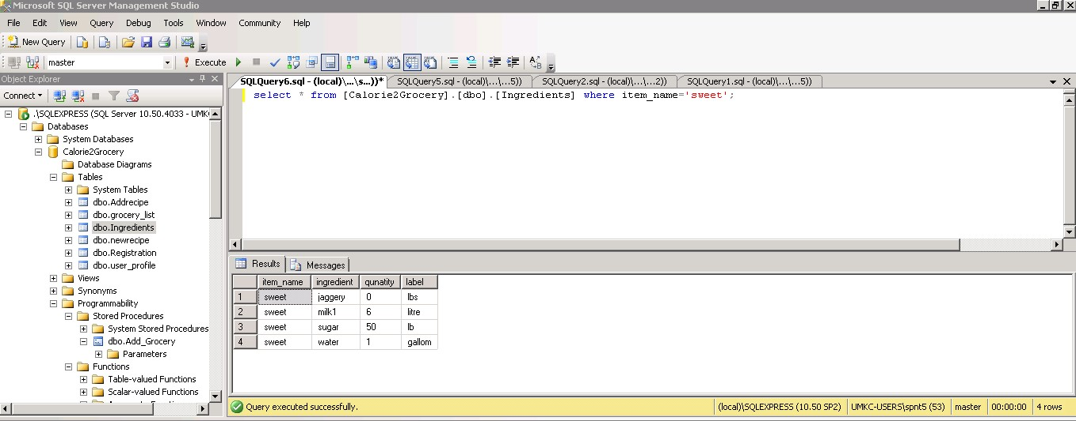

Screenshot the Ingredients list before the update the sweet Recipe

1. **Design Of Unit Test Cases**

**UI Testing:**

The following test cases has been written for UI testing and the actual output is validated with expected output. All of the below test cases which have been written obtained positive results.

|  |  |  |  |
| --- | --- | --- | --- |
| **Page** | **Button** | **Expected** | **Actual** |
| View Grocery list | view | Should display grocery list | Displaying grocery list |
|  | edit | Should modify the ingredients, quantity and label | Able to modify the ingredients, quantity and label |
|  | delete | Should delete the grocery items | Deleted the grocery items |
| Calorie count | Browse for a recipe | Should display list of the different recipes | Displays the list of different recipes |
|  | Select a particular recipe | Should display the ingredients list for the selected recipe | Displays the ingredients list for the selected recipe |
|  | Calorie count | Should display individual and total calorie count of ingredients | Displaying individual and total calorie count of ingredients |
| Get recipe and modify | Import recipe | The list of recipes should be added to the database | The list of recipes are added to the database |
|  | View recipe | Should display the recipe list | Displays the recipe list |
|  | Update recipe | Should allow us to update the ingredient, quantity , label of recipe | Allowing us to update the ingredient, quantity , label of recipe |
| Create new recipe | Create recipe | Add new recipe ingredients, quantity, label to database | Adding new recipe ingredients, quantity, label to database |
| Get recipe and share | Get recipe | should get imported and created recipes | Able to get imported and created recipes |
|  | Share recipe | Should share recipes to twitter and facebook | Able to share recipes to twitter and facebook |
| Notification | Send Notifications | Send Notifications to expiry dates | Sending Notifications to expiry dates |

**Data Validation:**

We have implemented N-Unit test cases to validate the data for all the newly created web services. We have used Assert methods to compare the actual output with the expected output.

**Screenshot of N-Unit validation:** This is used to validate the data for update grocery item method in the rest service.

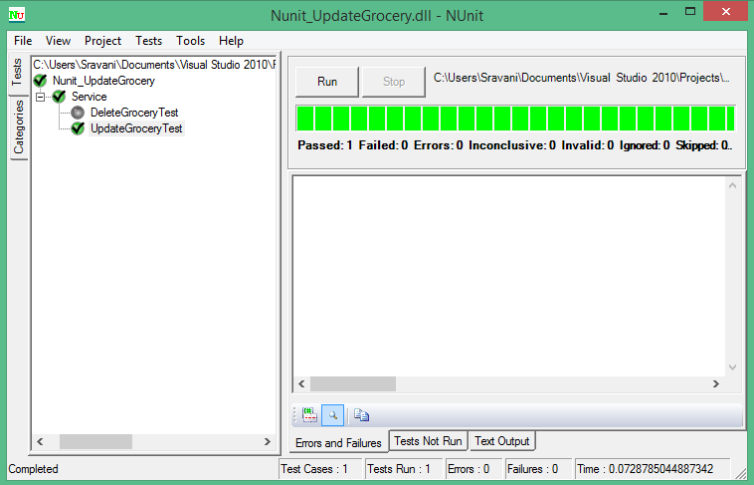

**Screenshot for N-Unit validation of delete groceries API:**

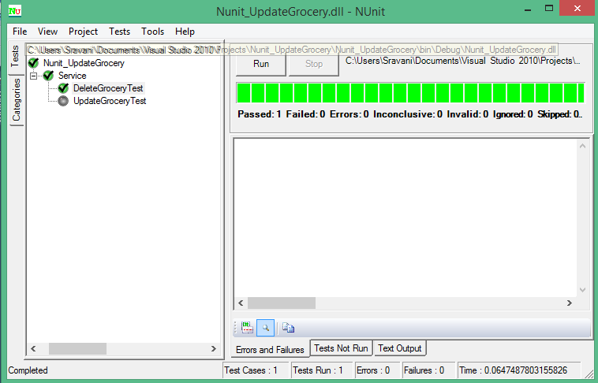

**Screenshot for N-Unit validation of Import groceries API:**

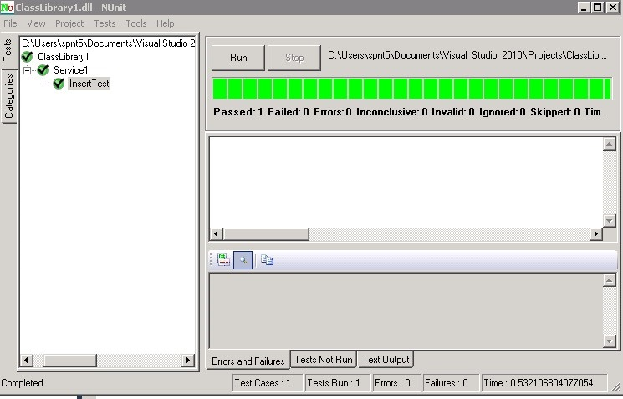

**Screenshot for N-Unit validation of Update groceries API:**

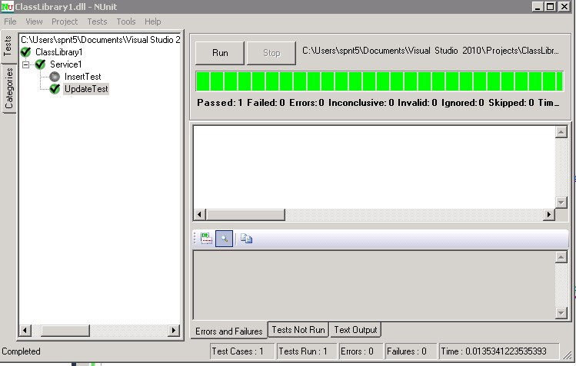

**Performance Testing:**

The following are the tools we used for performance testing:

* YSlow analyzer
* Firebug

1. **YSlow Analyzer:** This is a free, open source testing tool that analyzes web pages and suggests ways to improve their performance. The below screenshots shows the performance analysis of the web pages that are created in our app. This analysis is done using YSlow analyzer(Google chrome extension).

**Testing for a web page that generates notification about expiry dates**

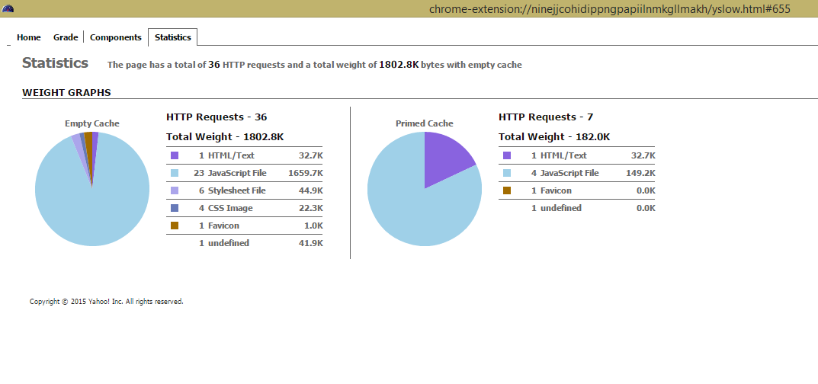

Screen Shot: 1

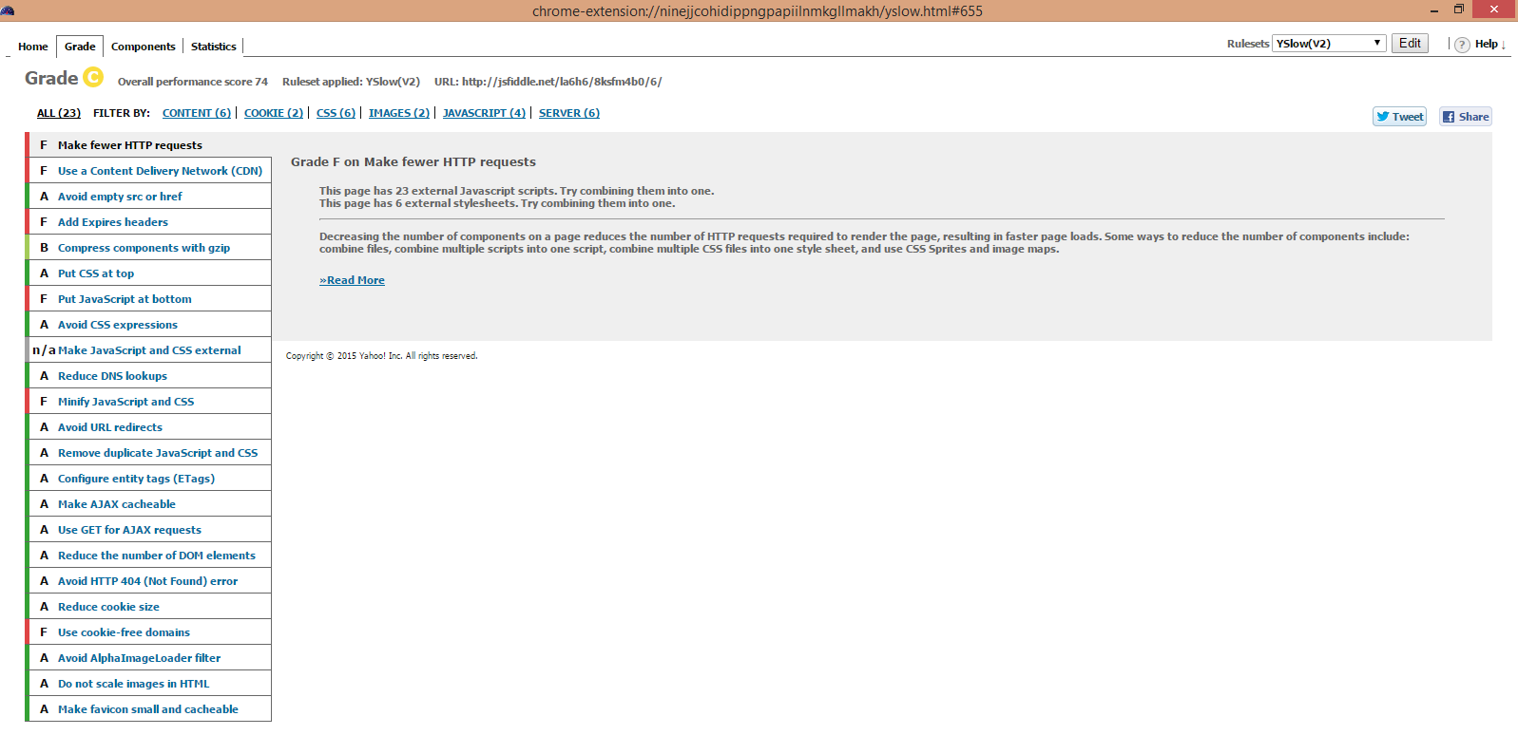

Screen Shot: 2

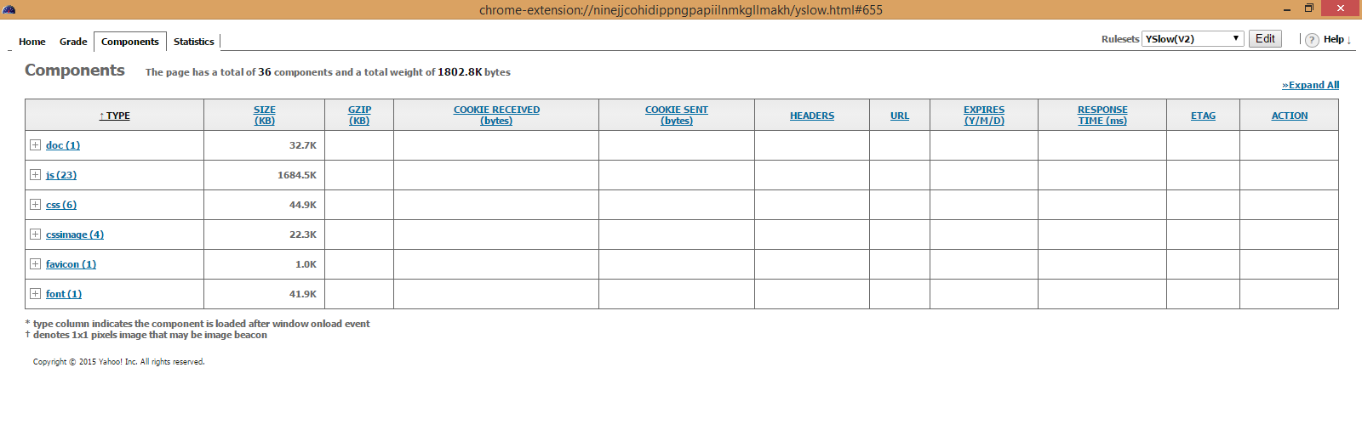

Screen Shot: 3

**Testing for a web page that searches a recipe from the database and share it on facebook and twitter**

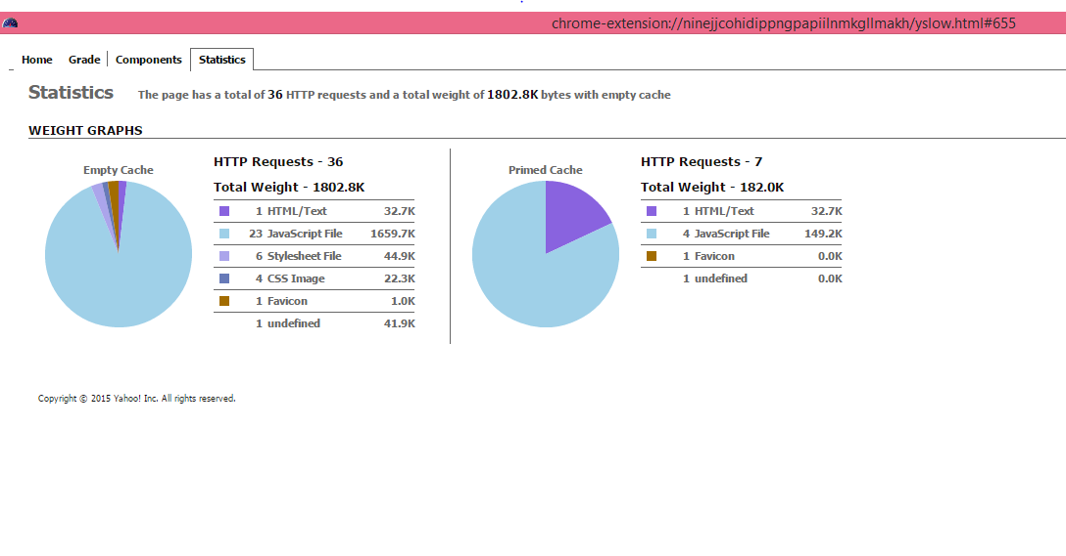Screen Shot: 1

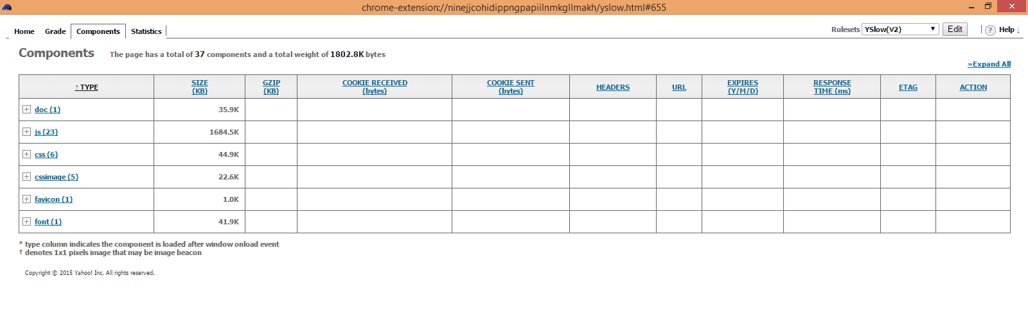

Screen Shot: 2

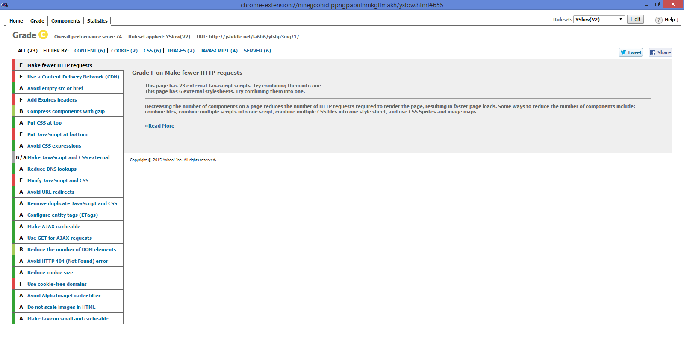

Screen Shot: 3

**Testing for a web page for Creating a recipe**

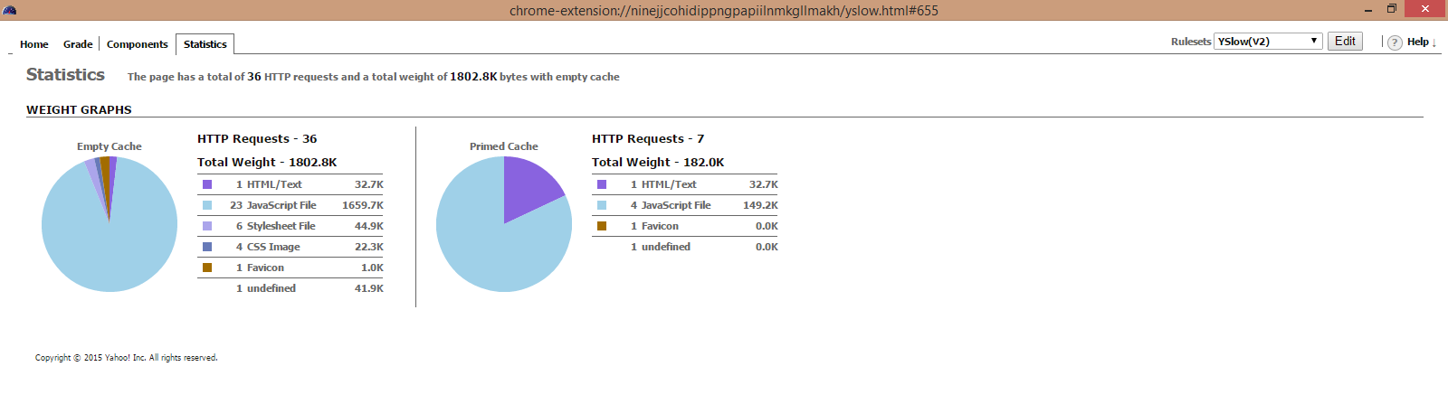

Screen Shot: 1

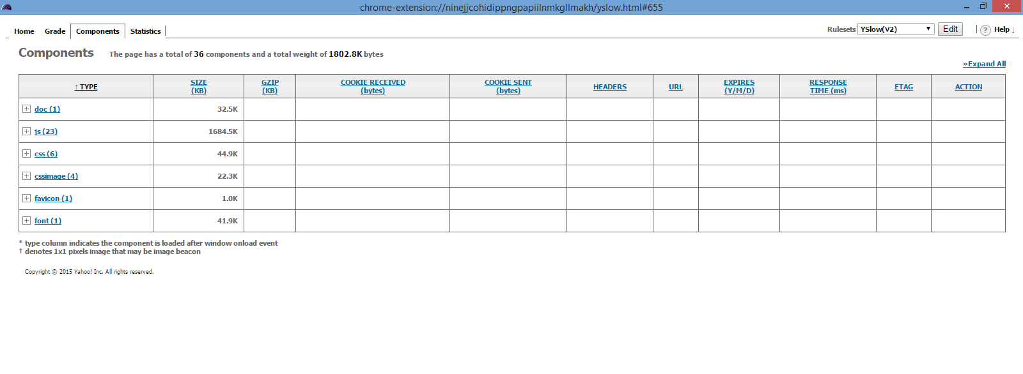

Screen Shot: 2

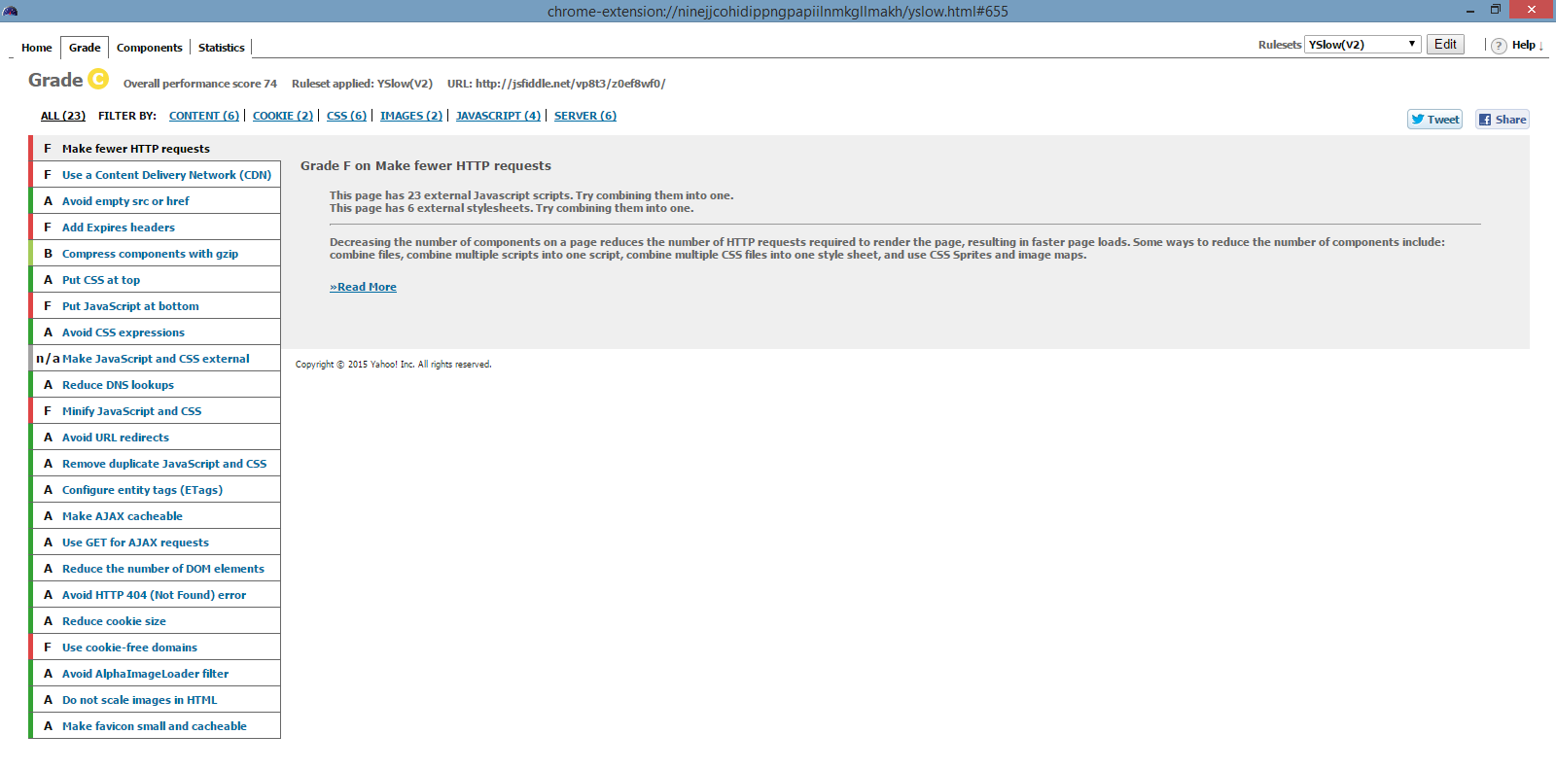

Screen Shot: 3

**Web Page for displaying a recipe long with calorie count**

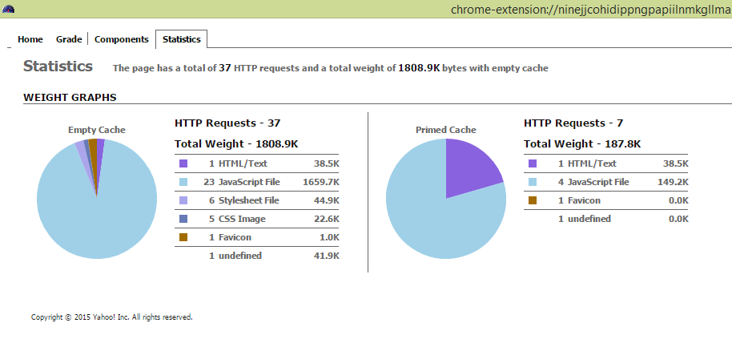

Screen Shot: 1

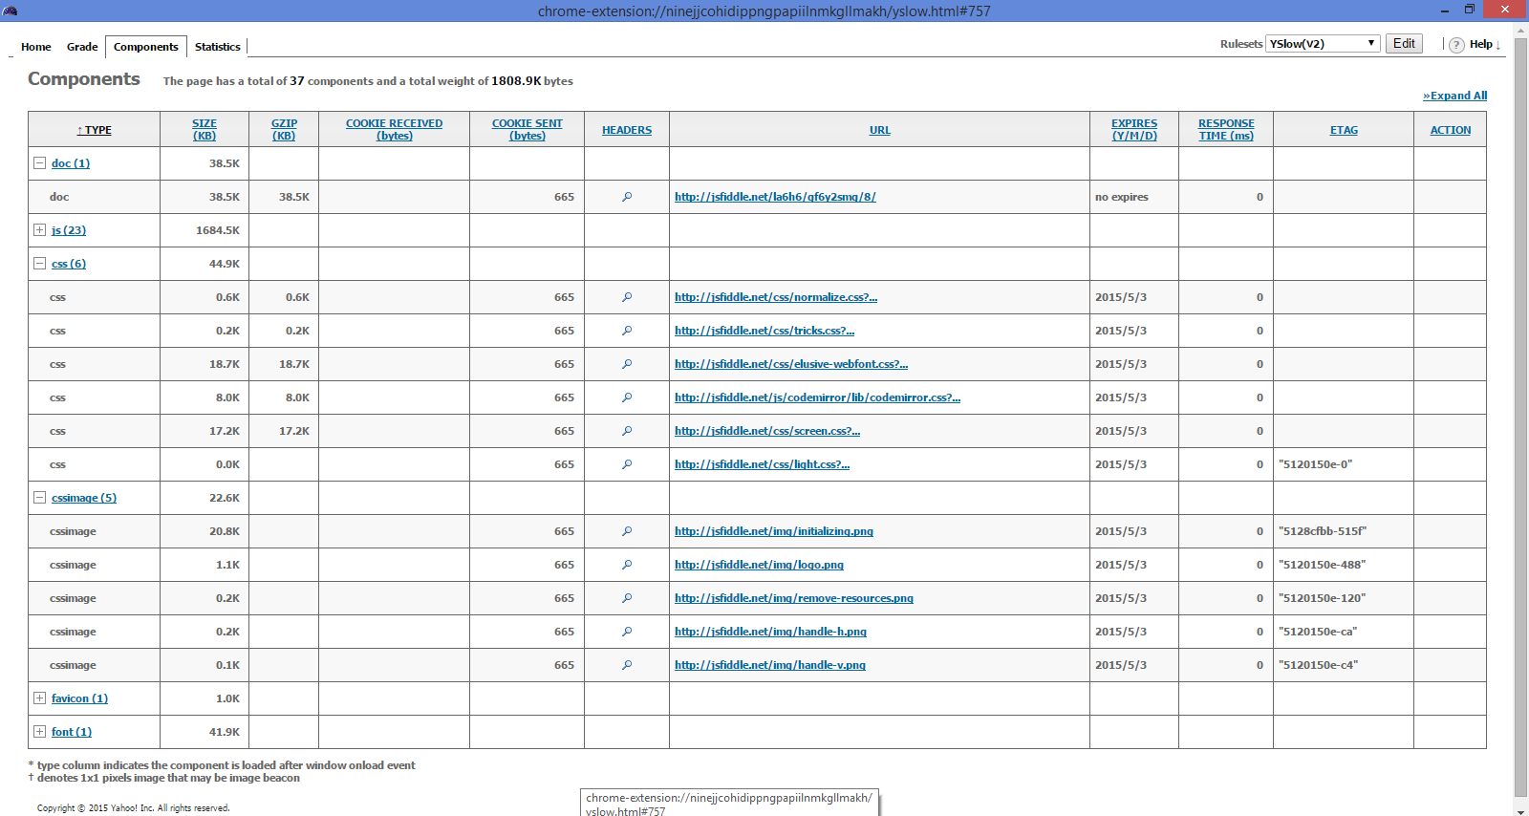

Screen Shot: 2

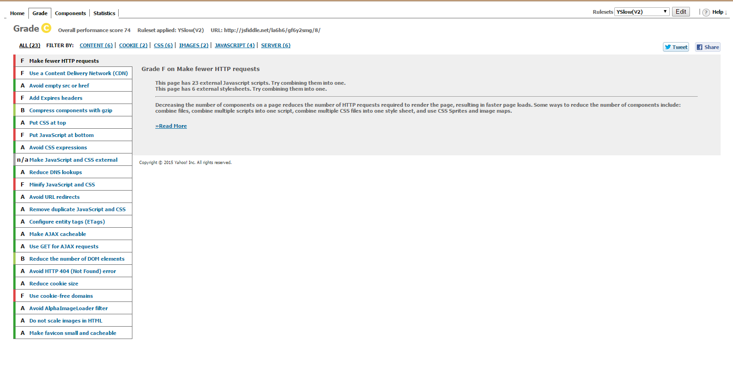

Screen Shot: 3

**Testing a web page that edits/removes the grocery item**

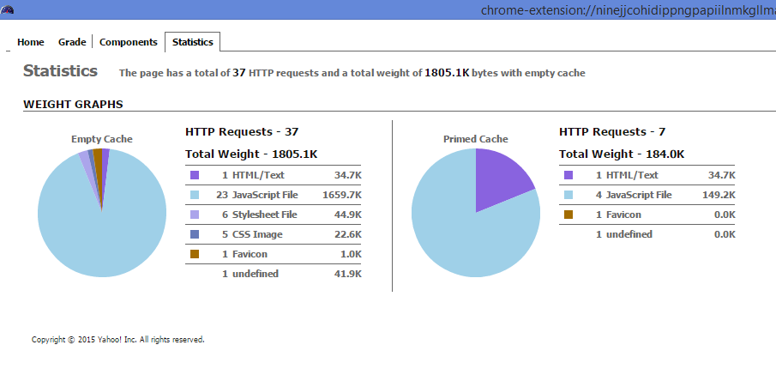

Screen Shot: 1

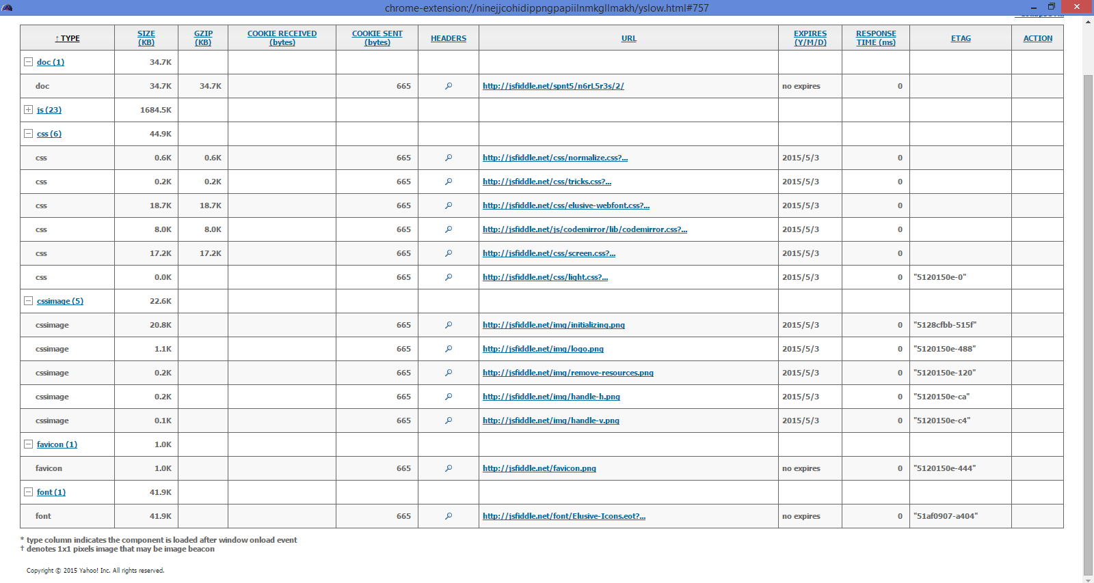

Screen Shot: 2

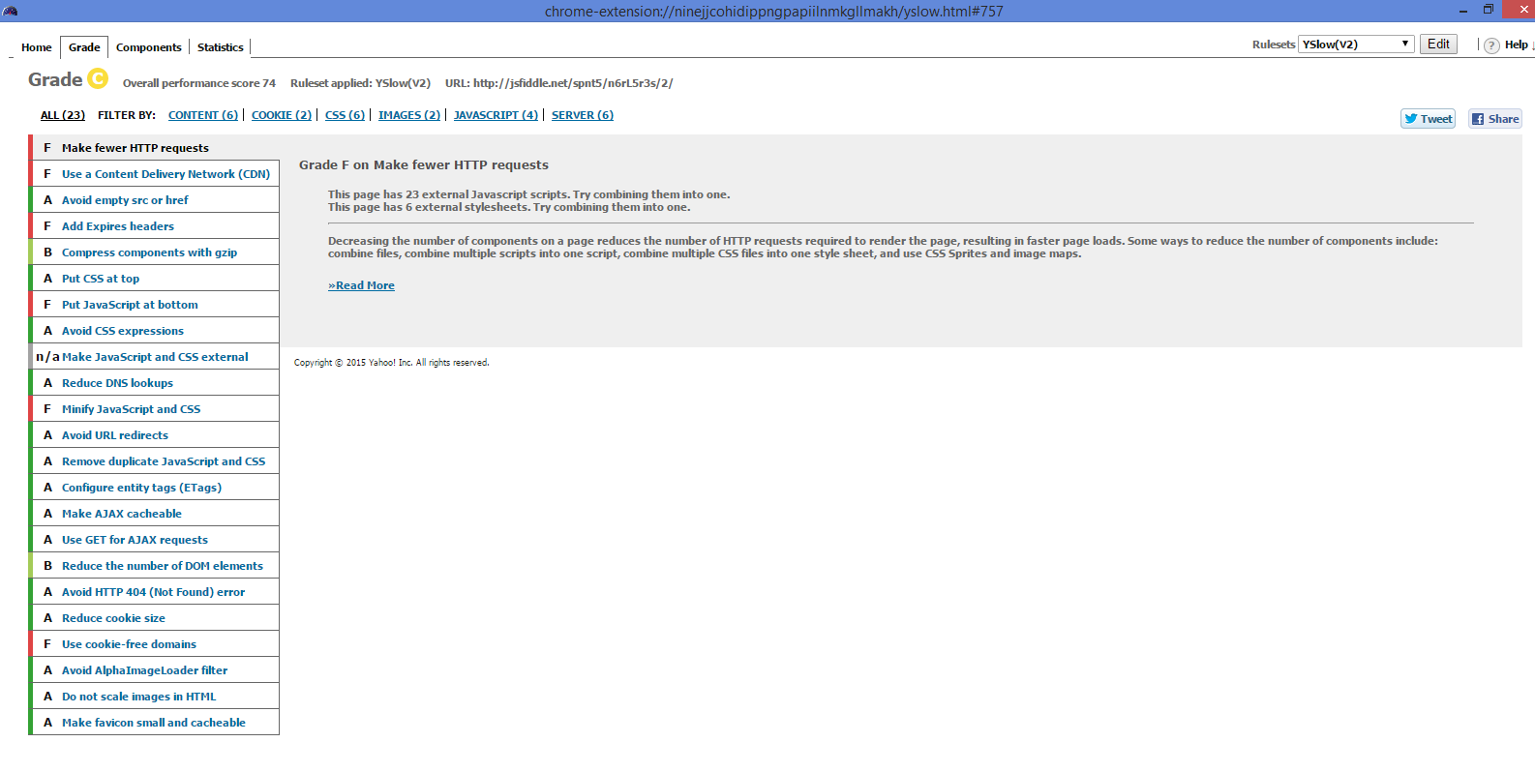

Screen Shot: 3

**Testing a web page for updating a recipe**

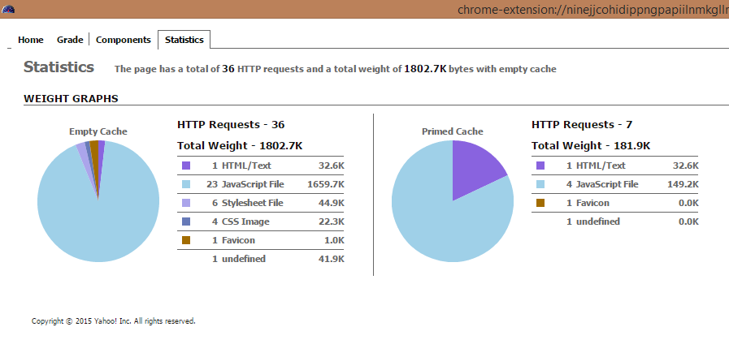

Screen Shot: 1

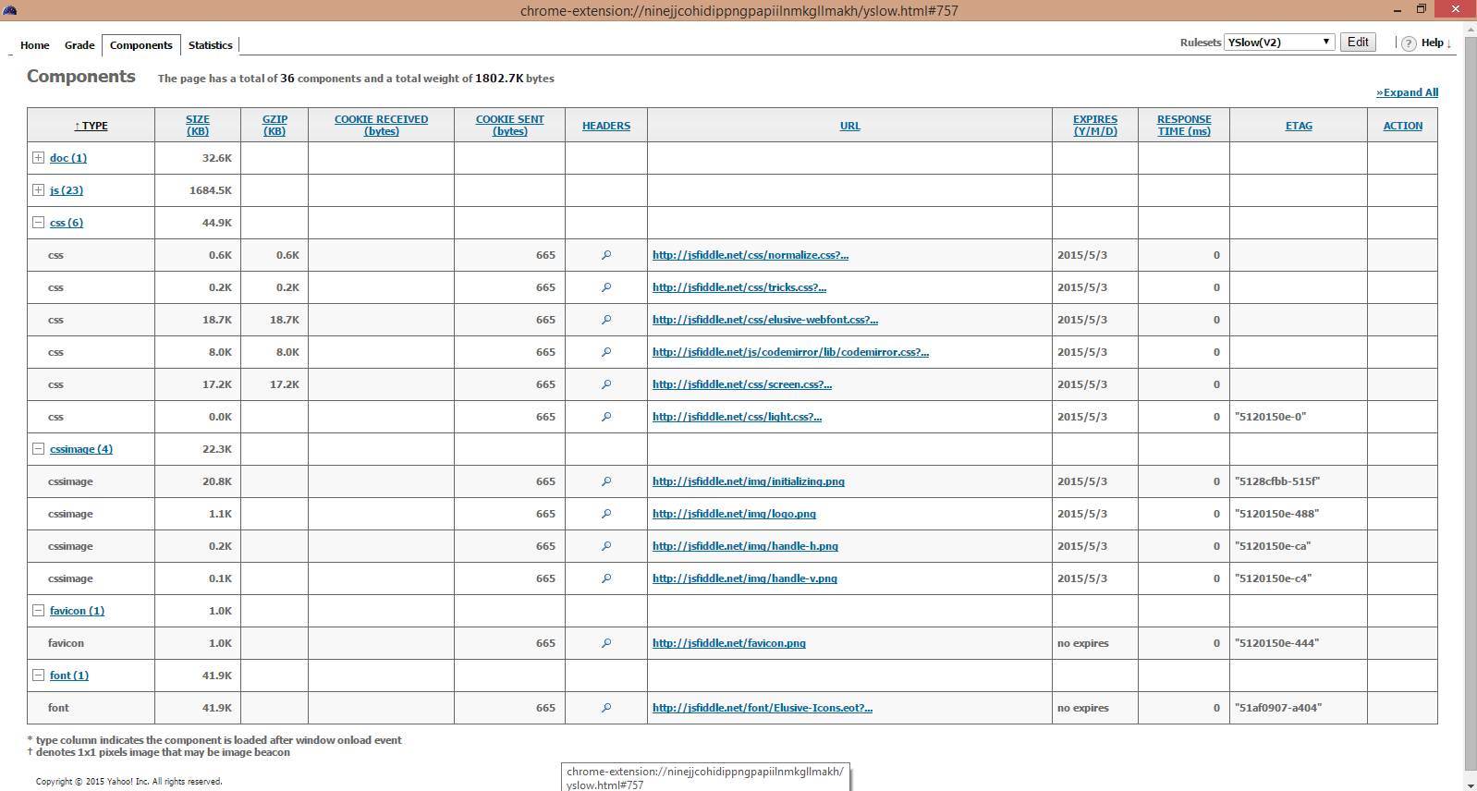

Screen Shot: 2

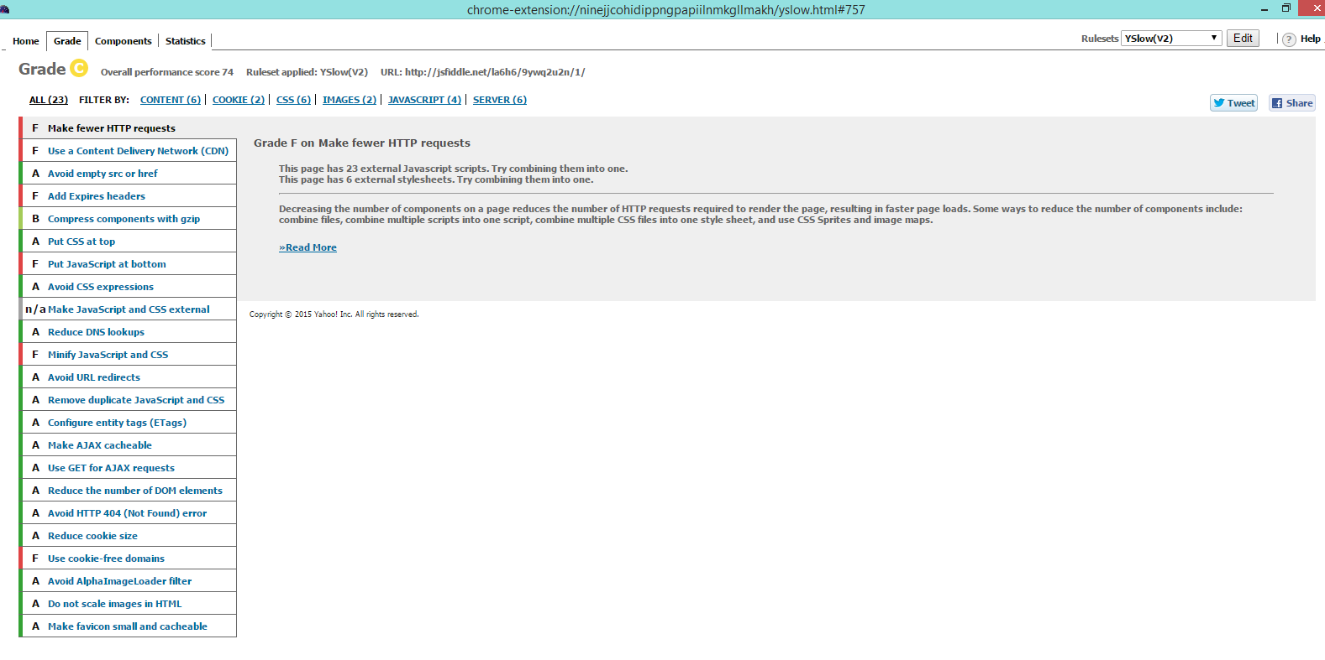

Screen Shot: 3

**Testing a web page for getting the favorite recipe**

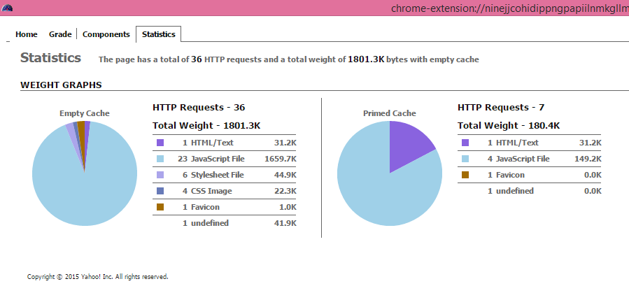

Screen Shot: 1

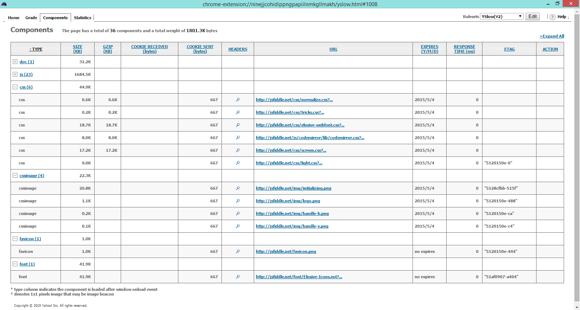

Screen Shot: 2

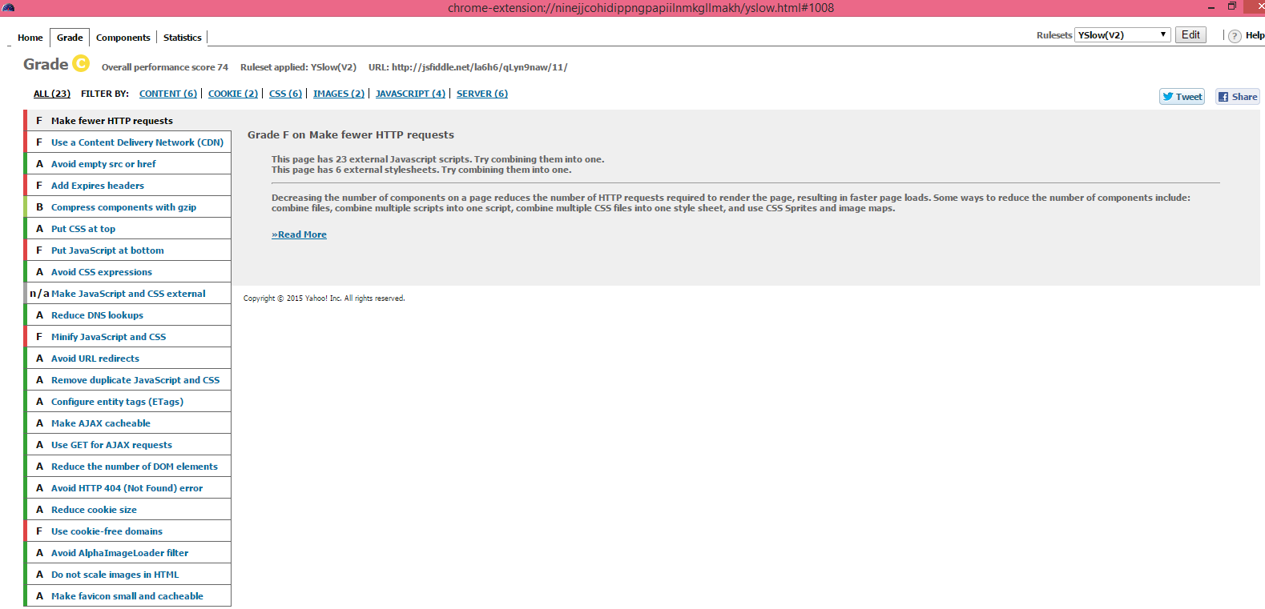

Screen Shot: 3

**Testing a web page for import and updating a recipe**

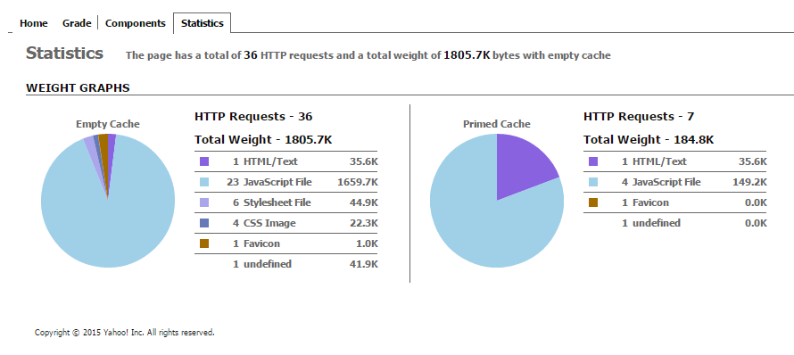

Screen Shot: 1

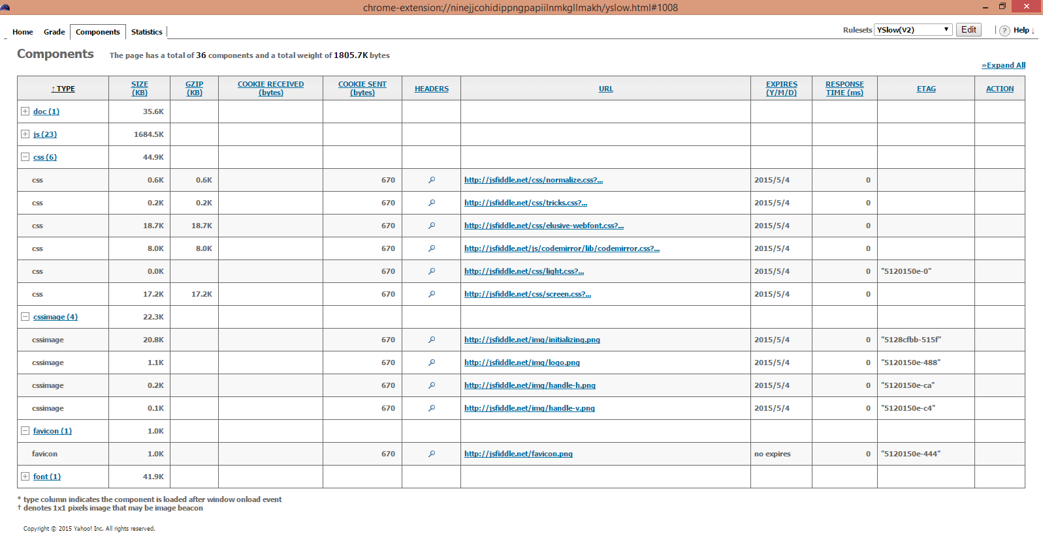

Screen Shot: 2

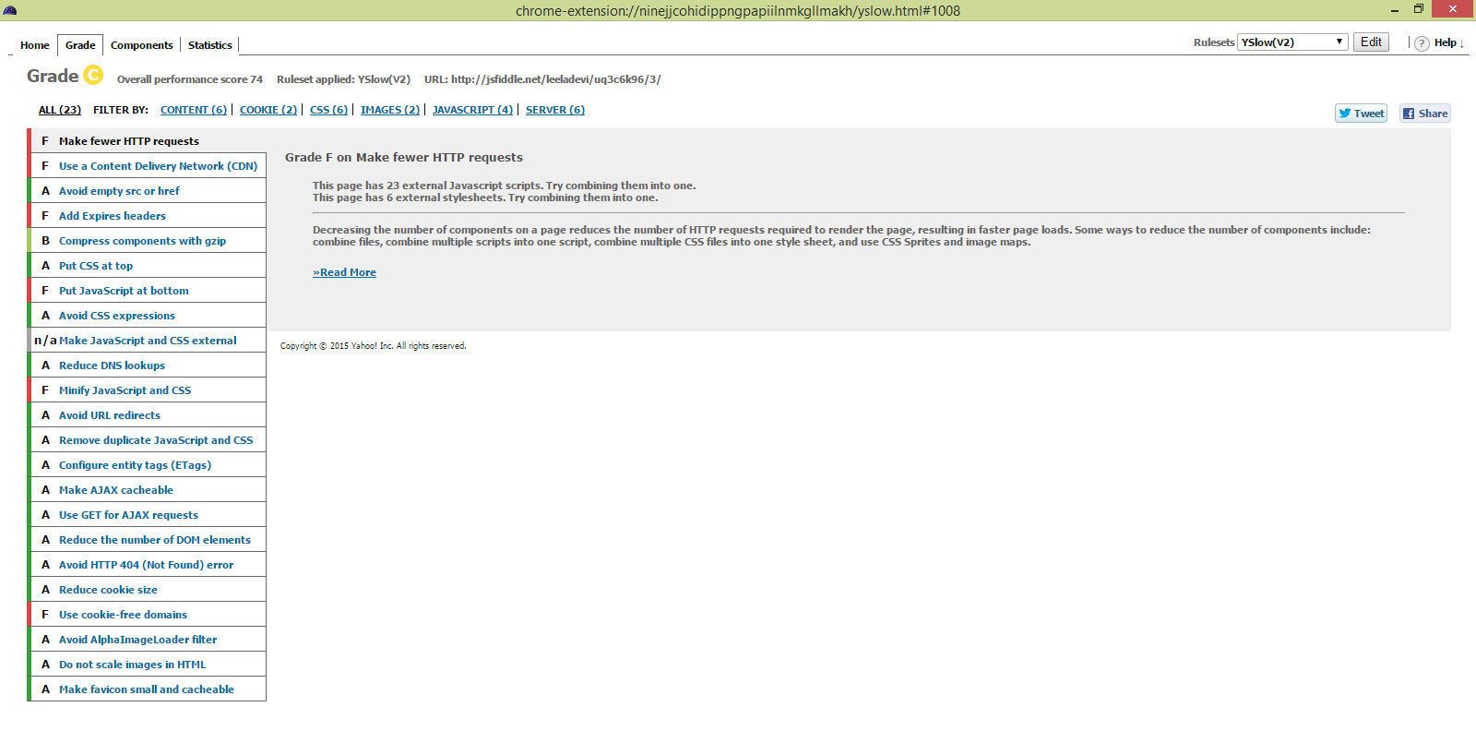

Screen Shot: 3

**Fire Bug tool:**

We used the fire bug tool to do the performance testing for html pages we used. The firebug tool will automatically show us if there are any errors in the JavaScript, CSS or HTML code. It also notify us if there are any errors in request URL’s or XHR requests. We have done this testing on all of the HTML pages we created in this increment. Mostly there are no errors detected while we performed this testing.

1. **Createrecipe.html**

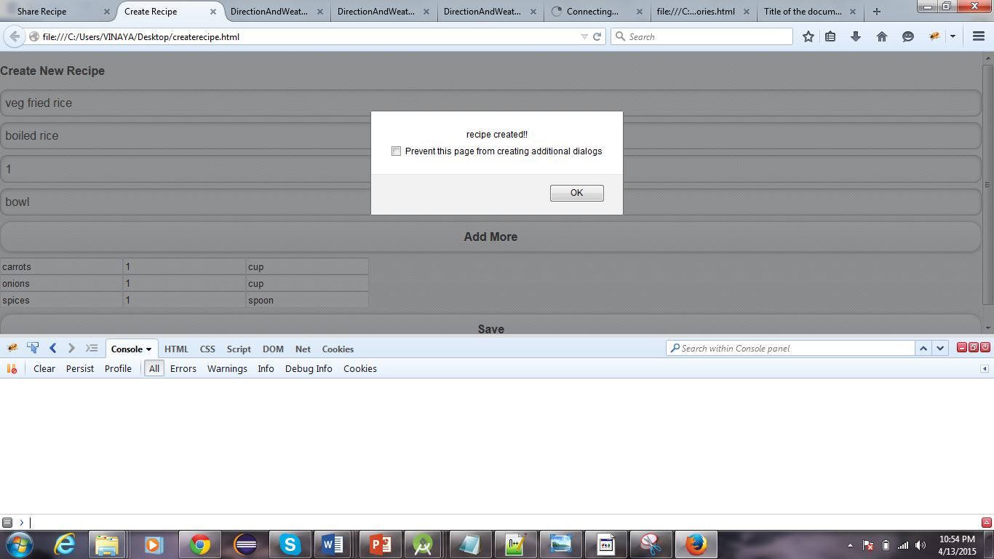

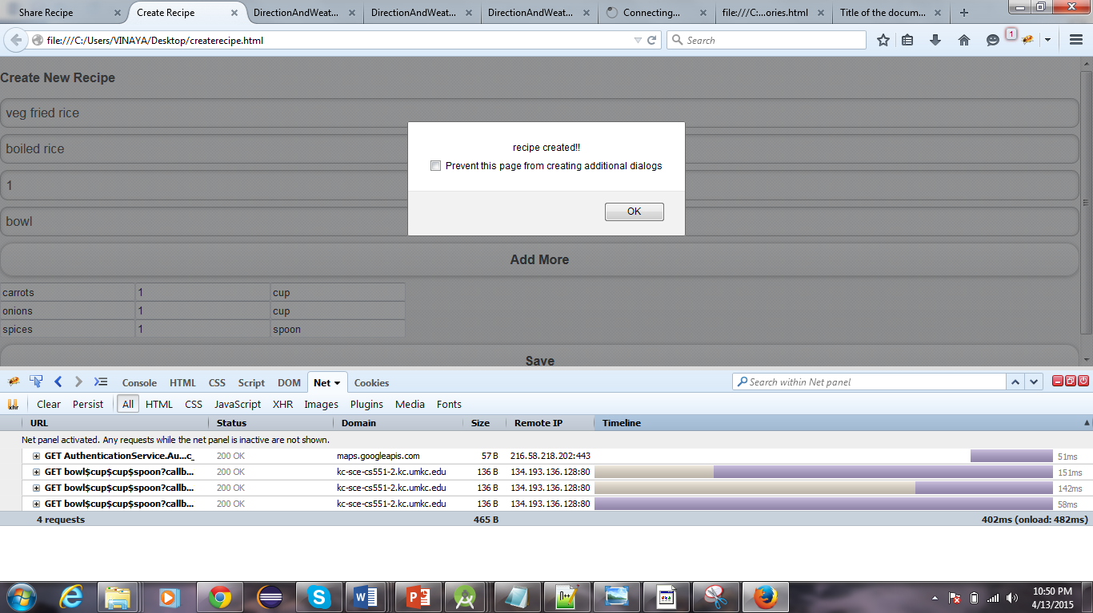

1. **Share Recipe.html**

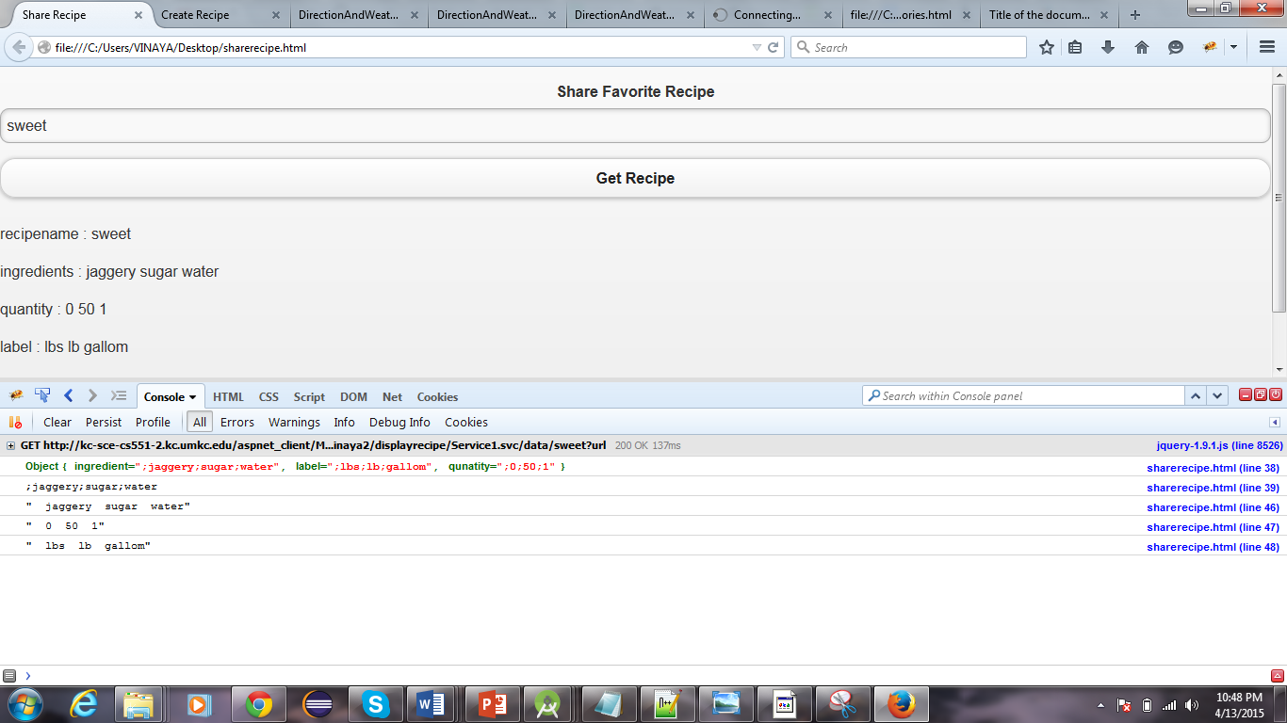

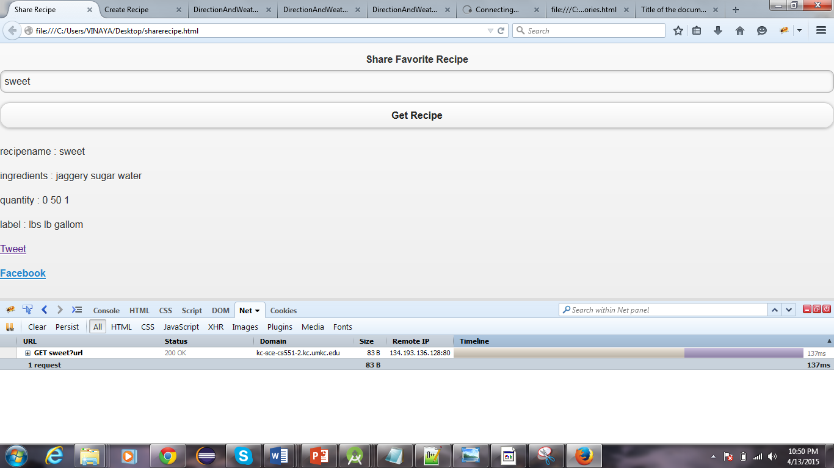

1. **viewRecipe.html**

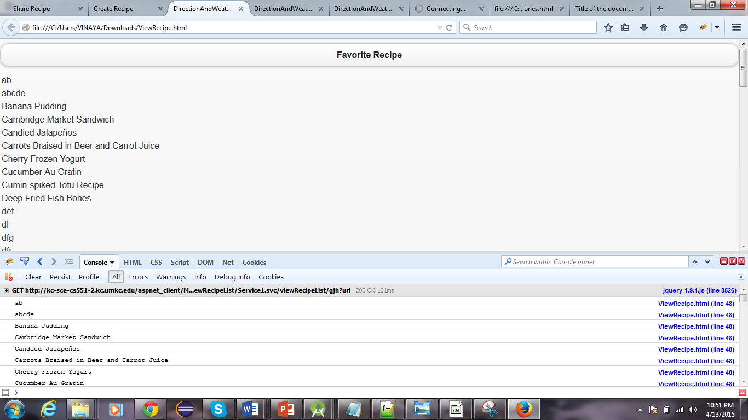

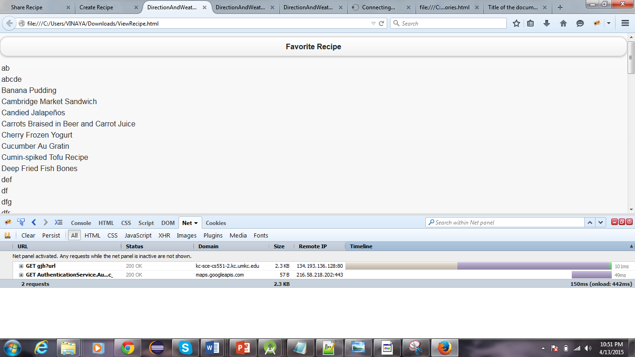

1. **Updaterecipe.html**

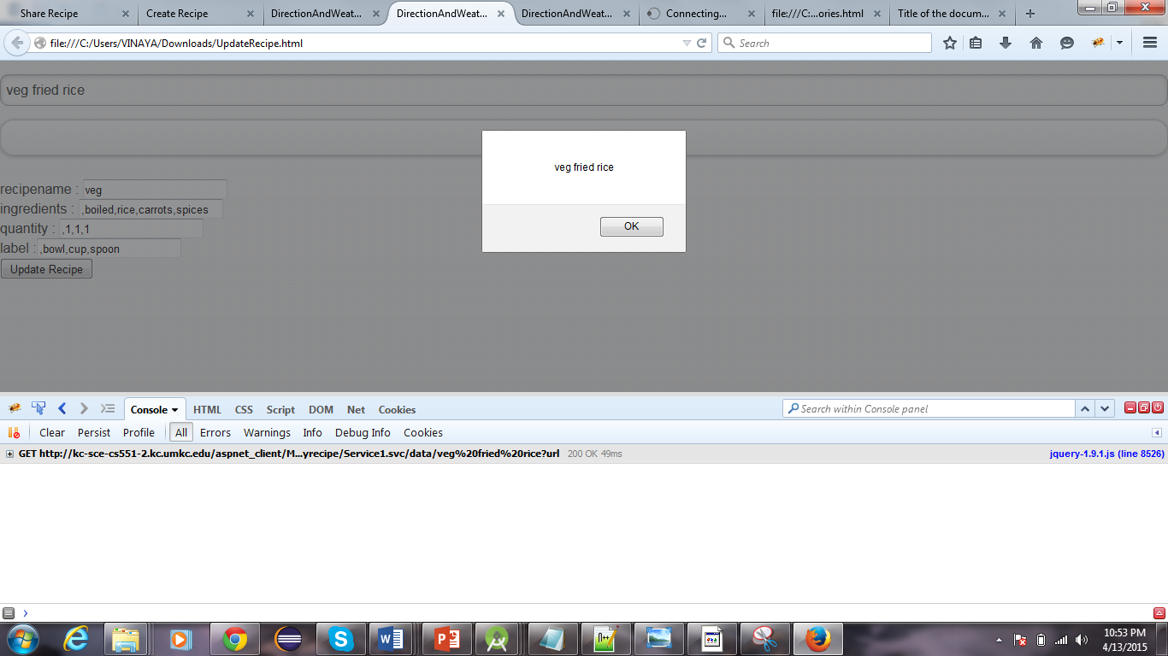

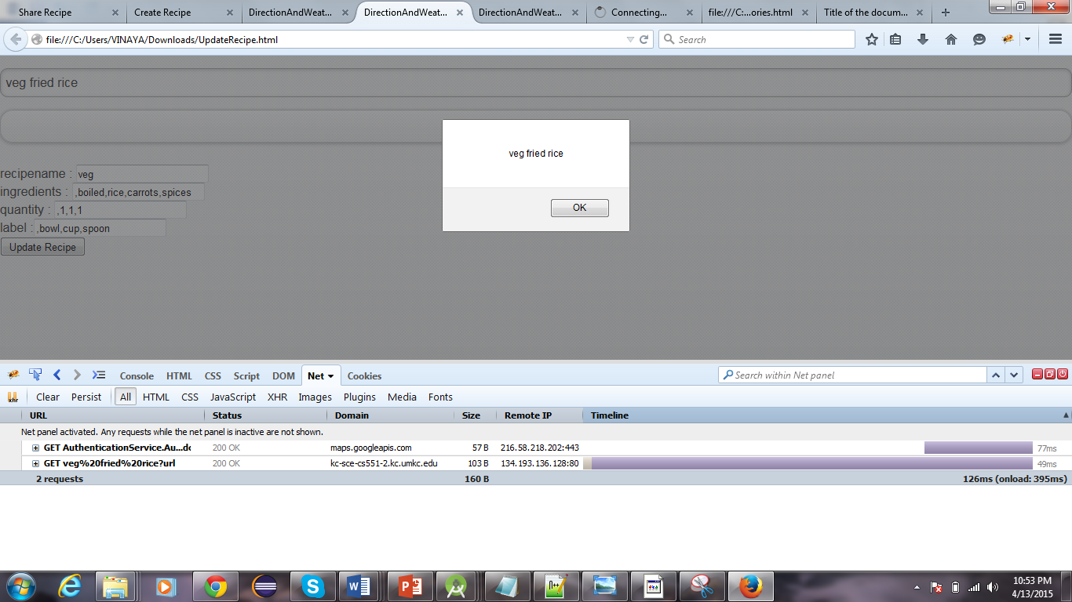

1. **Import Recipe.html**

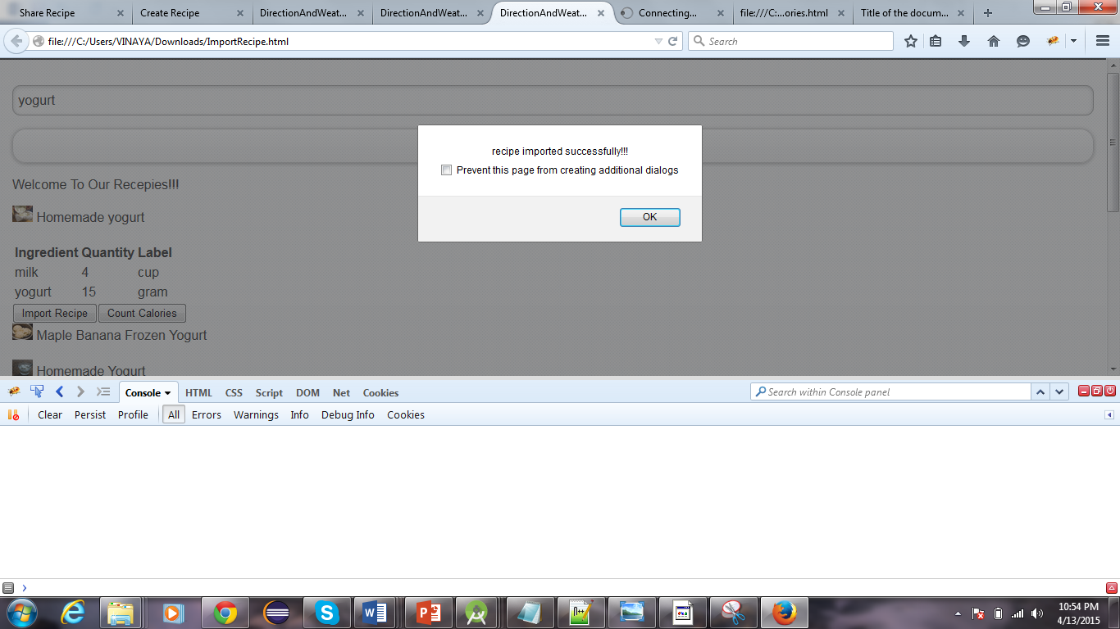

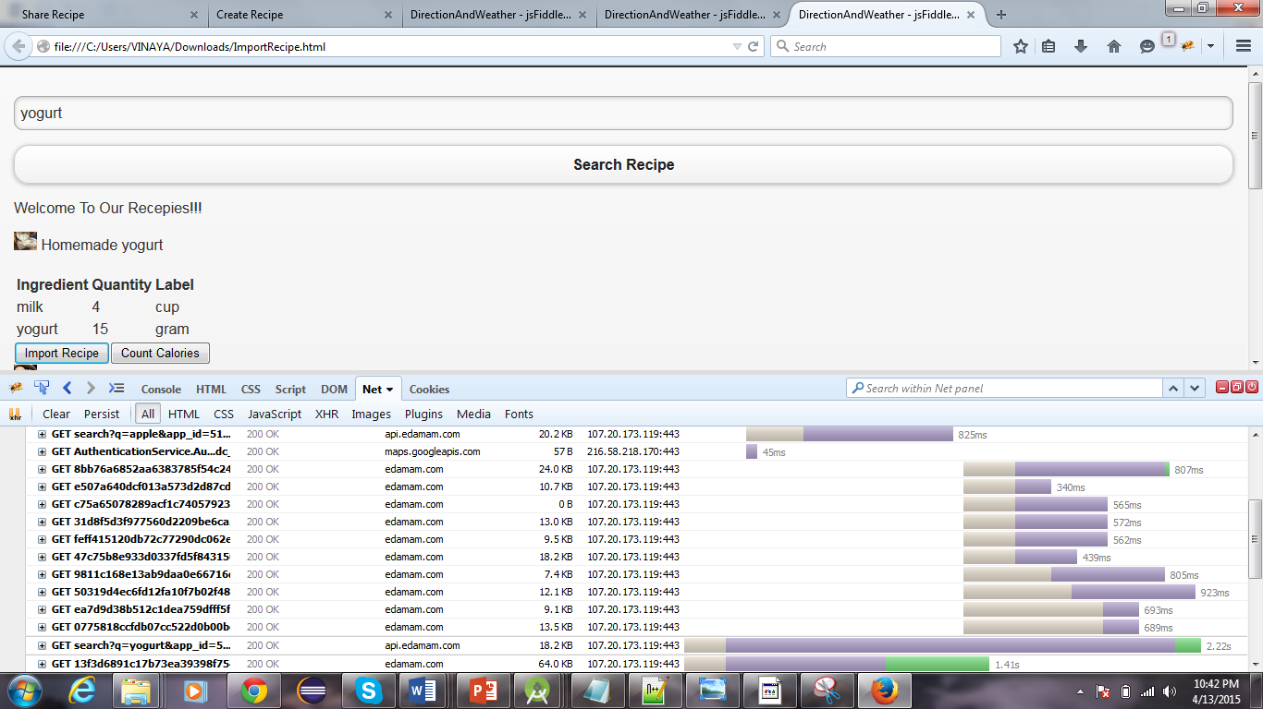

1. **Calorie.html**

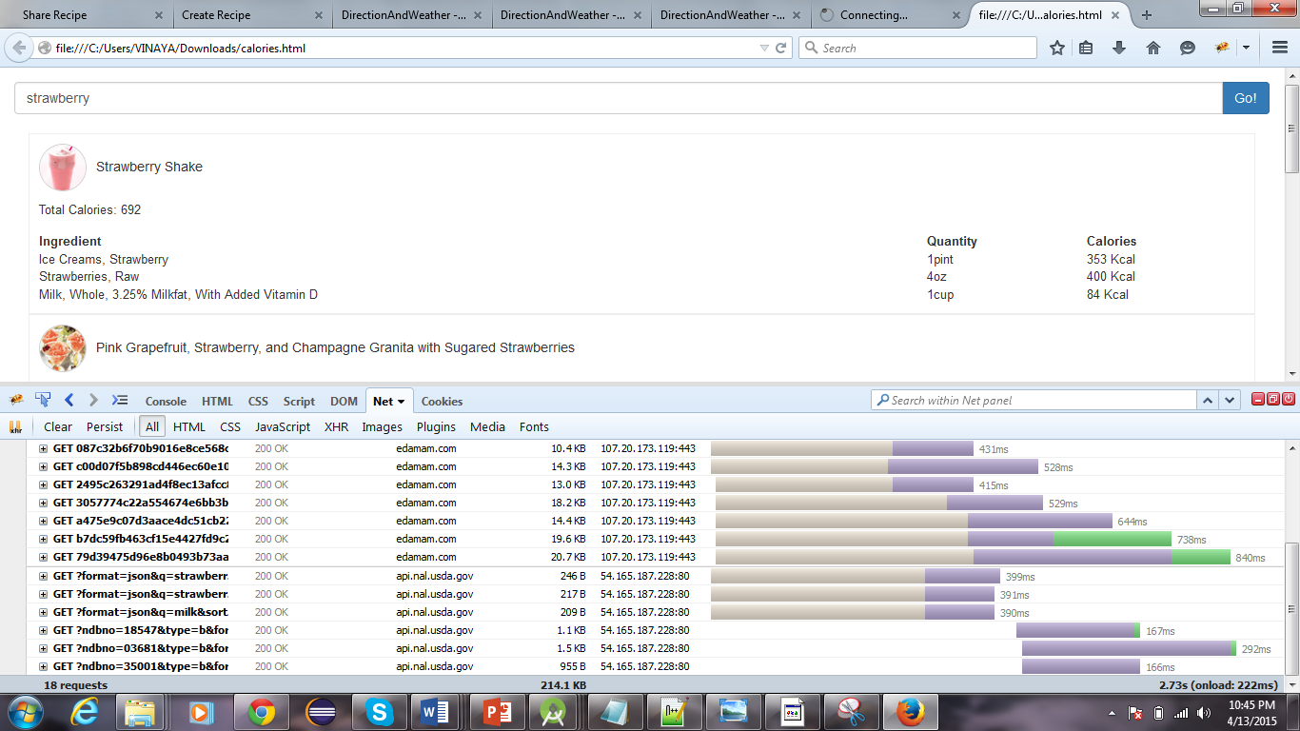

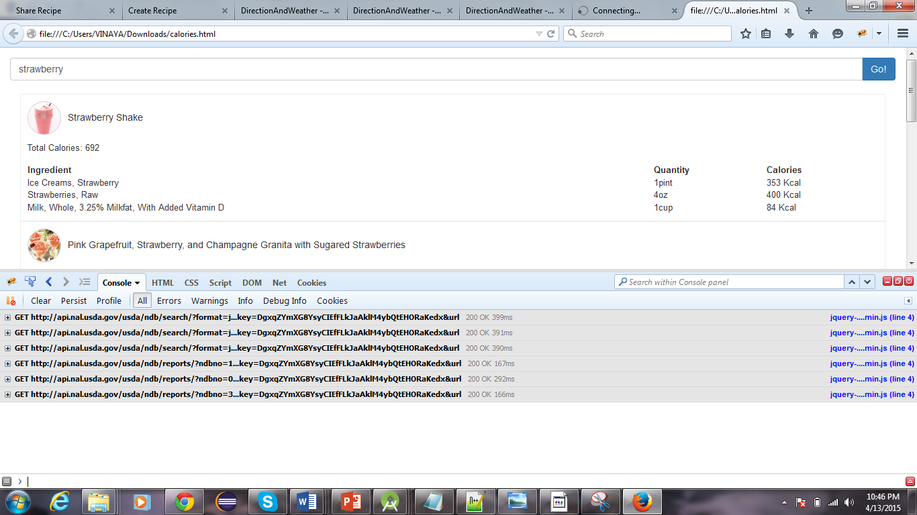

1. **Notification.html**

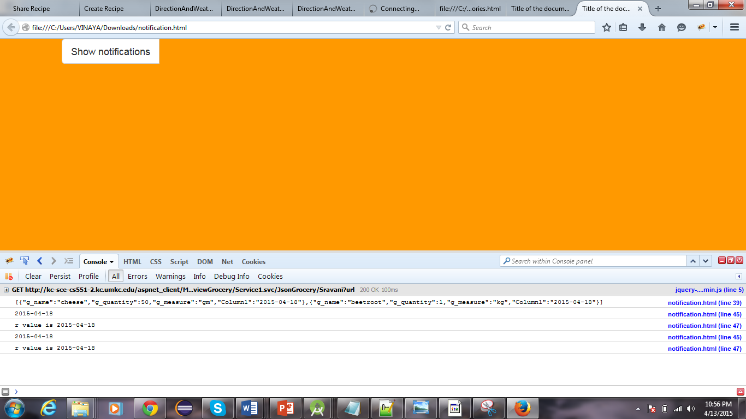

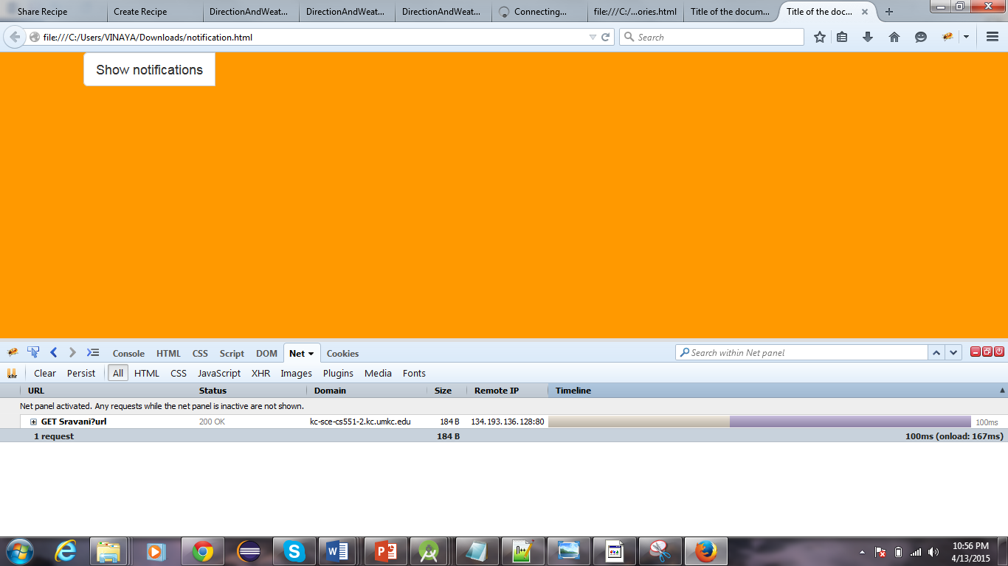

1. **viewGrocery.html**

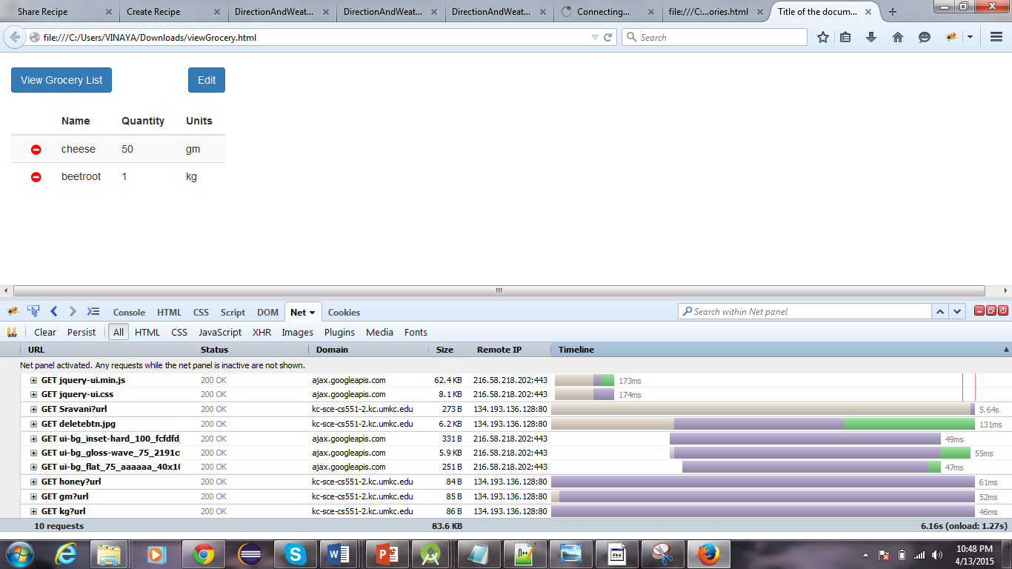

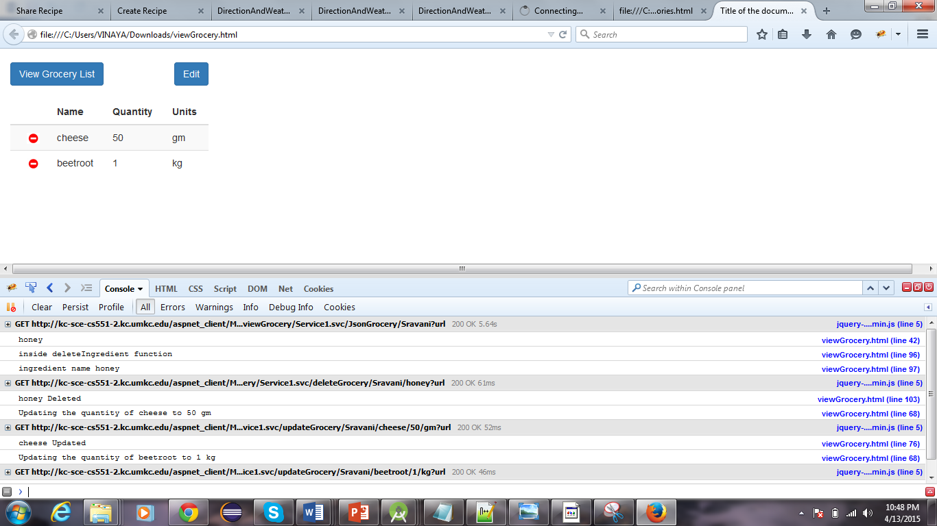

1. **ScrumDo**

We have used Scrumdo to track the progress of the project. The project development is divided into four increments. All the functions and development tasks are written as user stories.

Link: [https://www.scrumdo.com/projects/project/calorie2grocery3/iteration/122932#](https://www.scrumdo.com/projects/project/calorie2grocery3/iteration/122932)

**Screenshots for Increment#3 user stories:**

All the user stories planned for increment #3 have been successfully implemented.

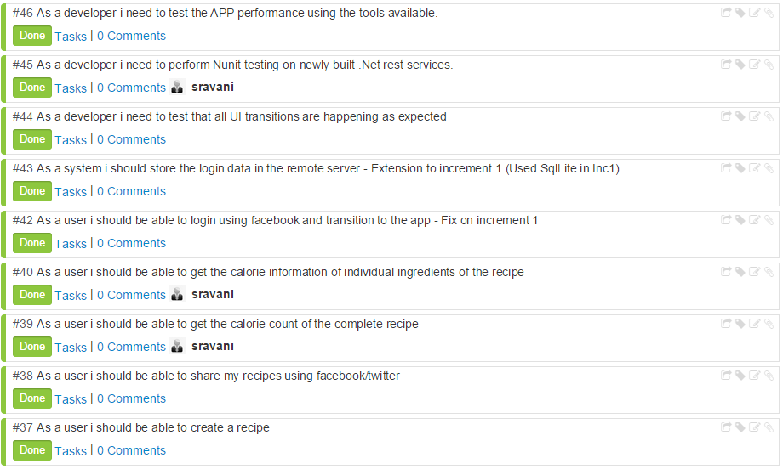



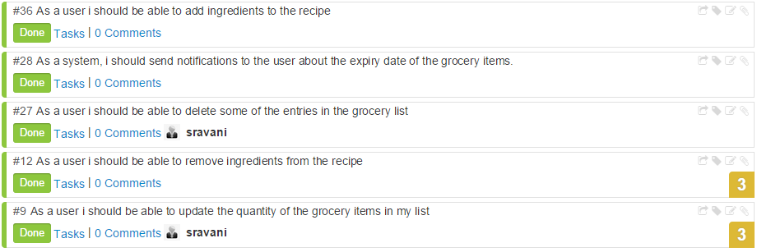

**Increment #4 user stories**

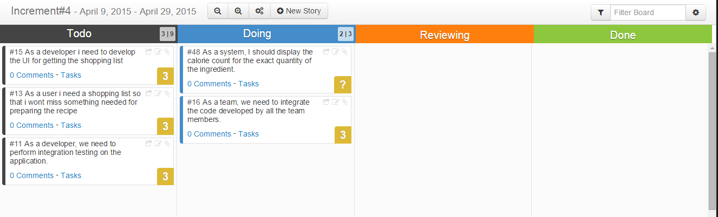

**Work Completed:**

|  |  |  |  |  |
| --- | --- | --- | --- | --- |
| **User Story#** | **User Story** | **Hours Worked** | **Team Member** | **Status** |
| 9 | As a user I should be able to update the quantity of the grocery items in my list | 10 | Sravani | Done |
| 27 | As a user I should be able to delete some of the entries in the grocery list | 8 | Sravani | Done |
| 28 | As a system, I should send notifications to the user about the expiry date of the grocery items. | 20 | Vaishnavi | Done |
| 12 | As a user I should be able to remove ingredients from the recipe | 15 | Leela | Done |
| 36 | As a user I should be able to add ingredients to the recipe | 15 | Leela | Done |
| 37 | As a user I should be able to create a recipe | 10 | Vinaya | Done |
| 38 | As a user I should be able to share my recipes using Facebook/twitter | 10 | Vinaya | Done |
| 39 | As a user I should be able to get the calorie count of the complete recipe | 2 | Sravani | Done |
| 40 | As a user I should be able to get the calorie information of individual ingredients of the recipe | 15 | Sravani | Done |
| 42 | As a user I should be able to login using Facebook and transition to the app - Fix on increment 1 | 5 | Vinaya | Done |
| 47 | As a system I need to store the recipes created by the user in the remote database | 5 | Vinaya | Done |
| 46 | As a developer I need to test the APP performance using the tools available. | 20 | Vaishnavi , Vinaya | Done |
| 45 | As a developer I need to perform Nunit testing on newly built .Net rest services. | 8 | Sravani, Leela | Done |
| 44 | As a developer I need to test that all UI transitions are happening as expected | 2 | Sravani, Leela | Done |

**GIT Hub URL:**

The Project code and documentation are uploaded to the following git hub URL:

<https://github.com/vaishnavi5054/AdvSoftEng>

**Bibliography:**

1. Reference: <http://api.bigoven.com/>

API: http://api.bigoven.com/recipes/47725api_key=dvx30p6vcIMHZWh3G1mghS88YvV6140D

This API provides two functions:

* Get Recipe
* Search Recipe

This is a REST based API. This API helps to search the recipes, display the list of ingredients. It redirects to another webpage where the user can see the recipe reviews etc… It also allows to update the grocery lists in the cloud. This supports either XML or JSON formats.

1. Reference: <https://www.recipal.com>

API: <https://recipal.com/api/v1/recipes/522>

This API helps to search and retrieve the recipes according to the scale. We can update an ingredient into the ingredient list. It also allows the user to create the customer ingredient object. The user can create a new recipe. Update an existing recipe etc…

1. Reference: <https://developer.edamam.com/>

API:https://api.edamam.com/search?q=chicken&app_id=51aba909&app_key=9fcd3aa5746d2a423a350cee3ea4d57d

This API provides services for the following:

* Nutritional Analysis API
* Recipe Search and Diet API

Here we are using Recipe Search and Diet API to search for a recipe. This API gives retrieves more information about the ingredients, the preparation time and procedure for that recipe. So, this API is more useful for our project as it gives the detailed information which helps us to import the ingredients. With the help of this API we can filter more while searching for a recipe like we can give allergic restrictions etc.

**PROJECT INCREMENT 4**

**Introduction**

Diet plays a major role in leading a healthy life style. Due to busy schedules, it has become difficult to plan for a healthy and nutritious diet. Diet is nothing but a pattern of eating food. It is important to concentrate on diet to stay healthy and happy. Proper diet reduces the risk of many diseases.

Obesity and weight gain are the most common problems today. Irregular and improper diet leads to obesity. So it is important to plan our meal to include necessary ingredients and avoid over consumption of food. Calorie information gives the energy content of food. Hence, Calorie intake is a good measure to check on weight gain.

Another common problem in day to day life is grocery management. Now-a-days, it is common to forget the groceries available at home. Not keeping track of the expiry dates leads to wastage of food. There are many web apps/Android apps which give the calorie information for different varieties of food items. Also, there are apps which aid in grocery management. But there is no single application that handles both the functionalities. An integrated app is much more useful to the user because it helps in proper planning of the meal based on calories per serving and groceries available.

**Overall Goal and Objectives**

Taste wins over health for most of the people. Also, after a day of work it is natural to prepare meal based on the ingredients that are available at home. Sometimes if vegetables are not available at home, people tend to eat junk food to fulfill their hunger. Hence it is important to plan for proper meal to maintain healthy life style.

Mobile apps are fun to use. Our endeavor is to develop an application that can be very useful in maintaining proper diet along with managing groceries efficiently. Our project aims to fulfill two main objectives:

* Firstly to provide calorie information about the ingredients used in preparing a recipe. This helps the user to take healthy choices about their meal.
* Secondly, to automatically generate a shopping list so that the user doesn’t miss something he needs to buy.

Users can create a recipe/search for a recipe and get the calorie count of the ingredients in the recipe. Based on the calorie information, user can chose to add or remove some of the ingredients in the recipe. Thus the app helps in planning for a healthy meal.

Our app provides the flexibility to log the groceries available at home as well as prepare a shopping list. Our app will generate alerts & notifications about the expiry date of the groceries, thus it helps in reduction of wastage of food. Also, based on the recipe chosen, our app prepares the list of ingredients to buy in order to prepare the recipe. Thus the app functions as a unified meal planner which takes care of grocery management as well as provide calorie information to plan for a healthy meal.

**Significance**

Our project focuses on providing all the required information for the user to plan for a healthy meal. A user can have a clear view of the groceries available at home from anywhere. This helps the user to plan his/her meal, search for the recipe and buy the required ingredients before reaching home. The app also gives the calorie information for each ingredient in the recipe thus providing nutritional information to the user. This information could drive the user to go for healthier meal options. Also, the app provides flexibility to add/remove ingredients in the recipe or create his/her own recipes. Our app works as follows:

Suppose a user would like to have vegetable sandwich for dinner. Say, he has tomatoes, onions and bread at home. Using our app he can do the following:

1. User can add tomatoes and onions to his currently available groceries list. User can update the list every time he purchases groceries.
2. User can search for a recipe of veg sandwich
3. The app displays the ingredients for the sandwich. Eg : Bread, Potatoes, Onions, Cucumber, Tomatoes, Lettuce
4. Based on the calorie information, user decides to remove potatoes from the sandwich and add olives. The app then updates the overall calorie count of the sandwich.
5. Once the user is satisfied with the recipe he can click ok, the app then displays the groceries he/she needs to buy to prepare the sandwich. Also, the quantity of tomatoes and onions will be decreased in the backend to reflect the usage. In this example, the app shows that the user needs to buy Cucumber, lettuce and olives.

**Project Background and related work**

There are few applications that gives calorie information of the particular item that could help the user to maintain proper diet, but this does not include the grocery information. Some of the other apps that are developed provides user with only grocery management and recipe information. Our idea is to facilitate the user with both the calorie information and grocery management. In this project, we are going to implement this idea which combines both the functionalities.

The Grocery management application titled “Fresh Box” addresses the mundane task by allowing users to simply snap a photo and upload it into their own virtual ice box. They call this their "what you see is what you get" feature, and the beautifully illustrated interface makes stocking the fridge a fun process similar to updating your Instagram. Once photos are uploaded, users can set an expiration date so the milk doesn't go sour, produce doesn't go bad. The following are the features of this application:

* Take snapshots of the items purchased
* Upload the photos in virtual ice box
* Set expiry date for the items

The Calorie intake application named “Fooducate” is helpful in making choices at the grocery store. You can scan an item’s barcode and the app will share nutritional highlights, compare it to similar items, and provide alternatives. But this app doesn’t provide the option to log the groceries available at home. Using this app, we can only compare the calorie count of similar products. Main features:

* The user gets the calorie details of the product
* Similar items are retrieved as alternatives which are having same count of calories

One of the Grocery shopping list application “Anylist” is specifically designed for grocery lists and recipes. When we start typing to add a new item, AnyList displays an auto-complete list. Tap an item to add it, and AnyList groups items in your list by store sections: Bakery, dairy, meat, frozen food, and so on. We can create multiple lists—one for each store and we can share them with others who use the app. You can also add recipes, so each item needed gets added to your grocery list. But this app doesn’t give the calorie information about the ingredients. The features of this application:

* Search for the particular recipe and get the ingredients
* Categorize the groceries into different groups
* Share the list with others

|  |  |  |  |
| --- | --- | --- | --- |
| Fresh Box | Fooducate | Anylist | Proposed System |
| User can add the items along with expiration date and get notifications whenever the product expired. | User can add the items based on barcodes but cannot add products which doesn’t have barcodes. | User can just add the groceries list depending upon the category. | User can add the items along with expiration date and get notifications whenever the product expired.  Expiration date will be automatically calculated if not entered. |
| Does not provide calorie information | Provides calorie information for a particular product but not for a recipe. | Calorie information is not evaluated for a recipe. | User can get the calorie count for each ingredient and can edit the quantity of ingredients depending on his/her choice and get the overall calorie count per serving. |
| No option to create and save recipes | No option to create and save recipes | User can search for a recipe but cannot save it for future reference | User can search for recipes/create his own recipe and save it. |
| Does not provide information regarding nearest grocery stores. | Does not provide information regarding nearest grocery stores. | Does not provide the information regarding nearest grocery stores. | Whenever ingredient is not available for the recipe the user can search for the nearest grocery store based on current location. |

**Proposed System**

Requirement Specification

Functional:

The goal of the project is to develop an application that allows the user to

1. Register or login securely through Facebook
2. Maintain a list of groceries available in their home
3. Search for recipes and save them for quick reference
4. Get the detailed information of calories per each ingredient required for the recipe
5. Add/remove the ingredients and adjust the quantity of the ingredients
6. Get the final count of calories per serving of the recipe
7. Based on the ingredients, get a list of groceries to buy in order to prepare the recipe.
8. Get the nearest grocery stores based on the current location
9. Get alerts/notifications about the expiry date of the groceries in home.

Non-Functional:

* Security: The app doesn’t require access to any sensitive information of the users. The app requests access for only the current location of the user. Also, users can login securely using Facebook.
* Stability: The app is designed to function as expected on any device with android version 4.0 and above.
* Visual Quality: The app displays all the text blocks and forms in acceptable formats.
* Performance: The app needs to load quickly and respond within 3-5 seconds.

Technological and architectural requirements:

|  |  |
| --- | --- |
| Requirement | Tools |
| Operating System | Android 4.0 or above |
| Development Operating System | Windows |
| Platform | Android Studio/Eclipse |
| UML Diagrams | Microsoft Visio |
| Languages | Java, C# , ASP.Net |
| Database | SQL Lite |
| Planning | ScrumDo |
| Version Control System | GIT |
| Rest Services | Facebook API |
| Google Places API |
| NDB API |

**Rest Services**

**Existing Services:**

1. Recipe Search & Diet API :

This API provides services for the following:

* Nutritional Analysis
* Recipe Search

We are using Recipe Search and Diet API to search for a recipe. This API provides information about the ingredients, the preparation time and procedure for a recipe. This API provides detailed information about the quantity of ingredients, total calorie count of the recipe etc. Also this API provides additional search capabilities like we can include restrictions on allergic items etc. Hence we are using this API to get the list of recipes based on a keyword and import the ingredient list.

API: <https://api.edamam.com/search?q=chicken&app_id=51aba909&app_key=9fcd3aa5746d2a423a350cee3ea4d57d>

Reference: <https://developer.edamam.com/>

1. USDA Nutrition API :

NDB is the nutrition database provided by the United States Department of Agriculture. Each food item is assigned a NDB number. We can fetch the calorie information of any ingredient only by knowing the NDB No.

The following API fetches the NDB No. of a food item. Ingredient name is passed as parameter to this url:

<http://api.nal.usda.gov/usda/ndb/search/?format=json&q=spinach&sort=n&max=1&offset=0&api_key=DgxqZYmXG8YsyCIEfFLkJaAklM4ybQtEHORaKedx>

The following API accepts NDB No. as an input and fetches the calorie information:

<http://api.nal.usda.gov/usda/ndb/reports/?ndbno=03127&type=b&format=json&api_key=DgxqZYmXG8YsyCIEfFLkJaAklM4ybQtEHORaKedx>

By using this rest service, we are displaying the calorie information for each ingredient in the recipe.

**New Services:**

We are storing the grocery and recipe information in the database. Our functionality mainly deals with managing this information. Hence most of the features in the application require interaction with the database. To achieve that, we have created the following rest services for implementing the server side logic for this application.

1. Grocery List: User can add the grocery items available at their home using our application. The grocery items added by the user will be stored in the database. This API is used to maintain the grocery lists. We have implemented 4 methods in this API.
   1. Add grocery Item: This method is used to insert the data entered by the user in the database. User name, grocery name, quantity and units are given as input to this method.

API: <http://kc-sce-cs551-2.kc.umkc.edu/aspnet_client/MPG12/Sravani/AddGrocery/Service1.svc/addgrocery/Sravani/butter/30/gm>

* 1. View grocery list: This method is used to retrieve the grocery list from the database. Username is passed as an input to this method.

API: <http://kc-sce-cs551-2.kc.umkc.edu/aspnet_client/MPG12/Sravani/viewGrocery/Service1.svc/JsonGrocery/Sravani>

* 1. Delete Grocery Item: This method is used to delete grocery items from the grocery list. We need to provide username and grocery item name as an input to the API URL.

API: <http://kc-sce-cs551-2.kc.umkc.edu/aspnet_client/MPG12/Sravani/viewGrocery/Service1.svc/deleteGrocery/Sravani/butter>

* 1. Update Grocery Item: This method is used to update the quantity & units of a grocery `item. We need to pass the grocery name, quantity & units as input to the URL.

API: <http://kc-sce-cs551-2.kc.umkc.edu/aspnet_client/MPG12/Sravani/viewGrocery/Service1.svc/updateGrocery/Sravani/butter/30/gm>

1. Recipes: One of the key functionalities of our application is to search for recipes or create their own recipes. So we need rest services to import the recipe information and store it in the database and manage the recipes. Following are the services created to provide different functionalities to the user:

1. Import Recipe: This API is created to import the recipe information from the recipe search API and store the recipe name and ingredient list in the database. We need to import this information to the database so that we can enable the users to customize the recipe.

API: http://kc-sce-cs551- 2.kc.umkc.edu/aspnet_client/MPG12/Sravani/viewGrocery/Service1.svc/importRecipe/

1. Add Ingredient to recipe: This rest service is used to add ingredients to the recipe based on user’s taste preference.

API: <http://kc-sce-cs551-2.kc.umkc.edu/aspnet_client/MPG12/vinaya2/RecipeIngredient/Service1.svc/data/>

1. Remove ingredient to recipe: This rest service is used to remove any of the ingredients from the recipe information in the database.
2. Update the ingredients in recipe: This service is used to update the quantity and units of ingredients in the recipe.

API: http://kc-sce-cs551-2.kc.umkc.edu/aspnet_client/MPG12/Leela/UpdateRecipe/Service1.svc/UpdateRecipe/

1. Shopping List: This rest service is used to generate the shopping list based on the ingredients in the recipe table and the items in grocery list. This service has the following methods:
2. Add to shopping list: Whenever a user clicks on generate shopping list after importing recipe, the difference between the recipe ingredients and the grocery list are stored in a shopping list table in the database.

API: http://kc-sce-cs551- 2.kc.umkc.edu/aspnet_client/MPG12/Sravani/viewGrocery/Service1.svc/importRecipe

1. View Shopping List: This rest service is used to fetch the data from the shopping list table in database.

API: <http://kc-sce-cs551-2.kc.umkc.edu/aspnet_client/MPG12/Sravani/viewGrocery/Service1.svc/userShoppingList>

1. Delete from shopping list: This rest service is used to delete the grocery items from the shopping list table. We need to provide the name of the grocery item which needs to be deleted as an input to this service.

API: <http://kc-sce-cs551-2.kc.umkc.edu/aspnet_client/MPG12/Sravani/viewGrocery/Service1.svc/deleteShoppingList/>

**System Architecture Diagram:**

The overall system architecture can be represented as below: Users interact with the application through GUI. Based on the user input, a request will be sent to the database using rest services. The response is then redirected to the user through the GUI.



Figure 1.2 System Model

**System Architecture Diagram:**

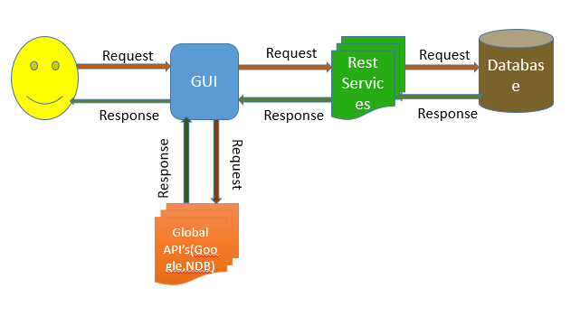

**Class Diagram:**



Figure 1.1 Class Diagram

**Activity Diagram:**

Figure 1.4 Activity Diagram

**Sequence diagrams**

1. For Login Page



1. Adding Grocery Items

**USER**

**REST API for**

**Remote**

**Database**

**REMOTE**

**DATABASE**

Add items to grocery list

**Recipe**

**Import API**

**Recipe**

**Search API**

items added

Views list of items

Sends the request to the database

Displays the grocery items from the database

Update Quantity of the grocery

Updates the quantity value into the data base

Search a recipe

Returns the recipe list

Select the desired recipe and get the ingredient list

Displays the ingredient list

Import the recipe and ingredient list

Imports the recipe and ingredient ist to the remote database

1. Importing recipes along with calorie count



**Use case Templates**

1. **Use Case Template for Adding grocery items:**

|  |  |
| --- | --- |
| Use Case Name | Add grocery items |
| Primary Actor | User |
| Pre-Conditions | 1. User has the app installed on his/her mobile. 2. User should be logged into the app. |
| Guarantee(Post Conditions) | Grocery items are stored in the database |
| Main Success Scenario | 1. User clicks on “Add Grocery” button in the home page. 2. The system transitions the UI to the “Add Grocery” layout. 3. User enters the grocery item name, quantity, selects the measuring unit from the drop down menu and clicks on “Add”. 4. System adds the grocery information to the database. 5. System sends a notification that the grocery item is successfully added to the database. 6. User can go back to the home page by clicking on return button. |
| Extensions | 3a. User enters incorrect value for quantity. Systems throws an error asking the user to add proper value.  4a. If the grocery item is already present in the list, systems sends an alert saying the given name already exists in the list. The user can update the quantity of the item in the list if desired.  5a. User can add as many groceries items as he needed to by following steps 3 & 4 and then go back to the home page. |

1. **Use Case Template to View the grocery list:**

|  |  |
| --- | --- |
| Use Case Name | View grocery list |
| Primary Actor | User |
| Pre-Conditions | 1. User has the app installed on his/her mobile. 2. User should be logged into the app. |
| Guarantee(Post Conditions) | User can view the list of groceries.  User can update the quantity of grocery items. |
| Main Success Scenario | 1. User clicks on “View Grocery List” button in the home page. 2. The system transitions the UI to the “View Grocery” layout. 3. System fetches the grocery list of the user from the database. 4. System displays the grocery list to the user. 5. User can update the quantity of any of the grocery items. 6. System updates the database to reflect the changes made by the user. 7. System sends a notification saying the update is successful. |
| Extensions | None |

1. **Use Case Template to update grocery item:**

|  |  |
| --- | --- |
| Use Case Name | Update grocery items |
| Primary Actor | User |
| Pre-Conditions | 1. User has the app installed on his/her mobile. 2. User should be logged into the app. |
| Guarantee(Post Conditions) | Quantity of grocery items is updated in database. |
| Main Success Scenario | 1. User clicks on “View/Edit grocery list” button in the home page. 2. The system transitions the UI to the “View Grocery” layout. 3. System fetches the grocery list of the user from the database. 4. User clicks on the quantity of the grocery item he/she needs to update. 5. System changes the quantity cell to editable mode. 6. User updates the quantity and hits enter. 7. System updates the data in the remote database. |
| Extensions | 3a. User clicks the units cell of the grocery item.  4a. System changes the units cell to editable mode.  5a. User updates the unit for the grocery item.  6a. System updates the measure of the grocery item in database. |

1. **Use Case Template to delete grocery item:**

|  |  |
| --- | --- |
| Use Case Name | Delete grocery item |
| Primary Actor | User |
| Pre-Conditions | 1. User has the app installed on his/her mobile. 2. User should be logged into the app. |
| Guarantee(Post Conditions) | Grocery item is deleted from the database. |
| Main Success Scenario | 1. User clicks on “View/Edit Grocery List” button in the home page. 2. The system transitions the UI to the “View Grocery” layout. 3. System fetches the grocery list of the user from the database. 4. System displays the grocery list to the user. 5. User can click on “Edit” button 6. System display minus sign in front of each grocery item in the list. 7. User clicks on the minus sign in front of the grocery item he/she wants to delete. 8. System opens an alert dialog asking the user to confirm deletion. 9. User hits “OK”. 10. System deletes the grocery item from the database. 11. System removes the row in the display |
| Extensions | 9a. User hits “Cancel”.  9b. System doesn’t delete the grocery item. |

1. **Use Case Templates for searching and importing a recipe:**

|  |  |
| --- | --- |
| Use Case Name | Search & import a recipe |
| Primary Actor | API |
| Pre-Conditions | The user must be a valid user to use the app |
| Post-Conditions | Retrieves the results for the search |
| Main Success Scenario | 1. If the user wants to search for a recipe, then, the user enters the keyword to search. 2. User clicks on the search recipes. 3. The system displays ten recipe names. 4. If the user wants to see the ingredient list, then the user can click on the recipe name. 5. System displays ingredient list along with quantity. 6. If the user wants to import the ingredient list then click on import. 7. The system stores the ingredient list in the database. |
| Extensions | None |
| Special Requirements | None |

1. **Use Case Templates to Add Ingredient to a recipe:**

|  |  |
| --- | --- |
| Use Case Name | Search & import a recipe |
| Primary Actor | User |
| Pre-Conditions | The user must be a valid user to use the app |
| Post-Conditions | Retrieves the results for the search |
| Main Success Scenario | 1. If the user wants to search for a recipe, then, the user enters the keyword to search. 2. User clicks on the search recipes. 3. The system displays ten recipe names. 4. If the user wants to see the ingredient list, then the user can click on the recipe name. 5. System displays ingredient list along with quantity. 6. If the user wants to import the ingredient list then click on import. 7. The system stores the ingredient list in the database. |
| Extensions | User can view and update the recipe |

1. **Use Case Templates to View Favorite Recipe:**

|  |  |
| --- | --- |
| Use Case Name | View recipe |
| Primary Actor | User |
| Pre-Conditions | The user must be a valid user to use the app |
| Post-Conditions | Retrieves the results for the search |
| Main Success Scenario | 1. If the user wants to get the favorite recipe then user clicks the view favorite recipe button 2. User clicks on the favorite recipes. 3. User gets all the favorite recipe list from the database. |
| Extensions | User can update the recipe |

1. **Use Case Templates to Update Recipe:**

|  |  |
| --- | --- |
| Use Case Name | View recipe |
| Primary Actor | User |
| Pre-Conditions | The user must be a valid user to use the app |
| Post-Conditions | Retrieves the results for the search |
| Main Success Scenario | 1. If the user wants to get the favorite recipe then user clicks the recipe name. 2. User clicks on the get recipe button 3. User gets all the recipe name, ingredient list , quantity and label from the database. 4. User can add, remove, update the ingredient , quantity and label 5. User can click the update button. 6. System uploads the changed the recipe list to the database. |

1. **Use Case Template to Create Recipe:**

|  |  |
| --- | --- |
| Use Case Name | View recipe |
| Primary Actor | User |
| Pre-Conditions | The user must be a valid user to use the app |
| Post-Conditions | Retrieves the results for the search |
| Main Success Scenario | 1. If the user wants to create the favorite recipe then user enters the recipe name , ingredients list and their quantity and labels. 2. User clicks on the add more button for more ingredients to the recipe. 3. User adds all the ingredients and quantity and their labels and clicks the save recipe button. 4. System uploads the recipe tot the database. |
| Extensions | User can Share the recipe in twitter and facebook. |

1. **Use Case Templates to Share Favorite Recipe:**

|  |  |
| --- | --- |
| Use Case Name | View recipe |
| Primary Actor | User |
| Pre-Conditions | The user must be a valid user to use the app |
| Post-Conditions | Users should be able to share the recipe using twitter or facebook. |
| Main Success Scenario | 1. User can search the recipe he would like to search from his list of recipes in database. 2. System displays the ingredients list, quantity and label for the recipe. 3. User can share the recipe in the twitter by providing twitter login 4. Recipe information will be shared in the users twitter account as a tweet 5. Similarly, User can share the recipe in the facebook using the facebook link. |

1. **Use Case Template to View & Edit shopping list:**

|  |  |
| --- | --- |
| Use Case Name | View shopping list |
| Primary Actor | User |
| Pre-Conditions | 1. User has the app installed on his/her mobile. 2. User should be logged into the app. |
| Guarantee(Post Conditions) | User can view the shopping list  User can edit the shopping list |
| Main Success Scenario | 1. User clicks on “Shopping List” button in the home page. 2. The system transitions the UI to the “Shopping List” layout. 3. System fetches the list of grocery items that need to be purchased from the database. 4. System displays the shopping list to the user. 5. User can delete any of the items from the list by clicking on edit button. 6. System displays minus sign against each item in the list. 7. User can click on the minus sign in the same row as the shopping item to be deleted. 8. System deletes the item from the database. |
| Extensions | None |

1. **Use Case Template to Generate Notifications:**

|  |  |
| --- | --- |
| Use Case Name | Generate Notifications |
| Primary Actor | System |
| Pre-Conditions | 1. User has the app installed on his/her mobile. 2. User should be logged into the app. 3. User should enter the grocery items along with expiry dates. |
| Guarantee(Post Conditions) | User can check the expiry dates of the grocery items |
| Main Success Scenario | 1. User clicks on show notifications 2. The system checks the expiry dates of all the items and generates notifications which are about to expire within 1 day. 3. The system generates notification “grocery expiry dates” in the notification bar of the android device. 4. User clicks on the notification to get the complete details. 5. The system transitions to other page which lists the grocery items which are about to expire. |
| Extensions | None |

**Implementation**

We have grouped the functionalities and developed the following layouts as part of UI implementation.

1. Registration and Login Page:

Allows the user to register to our application and login by providing username and password or by using facebook login.

1. Home Page:

Provides the necessary buttons to navigate to different functions.

1. Implementation of User Interface:

We have grouped the functionalities and developed the following layouts as part of UI implementation.

1. Registration and Login Page: Allows the user to register to our application and login by providing username and password or by using facebook login
2. Home Page: Provides the necessary buttons to navigate to different functions
3. My Groceries : Once we go to My groceries page, there are 2 options:
4. Add Grocery
5. View/Edit Grocery
6. Recipes: We have created the following buttons in this page:
7. Search Recipe
8. Create Recipe
9. Share Recipe
10. Update Recipe
11. Show Notifications: Notifies user about the expiry dates of the grocery items.
12. Shopping List
13. Grocery Stores

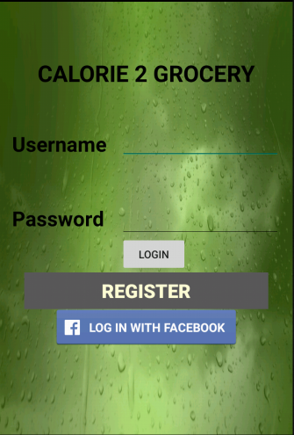**Screenshots:**

Login Page:

* User can login with username and password
* User can login with Facebook
* New user can register for the application

Technical Details:

* We have created a web service for retrieving the data from the registration table and comparing the data entered by the user and generating a message response
* Client side logic is implemented in android studio as a native app.

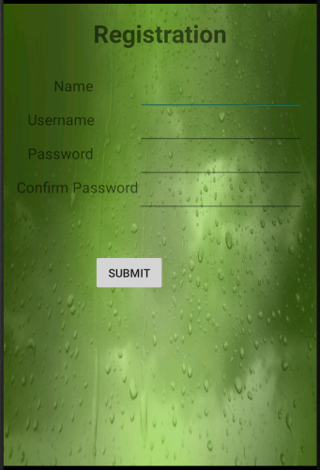

Registration Page:

* New user can register by filling form with name, username and password details and by clicking submit button

Technical Details:

* We have created a web service for inserting the data entered by the user in the registration table in the remote database.

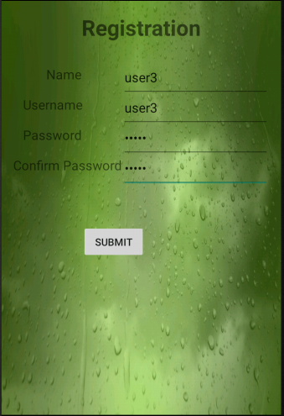 Registration page:

* The form filled with the details by the new user

Technical Details:

* Client side logic is implemented in android studio as a native app.

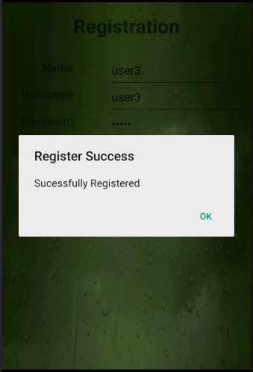

Registration page:

* The registration is successful and the new user is registered
* The message response generated showing “Successfully Registered”

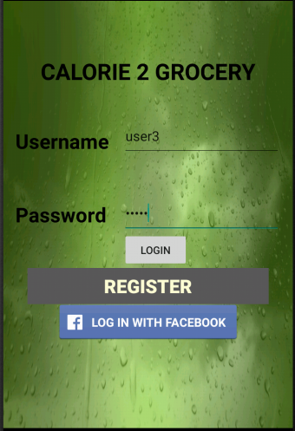

Login page:

* The registered user can now login by giving his/her username and password
* The registered user is thus logged in to the application

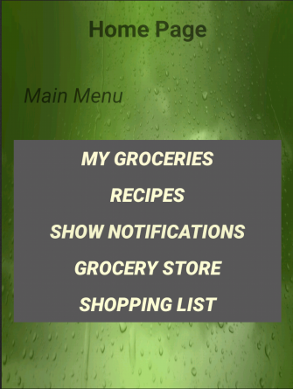

Home page:

* The user is logged in successfully in to the application
* The Home page will be displayed if login successful

Technical Details:

* Client side logic is implemented in android studio as a native app.

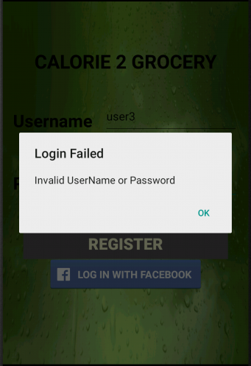

Login page:

* If the user has entered incorrect username or password the login fails
* The dialog box pops up saying login failed
* The message response generated showing “Invalid Username or Password”

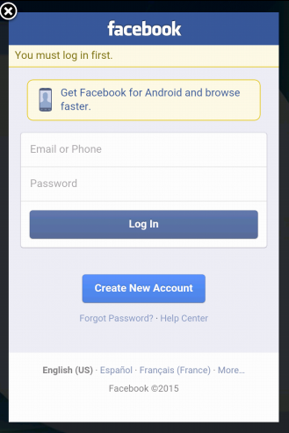

Facebook Login page:

* If the user has Facebook account, he can login with his account
* The user can login with Facebook by entering his/her Facebook username and password details

Technical Details:

* The Facebook SDK is imported into the application. Facebook App ID is configured and linked to the application.

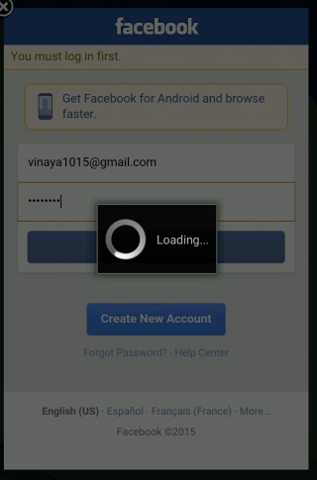

Facebook Login page:

* The user has entered his/her Facebook credentials and is logging in with Facebook account

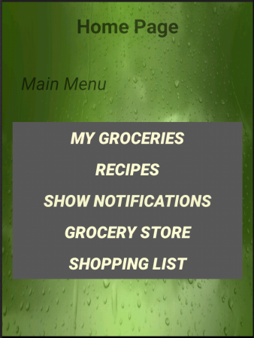

Home page:

* After successful login with application or with Facebook, the user is redirected to the home page
* It contains the Menu in which there are buttons like My Groceries, Recipes, Notifications, Find Grocery store and Shopping list

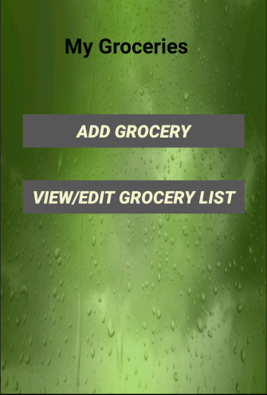

My Groceries page:

* User is provided with two buttons:
  + Add Grocery
  + View/Edit Grocery list
* Add Grocery: User can click this button if he wants to add grocery items to his list
* View/Edit Grocery list: If user wants to view the grocery list, he/she could click on this button

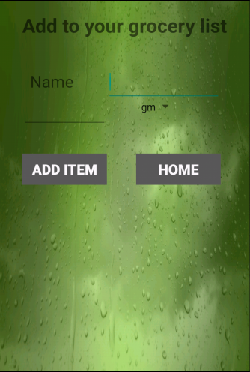

Add Grocery page:

* User enters the grocery item name, quantity.
* User can select the measuring unit from the drop down menu

Technical Details:

* Client side logic is implemented in android studio as a native app.

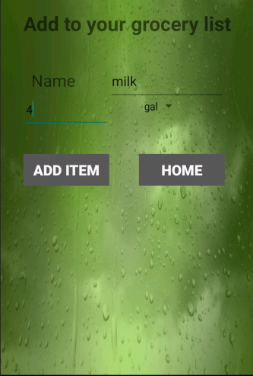

Add Grocery

* After entering the details about the grocery item, user clicks on add.
* System adds the information to the SQL server database.

Technical Details:

* We have created a web service for inserting the data entered by the user in the grocery_list table in the remote database.

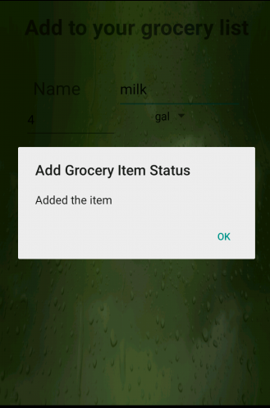

Add Grocery

* System sends a notification to the user saying the grocery item is added successfully.

After user clicks ok the add grocery UI is refreshed, the user can add more grocery items.

Technical Details:

* Web service to add the grocery items to database sends the result of the insert operation in the form of JSON.
* Used alert dialog to display the output message from the web service as a notification.

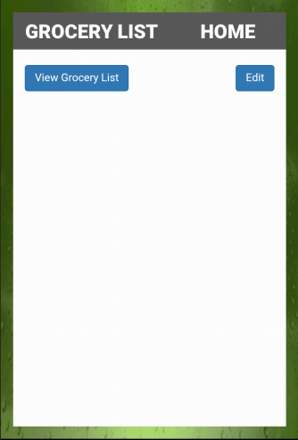

View Grocery List

* If the user clicks on “View grocery list” button in home page then the UI transitions to this page.
* Once the user clicks on “Grocery List” button, the web page is loaded into the web view.

Technical Details:

* Implemented the functionality for displaying the grocery list using web technologies.
* Used Web view to display the page.

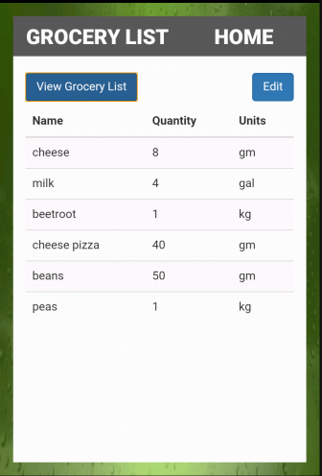 View Grocery List

* Once the user clicks on View Grocery List button within the page, the list of groceries is displayed in a table.

Technical Details:

* We have created a web service to retrieve data from the remote database
* We have used Ajax function to call the API and display the data
* Used twitter Bootstrap styling for table.

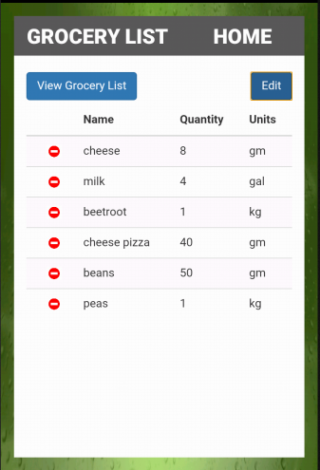 View Grocery List

* When user clicks on Edit button within the page, the list of groceries is displayed in a table.

Technical Details:

* We have created a web service to modify table and update table in the database.

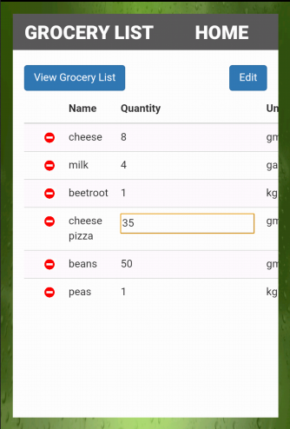

View Grocery List

* When user clicks on Edit button within the page, the list of groceries is displayed in a table.
* The user can edit particular item by clicking on it.

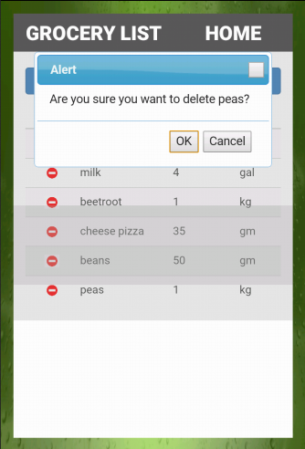

View Grocery List

* When user clicks on Edit button within the page, the list of groceries is displayed in a table.
* By click on the red color button on the left side, the particular item is deleted from the grocery list and the table gets updated.
* The alert dialog box pops up to confirm the deletion.

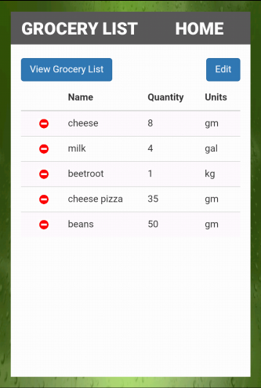

View Grocery List

* When user clicks on View Grocery List button within the page, the updated list of groceries is displayed in a table.

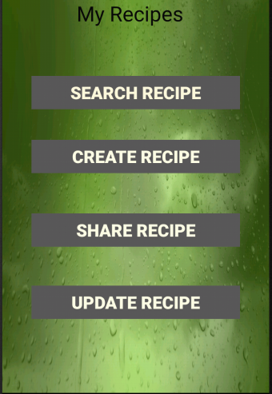 My Recipes page:

* User is provided with four buttons:
  + Search Recipe
  + Create Recipe
  + Share Recipe
  + Update Recipe
* Search Recipe: User can search recipes by clicking this button.
* Create recipe: If user wants to create new recipe he/she could click on this button.
* Share recipe: User can also share recipe to twitter and Facebook by clicking this button.
* Update Recipe: If user wants to update, view or delete the recipes he/she could click this button.

 Search Recipe page:

* The user gets the search recipe page when he clicks the search recipe button in My Recipes page.
* The user can search any recipe by giving the keywords in the search bar.

Technical Details:

* The client side logic is implemented using web technologies JavaScript, JQuery & Ajax
* Used bootstrap style sheets.

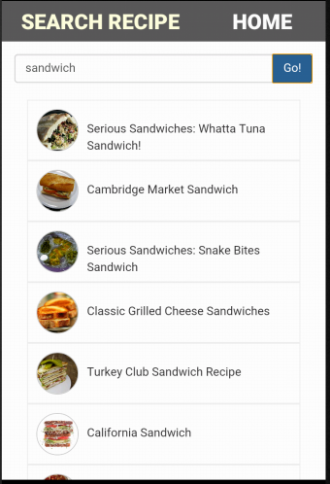

Search Recipe

* User enters sandwich as a search key to get various recipe on sandwich and clicks on GO button.
* It displays all the recipes and when user selects a particular recipe, the two buttons are displayed.
* Import recipe button: The user can store the particular recipe by clicking this button.
* Generate Shopping List button: The user can see whether he/she are having all the ingredients needed for a particular recipe.

Technical Details:

* We are using the recipe & diet api to fetch the recipe information

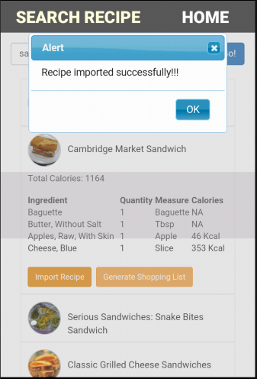 Search Recipe

* When user clicks on import recipe button, alert box is displayed showing Recipe imported successfully.
* The recipe is stored in the ingredients table in the remote database when import recipe button is clicked.

Technical Details:

* We have created a web service to add these imported recipes into ingredients table in the database.

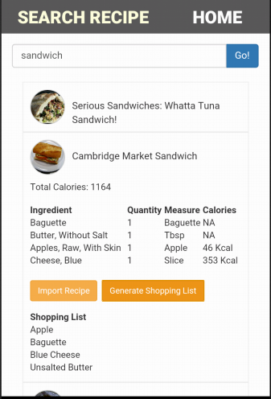

Search Recipe

* If user wants to check whether the groceries sufficient for the recipe ingredients, he/she will get this information by clicking Generate Shopping List button.

Technical Details:

* We have created a web service to compare the grocery_list table with the ingredients table and retrieve the items accordingly.

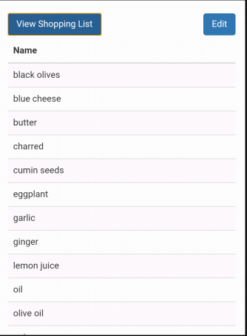

Search Recipe

* When user clicks the Generate Shopping List button, the grocery items which he need to buy are generated and displayed to the user.
* The user can also delete any grocery items from the shopping list by clicking the edit button.

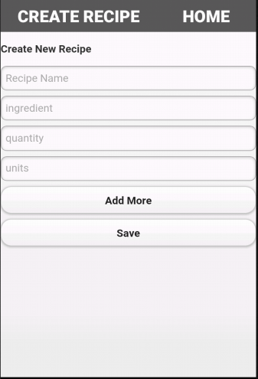

Create Recipe

* User can create his/her own recipes by clicking the create recipe button on My Recipes page.
* Create new recipe page will be displayed where user can enter the recipe information.
* The Add More button is used to add more ingredients.
* The recipe will be created by clicking the Save button.

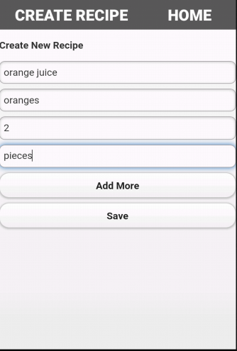

Create Recipe

* The user has entered the recipe details in the fields.

Technical Details:

* We have created a web service to insert the data into the ingredients table in the remote database.

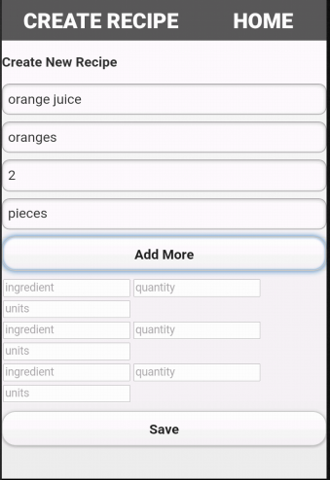

Create Recipe

* When user clicks on Add more button, more fields are displayed to add more ingredients.

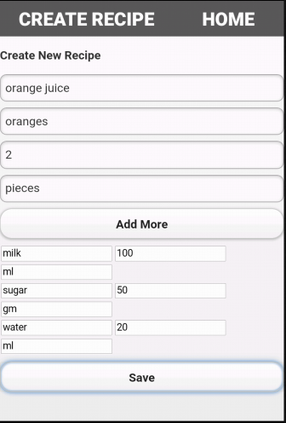

Create Recipe

* When user clicks on save button the recipe is created and inserted into the ingredients table in the remote database.

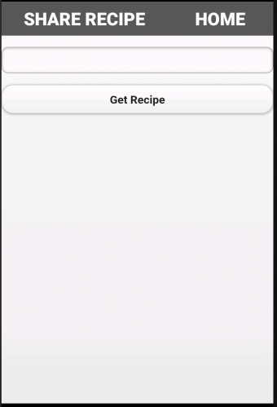 Share Recipe

* User can share recipes by clicking on Share Recipe button in My Recipes page.
* In share recipe page, user can get the particular recipe by giving the recipe name and can share with others.
* User can share imported recipes or his own created recipes to twitter or Facebook.

Technical Details:

* We have created a web service to retrieve the data from the ingredients table in the remote database.

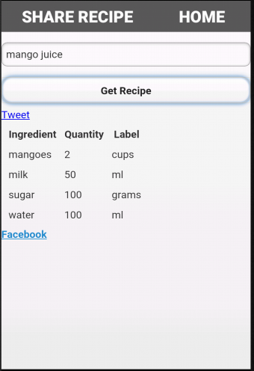 Share Recipe

* By clicking Get recipe button the list of ingredients for the particular recipe name given are retrieved.
* It also displays two options i.e. twitter or Facebook through which user can share the recipes to others.

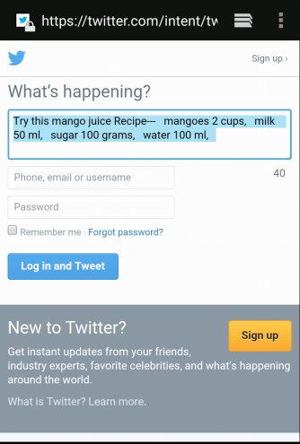

Share Recipe

* If user wants to share the recipe to twitter the popup is displayed with recipe name and ingredients list.
* The user should login to twitter if he/she wants to share.

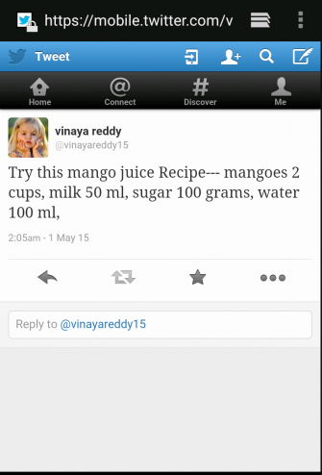

Share Recipe

* After sharing the recipe with others, the recipe is posted on to the wall.

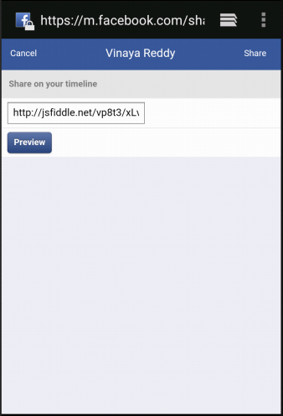

Share Recipe

* User can also share the recipe link to the Facebook.
* User must sign in through Facebook account to share the link.

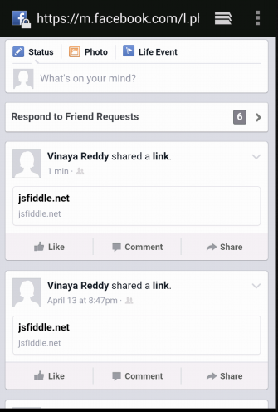

Share Recipe

* After sharing through Facebook, it is posted to Facebook wall.

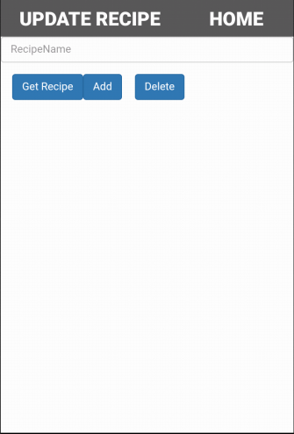

Update Recipe

* The recipes imported or created can be updated by clicking update recipe button on My Recipes page.
* The Get Recipe button is used to retrieve the recipe details.
* The Add button is used to add the ingredients for a particular recipe.
* The delete button deletes the ingredient from the recipe.

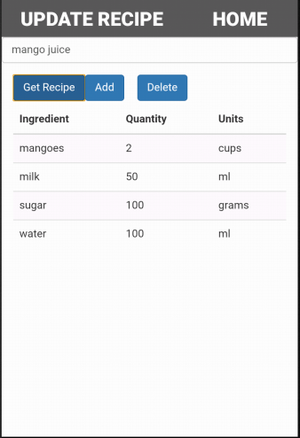

Update Recipe

* The ingredients list for a particular recipe are retrieved by clicking Get Recipe button.

Technical Details:

* We have created a web service to retrieve the data from the ingredients table in the remote database.

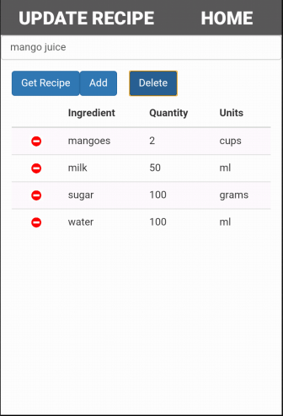

Update Recipe

* By clicking the delete button, the red colored icons are displayed on left side for each ingredient.

Technical Details:

* We have created a web service to update the modified recipes in the table.

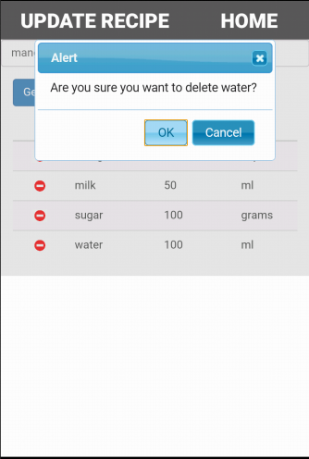

Update Recipe

* When the red colored icon for a particular ingredient is clicked, alert box pops up to confirm deletion.
* By clicking OK, the specific ingredient will be deleted.

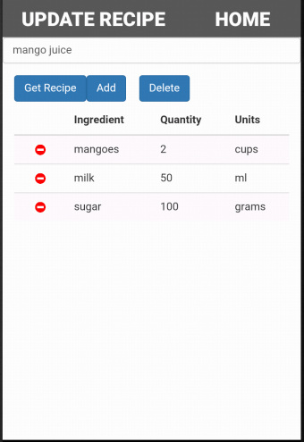

Update Recipe

* The recipe ingredient list which was previously modified.
* The specific ingredient is deleted and the recipe is updated.

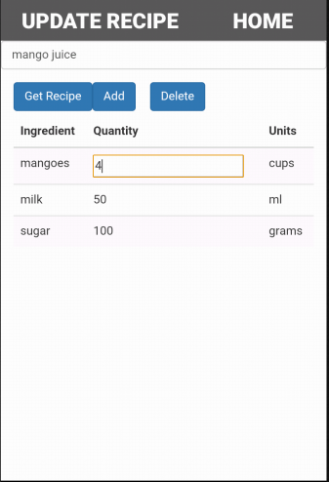

Update Recipe

* The ingredients list can also modified by clicking on the particular field.

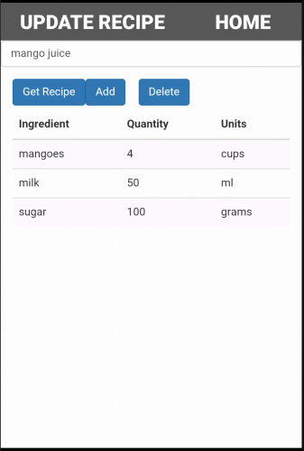

Update Recipe

* The ingredients list for a particular recipe are retrieved by clicking Get Recipe button which shows the updated recipe ingredients list.

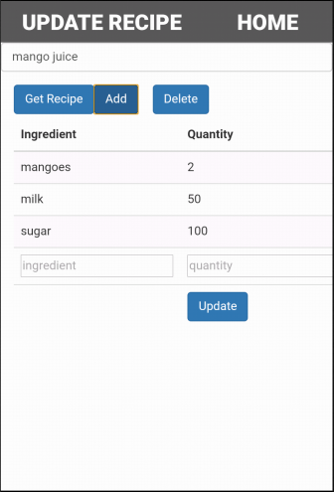

Update Recipe

* By clicking Add button, the field is displayed where we can add the ingredient for a recipe.

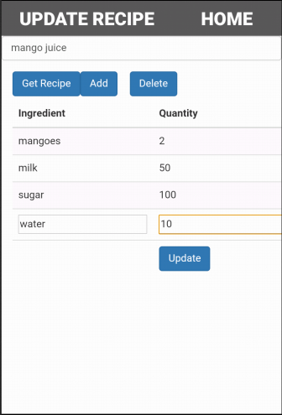

Update Recipe

* The ingredients are entered in the fields displayed.

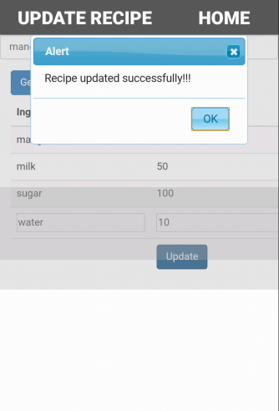

Update Recipe

* The ingredients are added by clicking update button.
* Alert dialog pops up showing recipe updates successfully.

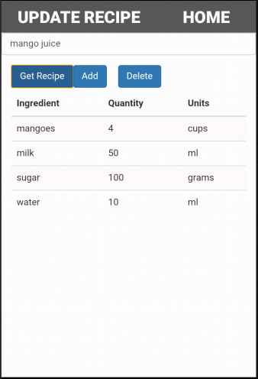

Update Recipe

* The updated ingredients list for the recipe are displayed.



Show Notifications Page

* The notifications if any item is being expired are displayed by clicking show notifications button in home page.

Technical Details:

* Client side logic is implemented in android studio as a native app.

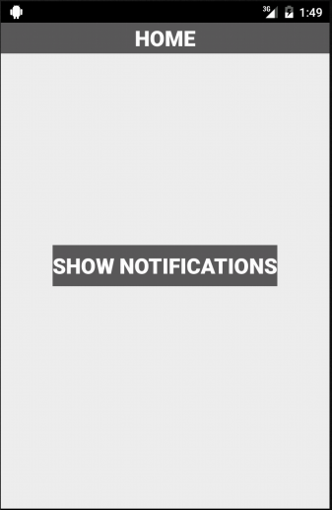

Show Notifications Page

* The android icon pops up when show notifications button is clicked.

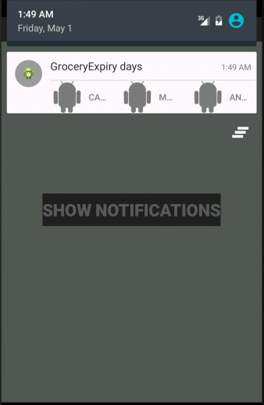

Show Notifications Page

* The notifications are displayed saying Grocery Expiry days when the popup icon is scrolled down.

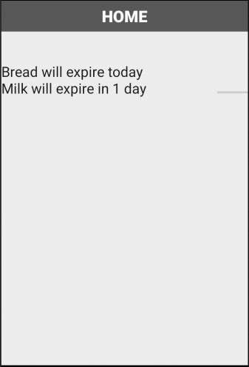

Show Notifications Page

* The notifications are displayed for the grocery items which are about to expire.



Grocery Stores Page

* The nearby grocery stores could be found by clicking the Grocery Stores button in Home page.

Technical Details:

* Client side logic is implemented in android studio as a native app.

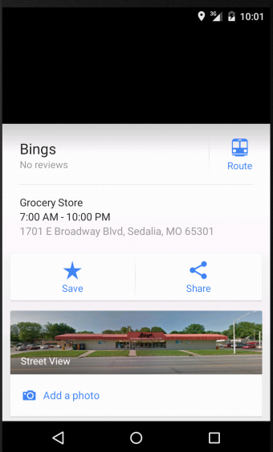

By Clicking on grocery stores, the application displays the nearby grocery stores as shown in the screenshot.

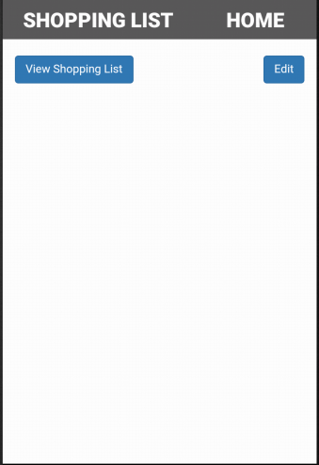

Shopping List Page

* The shopping list can be known to user by clicking on shopping list button on Home page.

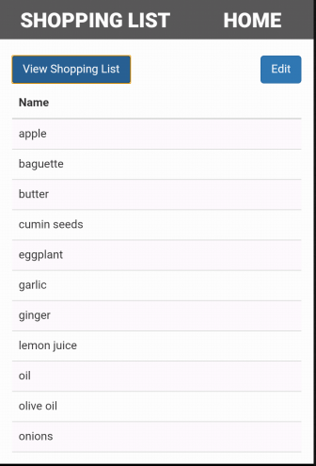

Shopping List Page

* The list is displayed when user clicks on view shopping list button.
* The list can be modified by clicking on edit button.

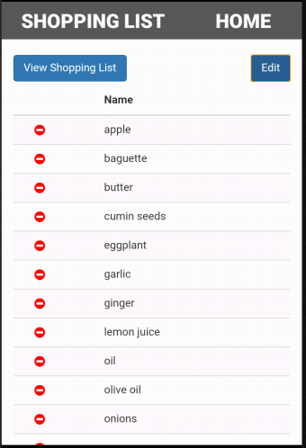

Shopping List Page

* When user clicks edit button the red colored icons are displayed on left side of each item.
* If user clicks this icon the particular item will be deleted.

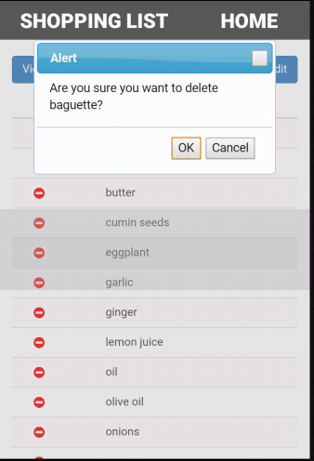

Shopping List Page

* The alert dialog box pops up to confirm the deletion of the item.
* On clicking OK button, the item will be deleted from the shopping list.

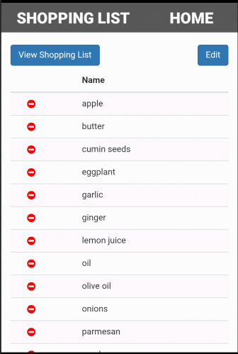

Shopping List Page

* The updated list is displayed after deleting the “baguette” from the shopping list.

1. Database Implementation

We have created Calorie2Grocery database in SQL Server and developed the following tables for our application:

User_profile

This table is used to store the user information like user_id, username, password, email, phone number and food preference.

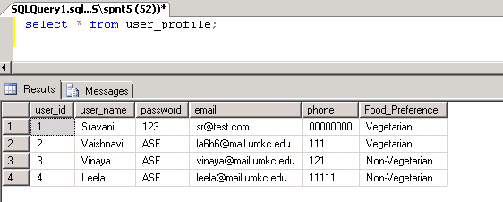

* Grocery_list

This table is used to store the list of grocery items that are available at users home. In this table user can save the grocery item along with the quantity.

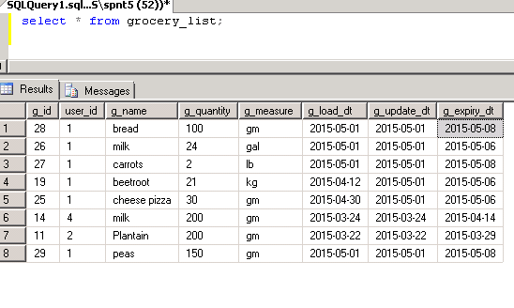

* Recipes

This table stores the information regarding the recipe and the ingredient list when the user searches for a recipe and import the ingredients of the recipe.

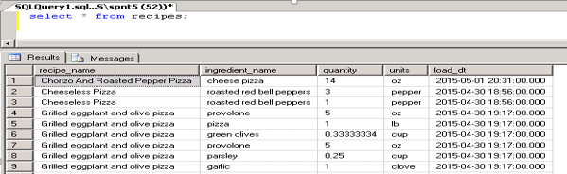

* Shopping List: This table stores the aggregated result for all the shopping lists generated by the user during different recipe searches.

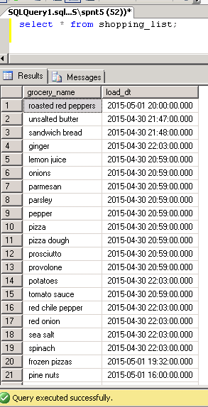

**Testing:**

1. UI Testing:

The following test cases has been written for UI testing and the actual output is validated with expected output. All of the below test cases which have been written obtained positive results.

|  |  |  |  |
| --- | --- | --- | --- |
| Page | Button | Expected | Actual |
| View Grocery list | view | Should display grocery list | Displaying grocery list |
|  | edit | Should modify the ingredients, quantity and label | Able to modify the ingredients, quantity and label |
|  | delete | Should delete the grocery items | Deleted the grocery items |
| Calorie count | Browse for a recipe | Should display list of the different recipes | Displays the list of different recipes |
|  | Select a particular recipe | Should display the ingredients list for the selected recipe | Displays the ingredients list for the selected recipe |
|  | Calorie count | Should display individual and total calorie count of ingredients | Displaying individual and total calorie count of ingredients |
| Get recipe and modify | Import recipe | The list of recipes should be added to the database | The list of recipes are added to the database |
|  | View recipe | Should display the recipe list | Displays the recipe list |
|  | Update recipe | Should allow us to update the ingredient, quantity , label of recipe | Allowing us to update the ingredient, quantity , label of recipe |
| Create new recipe | Create recipe | Add new recipe ingredients, quantity, label to database | Adding new recipe ingredients, quantity, label to database |
| Get recipe and share | Get recipe | should get imported and created recipes | Able to get imported and created recipes |
|  | Share recipe | Should share recipes to twitter and facebook | Able to share recipes to twitter and facebook |
| Notification | Send Notifications | Send Notifications to expiry dates | Sending Notifications to expiry dates |
| Generate Shopping List | Shopping List | Generates an aggregated shopping list of all the recipes | Generating all the shopping list items from all the imported recipes |

1. Data Validation:

We have implemented N-Unit test cases to validate the data for all the newly created web services. We have used Assert methods to compare the actual output with the expected output.

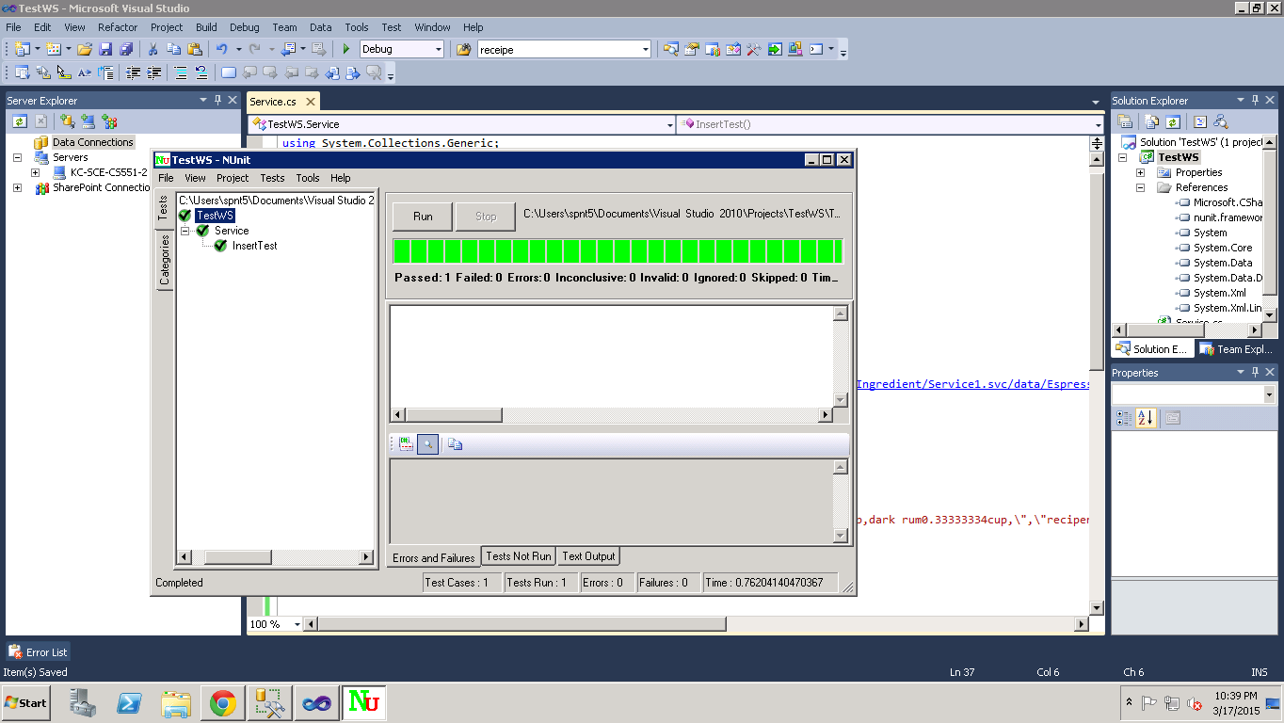Screenshot of N-Unit validation: This is used to validate the data for Import recipe API:

Screenshot for N-Unit validation of Add groceries API:

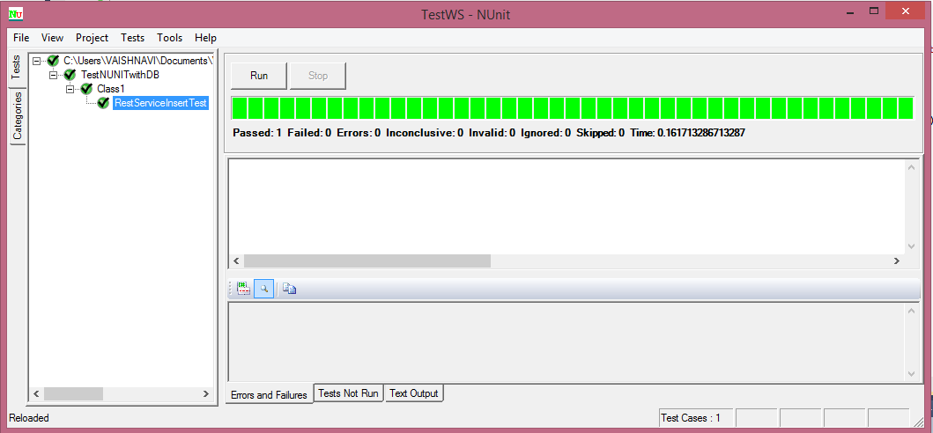

Screenshot of N-Unit validation: This is used to validate the data for update grocery item method in the rest service.



Screenshot for N-Unit validation of delete groceries API:



Screenshot for N-Unit validation of Import groceries API:



Screenshot for N-Unit validation of Update groceries API:



**Performance Testing:**

The following are the tools we used for performance testing:

* YSlow analyzer
* Firebug

1. YSlow Analyzer: This is a free, open source testing tool that analyzes web pages and suggests ways to improve their performance. The below screenshots shows the performance analysis of the web pages that are created in our app. This analysis is done using YSlow analyzer(Google chrome extension).

Testing for a web page that generates notification about expiry dates



Screen Shot: 1



Screen Shot: 2



Screen Shot: 3

Testing for a web page that searches a recipe from the database and share it on facebook and twitter



Screen Shot: 1



Screen Shot: 2



Screen Shot: 3

Testing for a web page for Creating a recipe



Screen Shot: 1



Screen Shot: 2



Screen Shot: 3

Web Page for displaying a recipe long with calorie count



Screen Shot: 1



Screen Shot: 2



Screen Shot: 3

Testing a web page that edits/removes the grocery item



Screen Shot: 1



Screen Shot: 2



Screen Shot: 3

Testing a web page for updating a recipe



Screen Shot: 1



Screen Shot: 2



Screen Shot: 3

Testing a web page for getting the favorite recipe



Screen Shot: 1



Screen Shot: 2



Screen Shot: 3

Testing a web page for import and updating a recipe



Screen Shot: 1



Screen Shot: 2



Screen Shot: 3

Fire Bug tool:

We used the fire bug tool to do the performance testing for html pages we used. The firebug tool will automatically show us if there are any errors in the JavaScript, CSS or HTML code. It also notify us if there are any errors in request URL’s or XHR requests. We have done this testing on all of the HTML pages we created in this increment. Mostly there are no errors detected while we performed this testing.

1. Createrecipe.html





1. Share Recipe.html





1. viewRecipe.html





1. Updaterecipe.html





1. Import Recipe.html





1. Calorie.html





1. Notification.html





1. ViewGrocery.html





Screen Shots for shopping list generation:

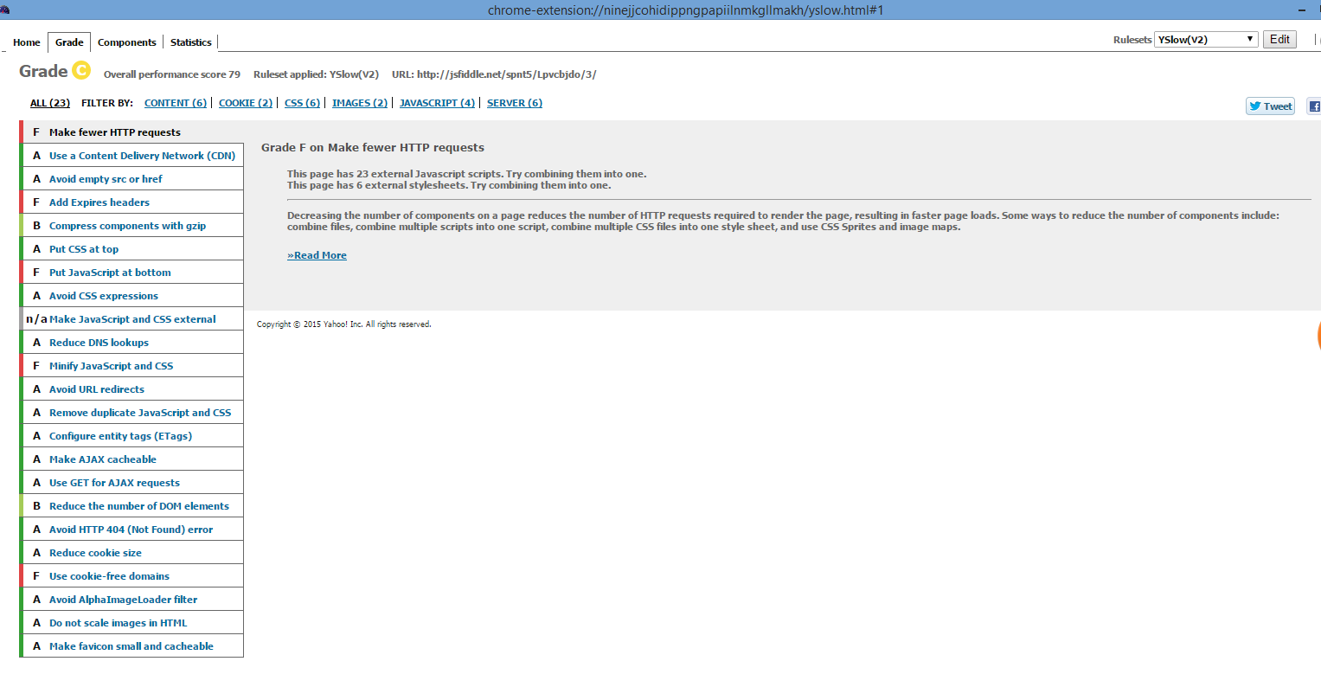

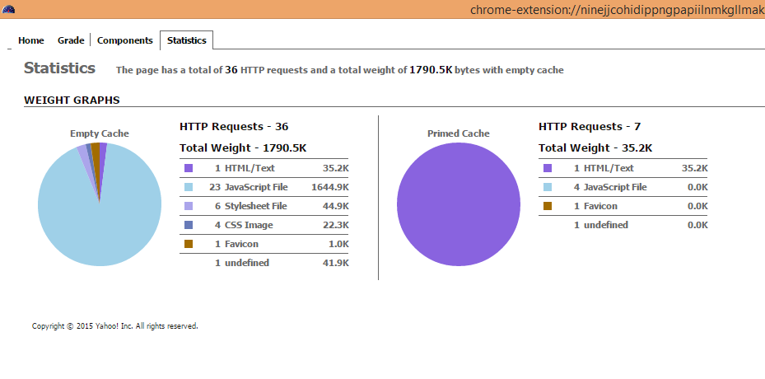

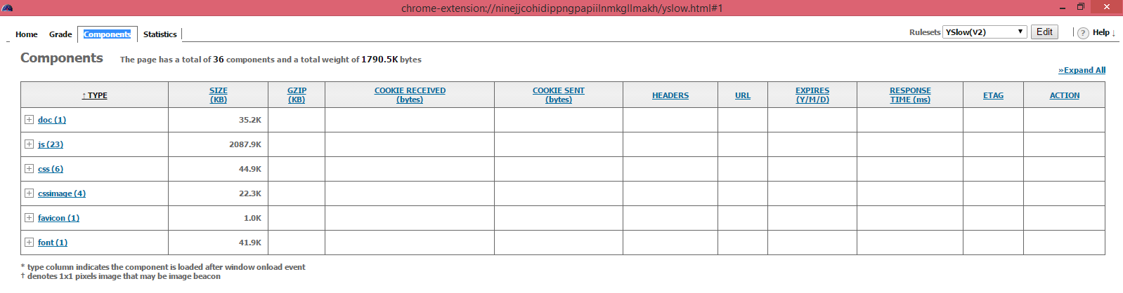

Screen Shots for Import recipe

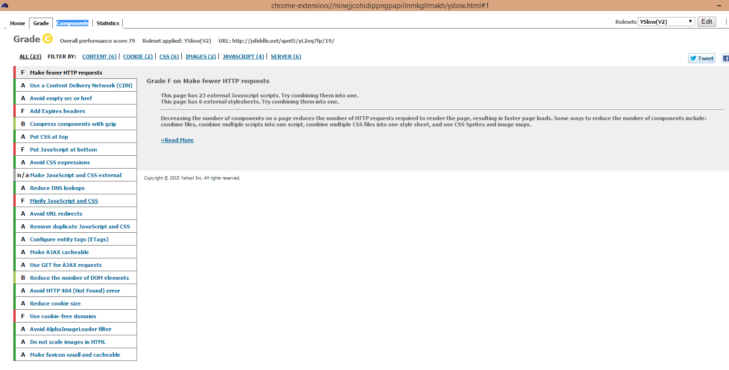

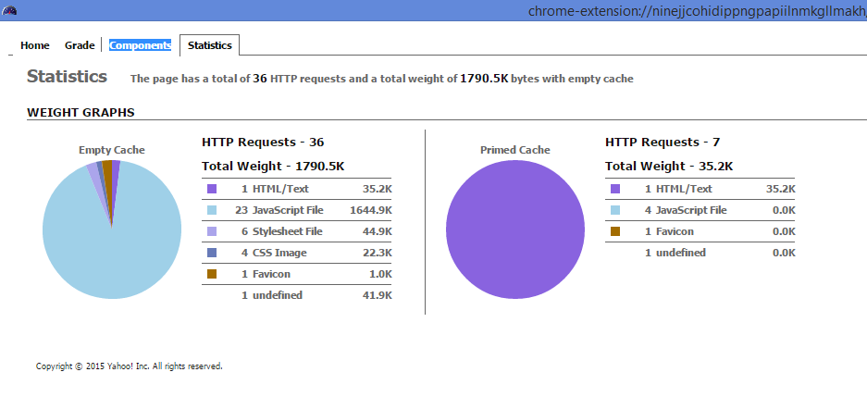

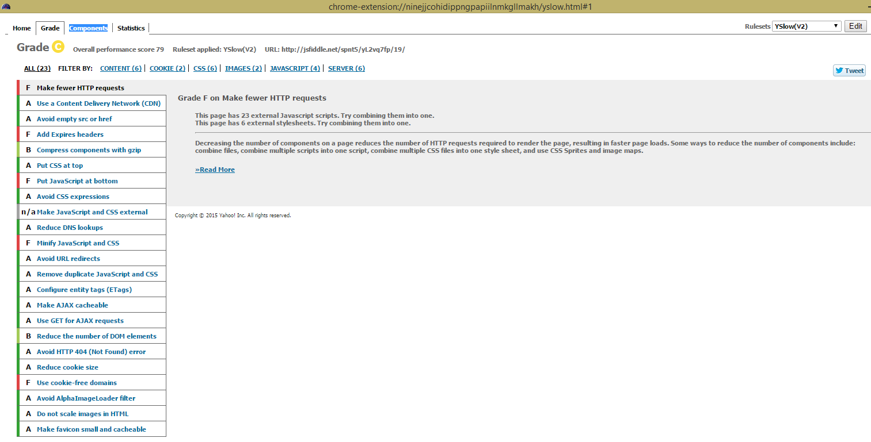

**Task Planning**

We planned to implement the project by using latest technology & tools. The project is divided into four iterations.

Increment#1:

We have developed four layouts as part of UI implementation in increment 1.

1. Registration page
2. Login page
3. Welcome/Home page
4. Layout for viewing the google maps

If the user is a new user, then he has to register to use the app. After registering, the app redirects to the login page where the user can login to use the features of this app. When the user logs in successfully, he can perform the following operations:

* He can visualize his current location using google maps.
* He can search the list of nearby grocery stores.

Increment#2:

As part of Increment#2, We have developed the following features of our application.

* Add groceries items that are available at home to a list.
* View grocery list
* Search for a recipe.
* See the ingredient list for that recipe.
* Import the ingredient list to the local system.

We developed a native android application for adding the list of groceries along with quantity. We have used web technologies for implementing the client side logic rest of the functionalities listed above. We are storing the data in SQL Server remote database. Hence we have created rest services to push/pull the data from the database.

Increment#3:

In Increment3 we have enhanced the features developed in increment#2 and provided certain new features:

1. Update the quantity of grocery items
2. Delete the grocery items from the list
3. Create a recipe and store the recipe in the database
4. Share the recipe through Facebook and twitter
5. Send notifications to users about the expiry date of recipes
6. Get calorie information for each ingredient of the recipe

Increment#4:

Following are the new features and enhancements provided in increment#4

1. Shopping list generation
2. Updating recipes imported/created
3. Fixing the issues with notifications
4. Integrating the code from all the increments
5. Integration testing

In brief each iteration consists of following tasks:

1. Designing graphical user interface.
2. Connecting to the database and implementing web services.
3. Testing the entire application and bug fixing.

**Scrum Do**

We have used Scrumdo to track the progress of the project. The whole process of development and tasks division has been completely displayed in the scrum Do tool and below is the link for the Scrum DO action of our project.

Link: [https://www.scrumdo.com/projects/project/calorie2grocery3/iteration/122933#](https://www.scrumdo.com/projects/project/calorie2grocery3/iteration/122933)

User Stories for increment#1:



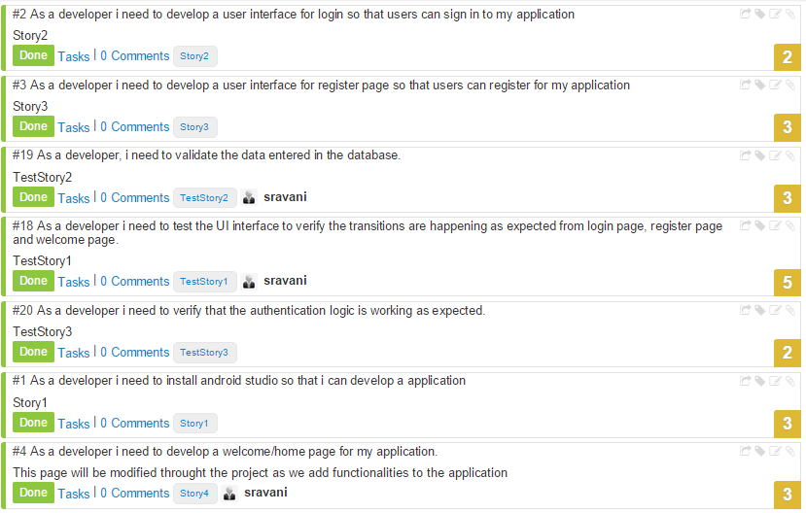

User Stories for increment#2:

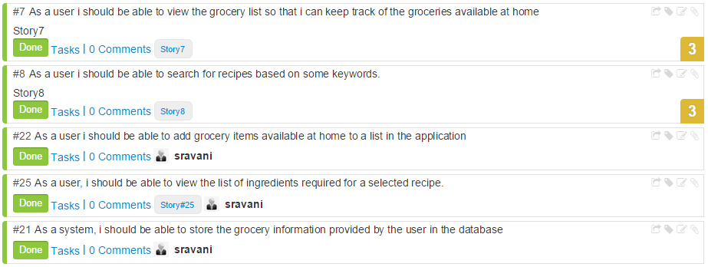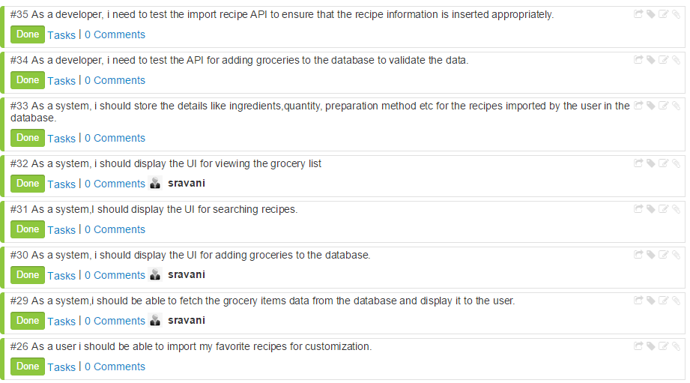

User stories for increment#3:







User stories for Increment#4:

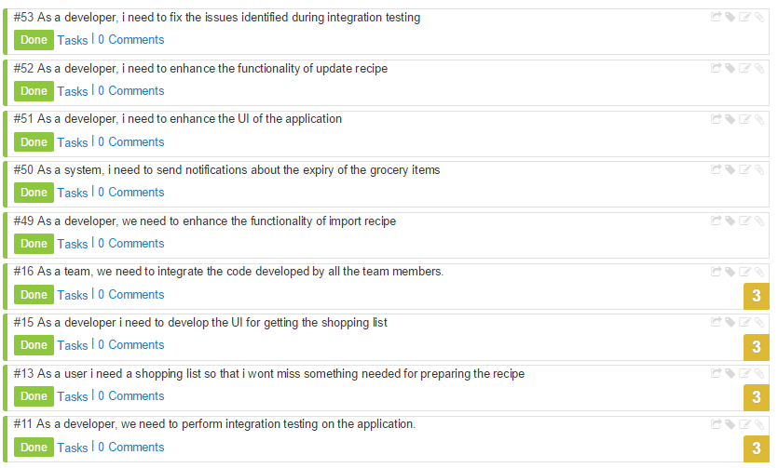

**Work Completed for Increment#4**

|  |  |  |  |  |
| --- | --- | --- | --- | --- |
| User Story# | User Story | Hours Worked | Team Member | Status |
| 52 | As a developer, I need to enhance the functionality of update recipe | 10 | Leela | Done |
| 51 | As a developer, I need to enhance the UI of the application | 5 | Vinaya | Done |
| 50 | As a system, I need to send notifications about the expiry of the grocery items | 15 | Vaishnavi | Done |
| 49 | As a developer, we need to enhance the functionality of import recipe | 10 | Sravani, Leela | Done |
| 16 | As a team, we need to integrate the code developed by all the team members. | 20 | Vinaya, Sravani | Done |
| 15 | As a developer I need to develop the UI for getting the shopping list | 3 | Sravani | Done |
| 13 | As a user I need a shopping list so that I won’t miss something needed for preparing the recipe | 10 | Sravani | Done |
| 11 | As a developer, we need to perform integration testing on the application. | 15 | Vinaya, Leela | Done |
| 53 | As a developer,  I need to fix the issues identified during integration testing | 15 | Leela, Vaishnavi | Done |

**GIT Hub URL:**

The Project code and documentation are uploaded to the following GIT hub URL:

<https://github.com/vaishnavi5054/AdvSoftEng/tree/master/ASE%20Increment_4%20PG_12>

Youtube URL: <http://youtu.be/tT-zoL18Qd8>

**Bibliography**

<https://developer.android.com/training/index.html>

<http://www.apartmenttherapy.com/whats-for-dinner-6-fridge-management-apps-weekly-smartphone-app-roundup-189441>

<http://www.snaptohealth.org/nutrition-hub/nutrition-on-the-go/>

<http://www.techhive.com/article/2455133/six-grocery-shopping-apps-to-replace-your-paper-list.html>

<http://www.groceryiq.com/>

<https://www.anylistapp.com/>

**This work was done in the partial fulfilment of CS5551 Advanced Software Engineering Course, CSEE Department.**

**By**

**Instructor: Dr.YugYung Lee**

**TA’s: Malathy Krishnan,**

**Mayanka Chandra Sekhar,**

**Bharat Viswanadham.**

**University of Missouri-Kansas City**

**(Spring-2015)**